NLP HW3  
陽明交通大學(NYCU) 資工系 大三 吳定霖

程式執行環境 :

* Python version : 3.9.0
* Hardware :   
  我在 local environment (我的電腦) 執行 HW3 的程式。  
  CPU : AMD Ryzen 5 7500F 6-Core Processor  
  GPU : NVIDIA GeForce RTX 4060 Ti 16GB  
  記憶體 : 32GB  
  磁碟 : 2TB
* Python Packages :   
  請查看 requirements.txt。

Usage with GAI or Internet sources :

1. OpenAI ChatGPT
2. Google Gemini
3. Hugging Face
4. Google Colab AI

Todo Code Explanation :

(a)

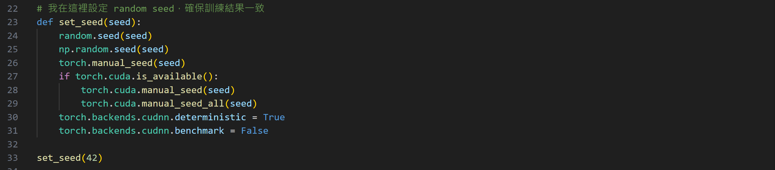

我在這裡設定 random seed，確保訓練結果一致。

(b)

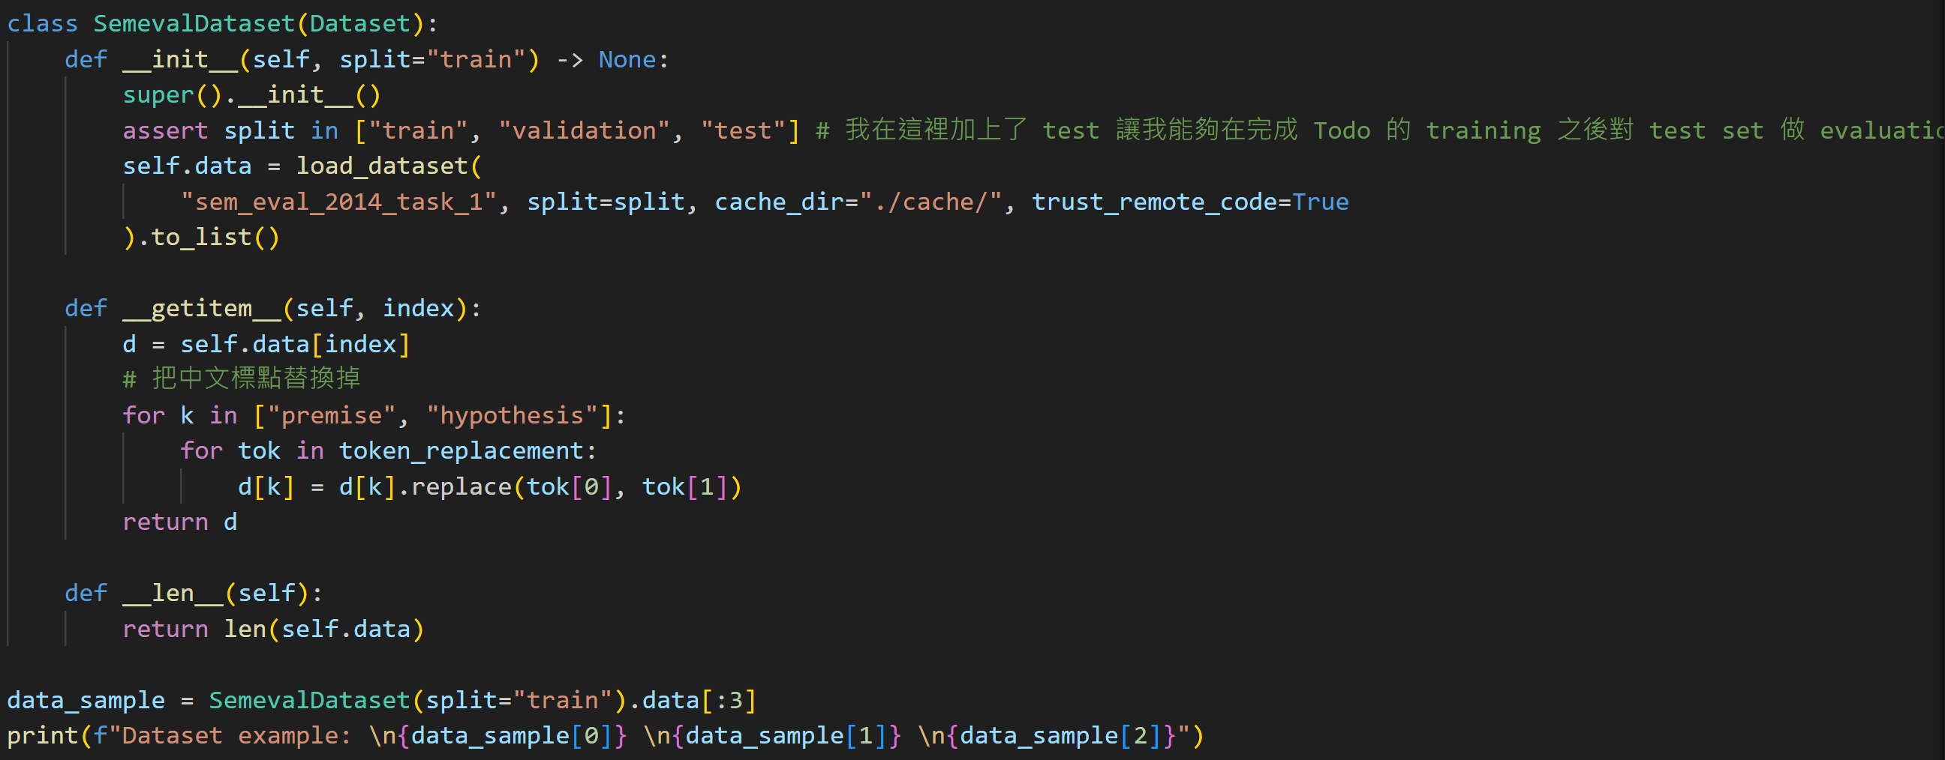

我在 split 加上了 test，讓我能夠在完成 Todo 的 training 之後對 test set 做 evaluation。

(c)

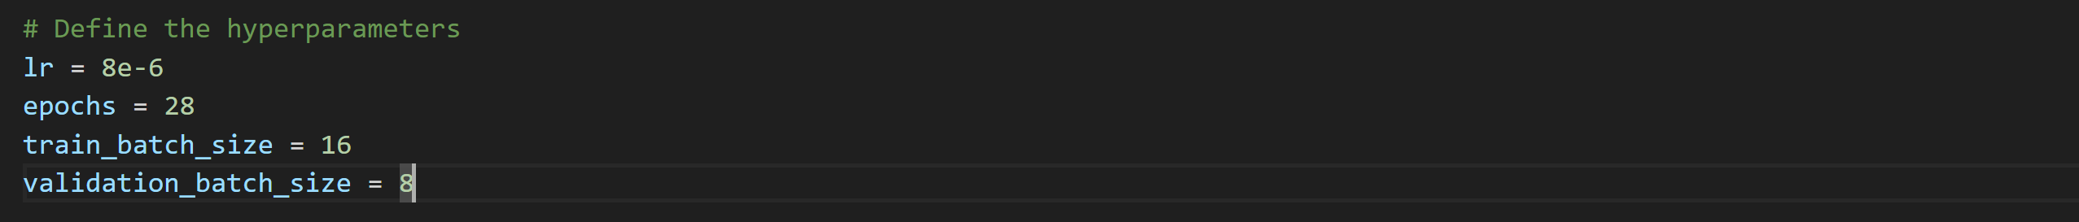

設定我的最佳 model 的 hyperparameters。

(d)

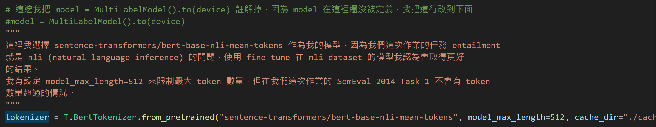

這裡我選擇 sentence-transformers/bert-base-nli-mean-tokens 作為我的模型，因為我們這次作業的任務 entailment就是 nli (natural language inference) 的問題，使用 fine tune 在 nli dataset 的模型我認為會取得更好的結果。

我有設定 model_max_length=512 來限制最大 token 數量，但在我們這次作業的 SemEval 2014 Task 1 不會有 token數量超過的情況。

我把 model = MultiLabelModel( ).to(device) 註解掉，因為 MultiLabelModel( )在這裡還沒被定義，我把這行改到後面。

(e) Todo 1-1

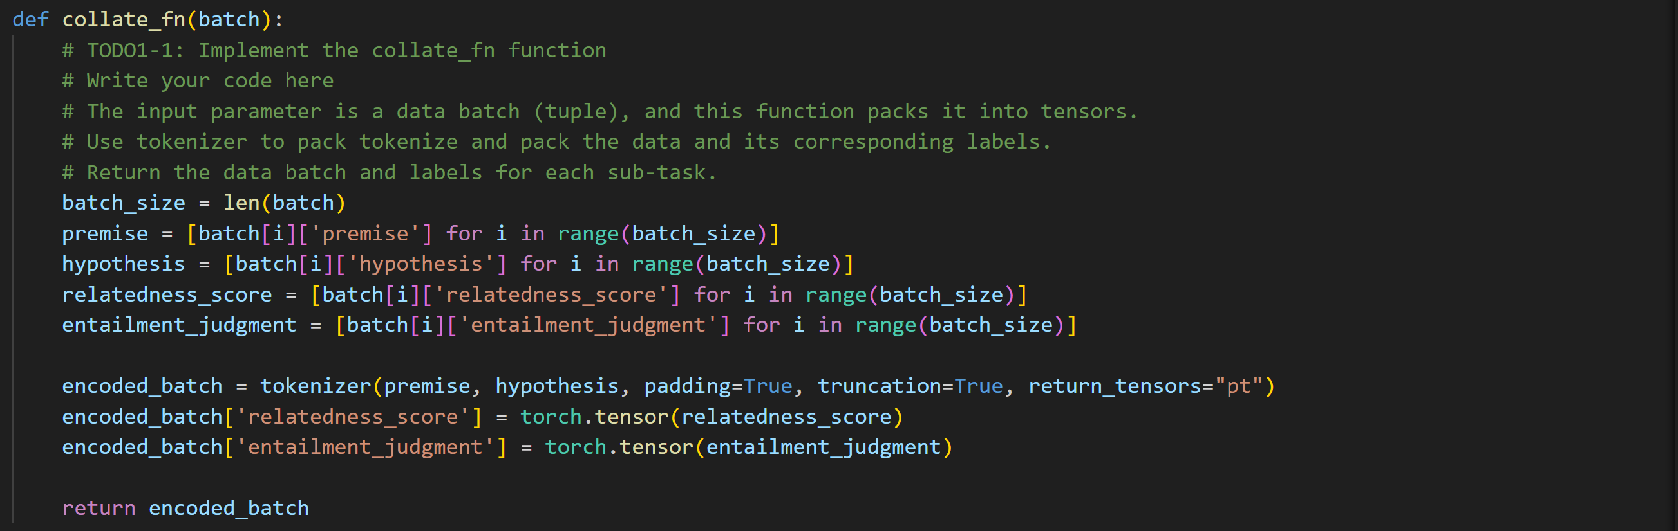

這裡我透過 Colab AI + ChatGPT 來協助我完成這部分的程式碼。

對於 pytorch dataloader 中輸入到 collate_fn 的 input batch，先把這個 input batch list 裡面的 premise, hypothesis, relatedness_score, entailment_judgment 分別取出來存到各自的 list 當中，再把 premise, hypothesis 丟到 tokenizer 中，把 padding, truncation 都設為 True，並設定 tokenizer 的 return tensors 為 pytorch tensor。

再來把 return 的 encoded_batch 的 dictionary 再加上 relatedness_score, entailment_judgment 兩個 key，存入它們對應的 tensor。

(f) Todo 1-2



把 train, validation 的 dataloader 分別存到 dl_train 和 dl_validation 中，設定好 batch size，並且把前面 Todo 1-1 寫好的 collate_fn 傳入取代 default collate_fn。

(g) Todo 2

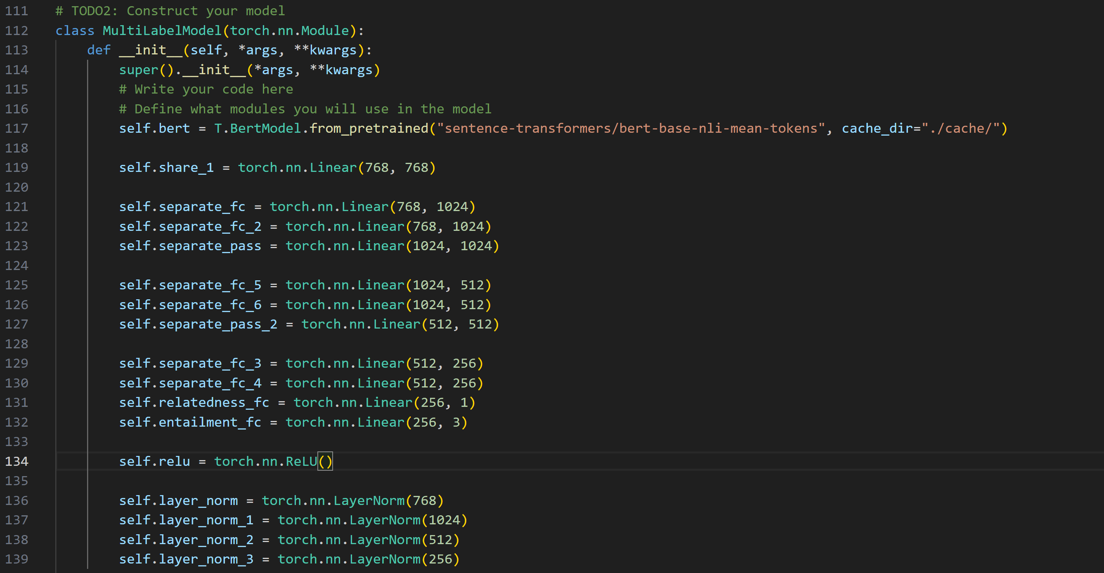

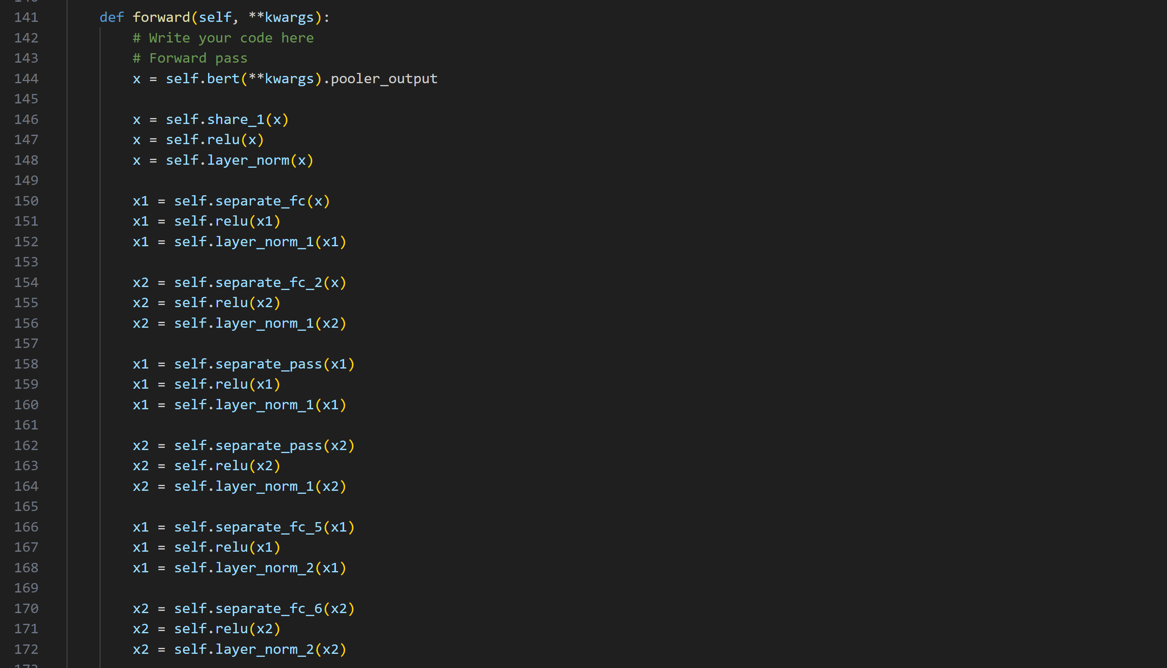

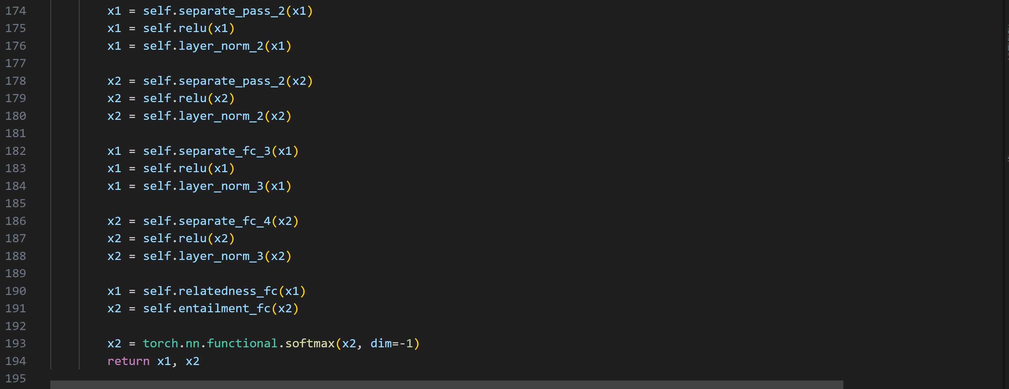

這裡定義了模型架構，把 pretrained 的 "sentence-transformers/bert-base-nli-mean-tokens" load 到我們的模型中，將 BERT 的輸出連接到一個 shared layer，接著分成兩個不同的 Head 分別通過兩個不同的 Neural Network Layer，其中一個用來做 regression 直接 return 其值，另一個做 classification ，先經過 softmax 之後再輸出。詳細的模型介紹以及為什麼這樣設計會在後面講解。

(h) Todo 3

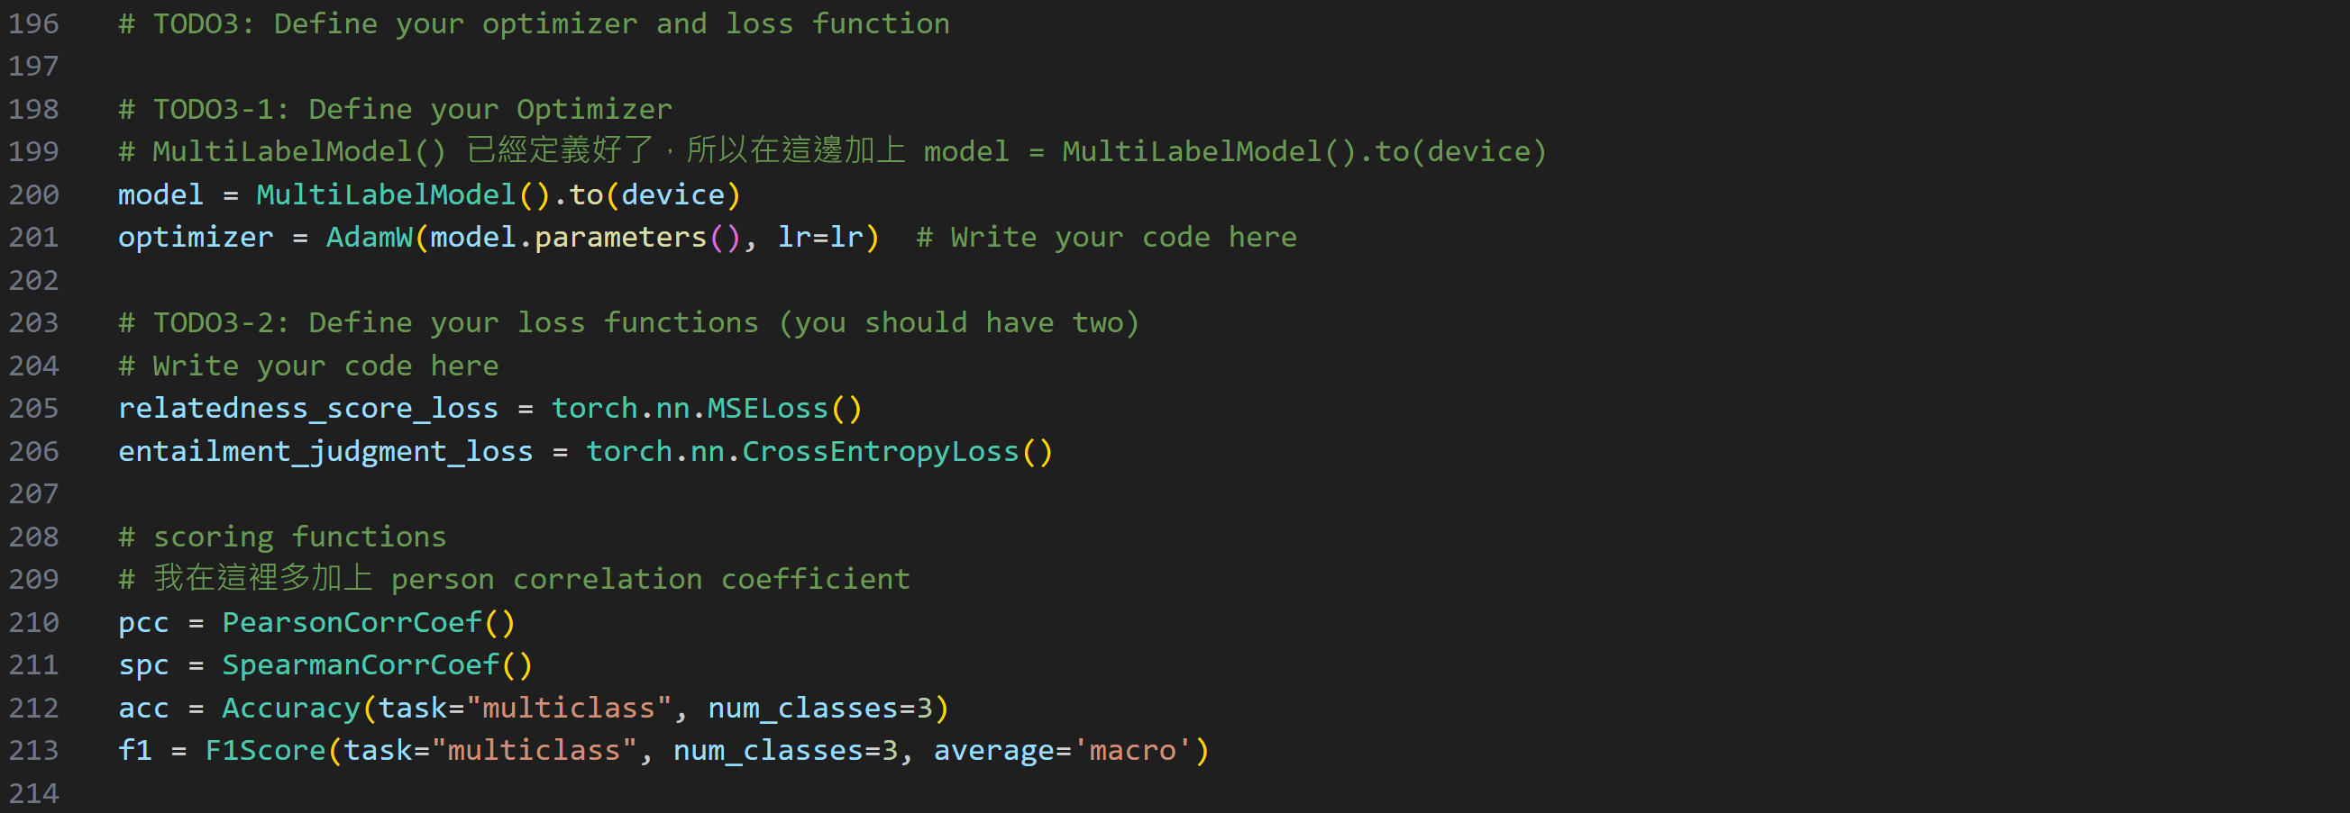

這裡我透過 Colab AI + ChatGPT 來協助我完成這部分的程式碼。

這裡把前面 (d) 註解掉的 model 重新寫回來，然後定義 optimizer 是 AdamW 並設定 learning rate。

Loss 的部分，對於 relatedness 這種 regression 問題使用 MSE loss；對於 entailment 這種 classification 問題使用 Cross Entropht loss。

我在 torchmetrices 用來計算不同的 score 的地方加入了 PersonCorrCoef。  
(i) Todo 4

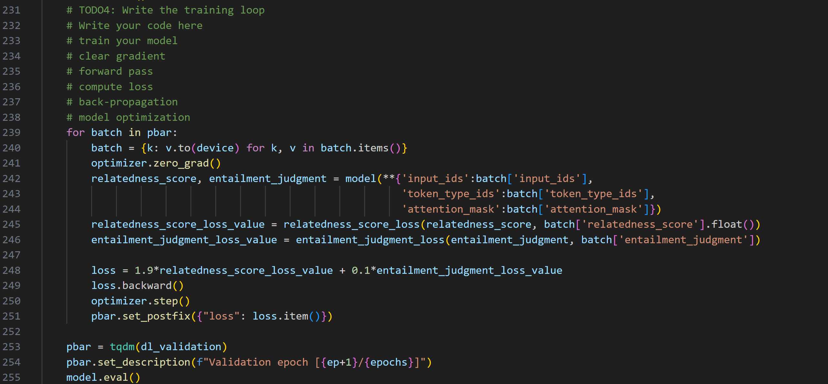

這裡我透過 Colab AI + ChatGPT 來協助我完成這部分的程式碼。

先把 batch 中所有 element 都放到 GPU 上面跑。

把 optimizer 的 gradient 歸零。

對於每個 batch，我先把 batch 中的 input_ids, token_type_ids, attention_mask 取出來並存到另一個新的 dictionary 中，再傳入之前定義好的 Model 中，這樣才會是正確的 BERT input。得到模型對 relatedness 和 entailment 分別的 predictions 之後，計算 relatedness loss 和 entailment loss ，最後透過把 relatedness loss 和 entailment loss 加權加在一起，然後把這個組合的 loss 做 backpropagation 並用 optimizer.step() 更新 model weights。

(j) Todo 5

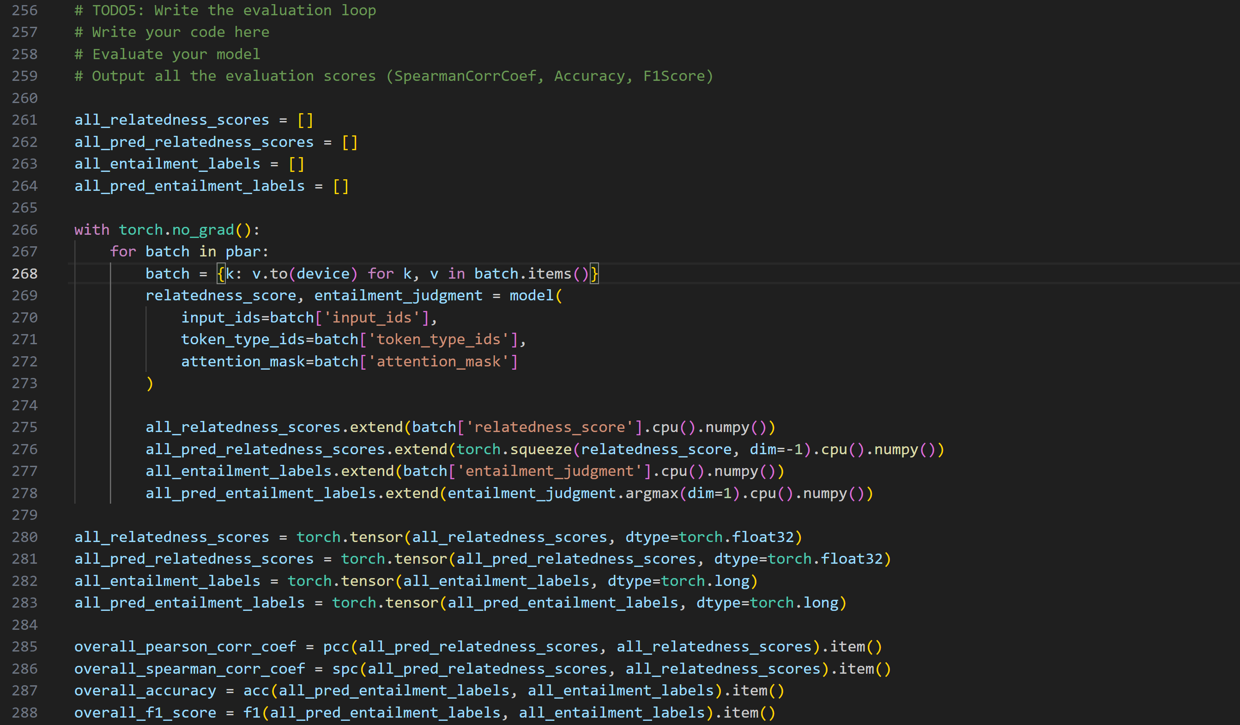



這裡我透過 Colab AI + ChatGPT 來協助我完成這部分的程式碼。把 evaluation 的 batch 丟到 model 中得到 predictions，然後分別透過不同的 torchmetrics 算出person correlation coefficient, spearman correlation coefficient, accuracy, f1 score。兩個 correlation coefficient 使用 relatedness (regression) 來計算，accuracy和 f1 score 用 entailments (classification) 來計算。

(k) Test data Evaluation

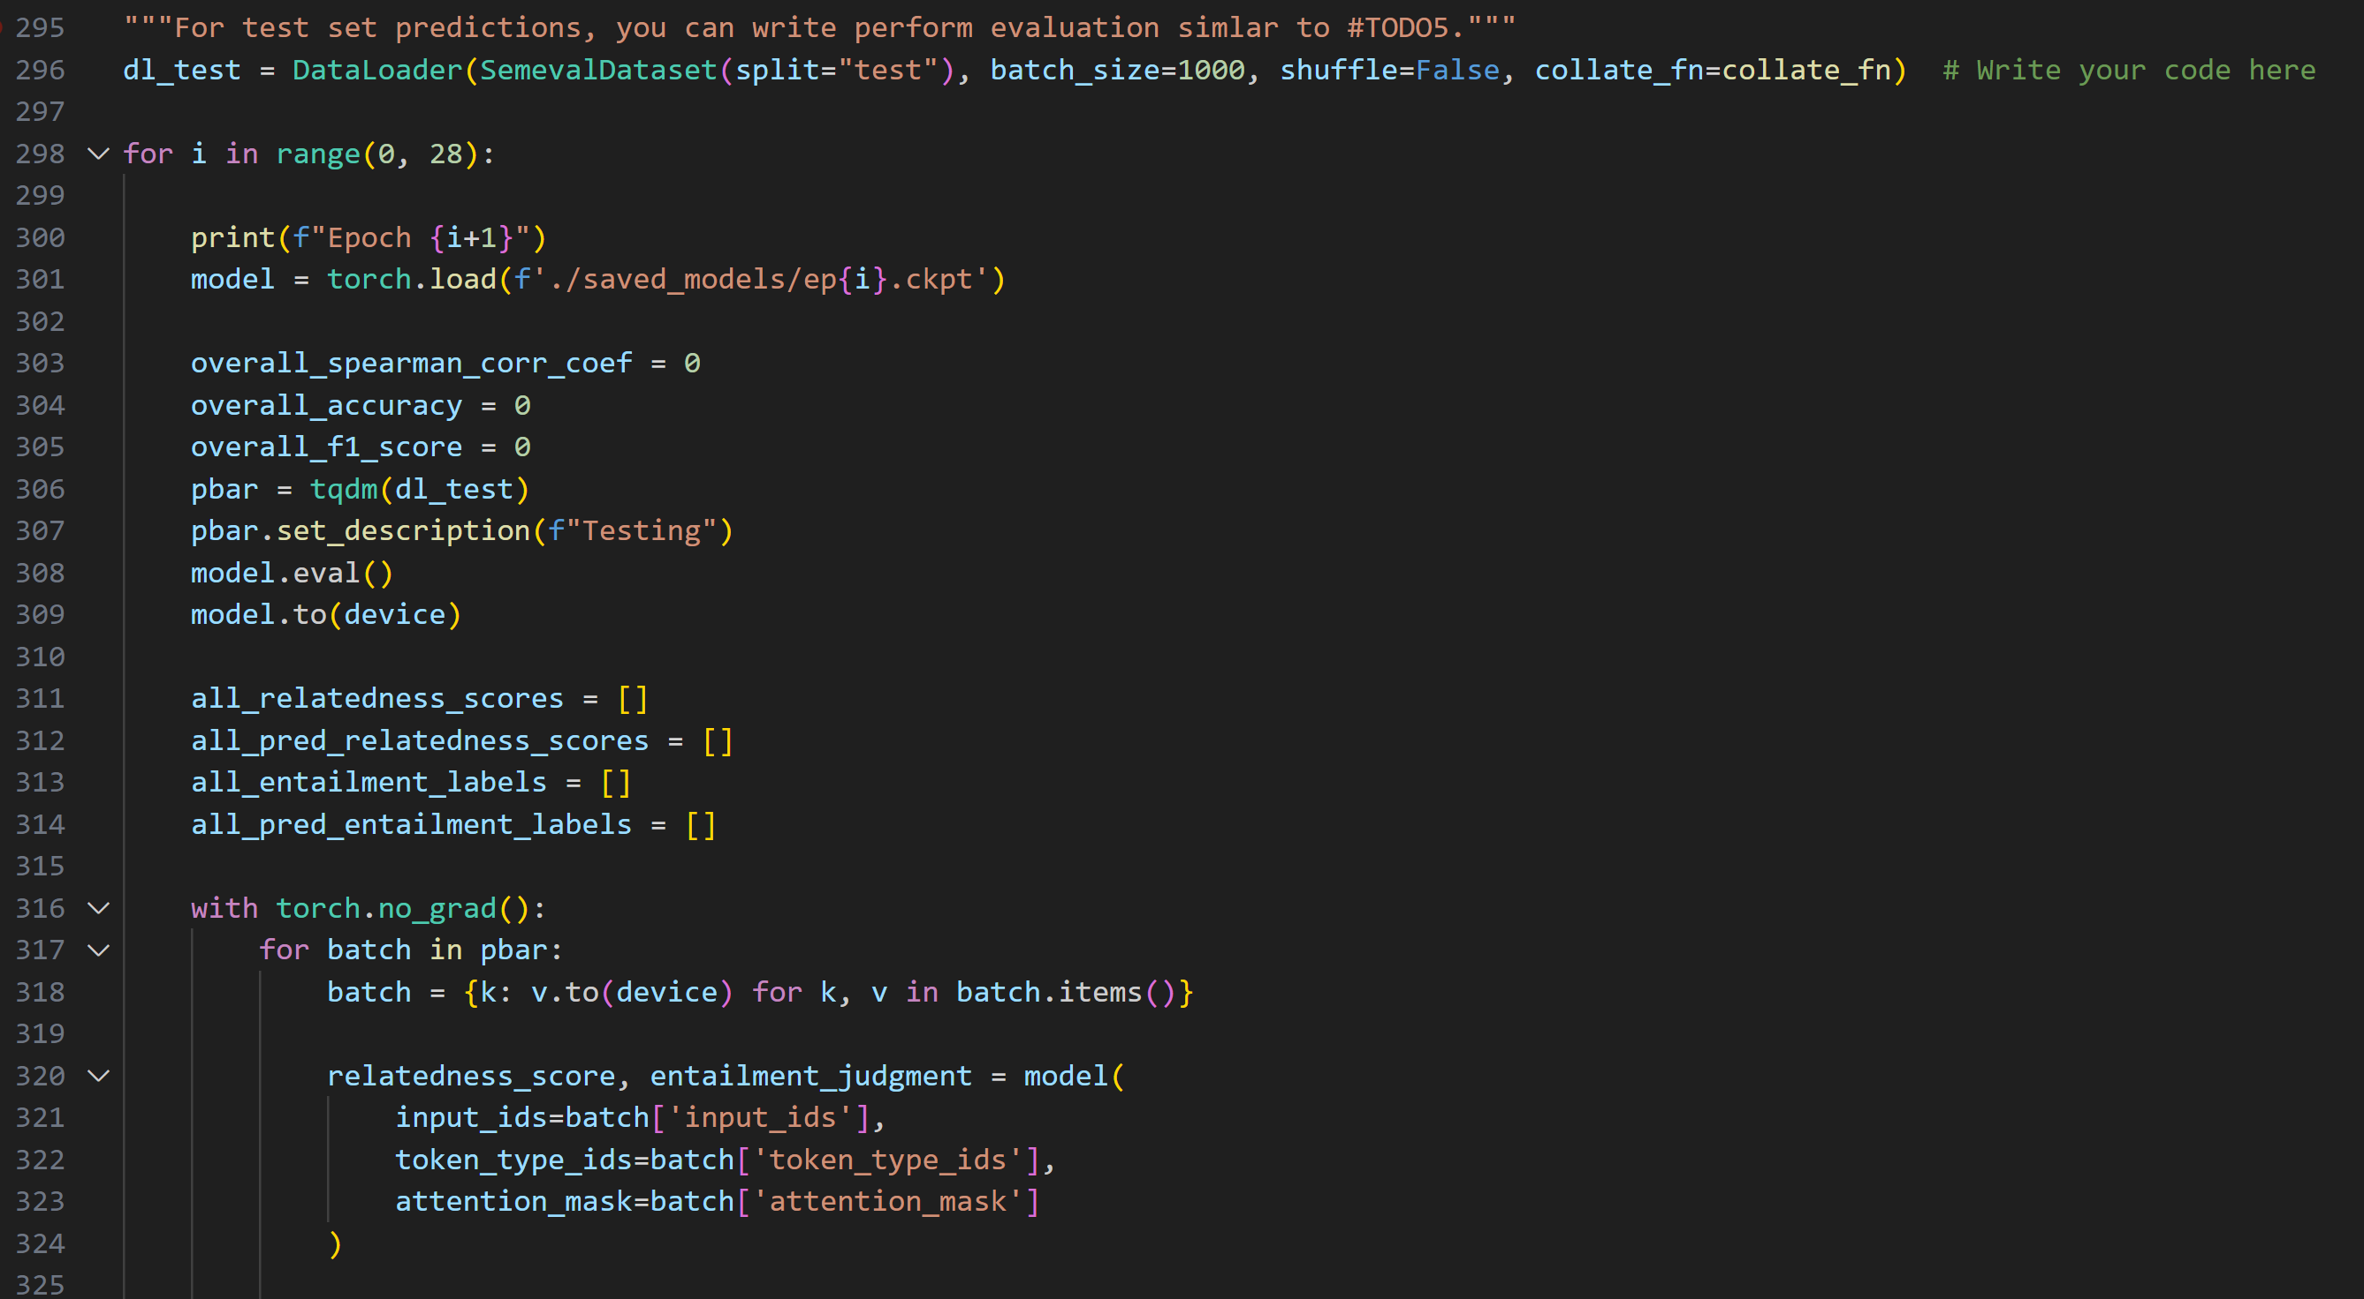

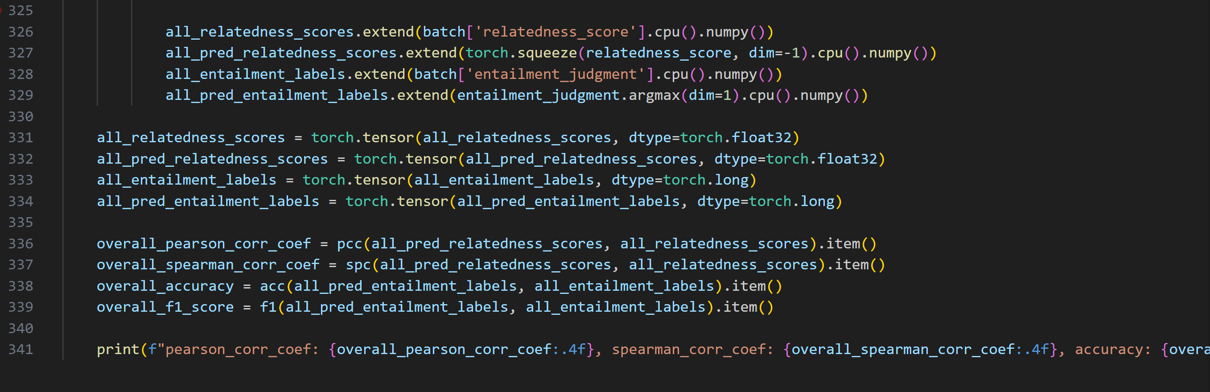

這裡我透過 Colab AI + ChatGPT 來協助我完成這部分的程式碼。

和 (j) Todo 5 相似，只是換成用 test dataloader。

My model and results :

1. 模型架構 :

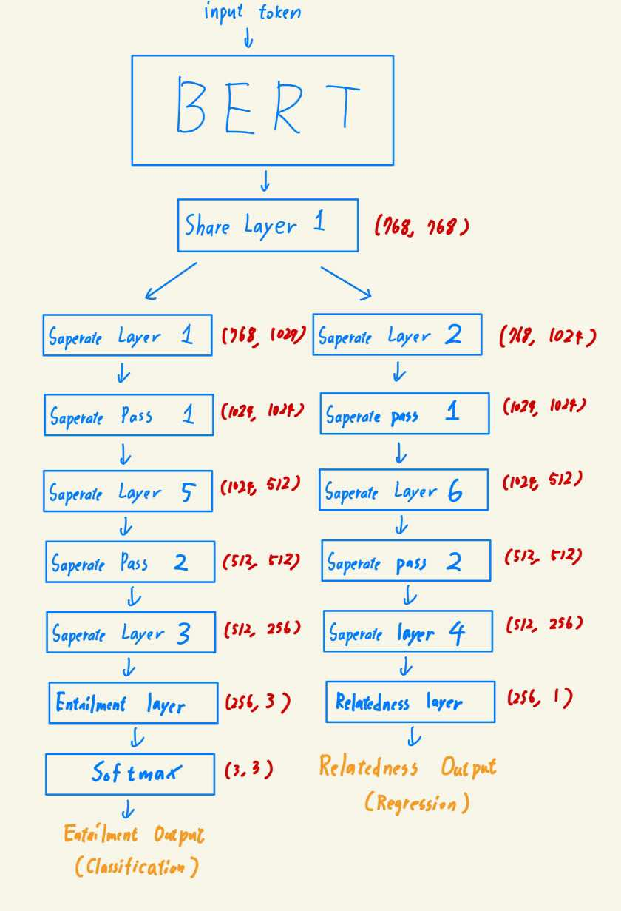

上圖是我的模型架構，我使用 "sentence-transformers/bert-base-nli-mean-tokens" 作為我的 BERT model。把 input token 經過 BERT 之後，把 BERT 的 output 先通過一個 share layer，經過 layer norm，然後將其 output 分別通過兩個不同的 head，一個 head 是 Entailment 的 output，把模型維度從 1024 -> 512 -> 256 -> 3，然後再通過 soft max 得到 Entailment output (classification)，中間的 linear 層皆有通過 relu 和 layer norm。另一個 head 是 relatedness 的 output。把模型維度從 1024 -> 512 -> 256 -> 1，最後 dimension 為 1 的 Linear layer output 及為 relatedness output (regression)。

下面是程式碼 :







Hyperparameters :

lr = 8e-6

epochs = 28

train_batch_size = 16

validation_batch_size = 8

random_seed = 42

(b) Evaluation set 的結果 :

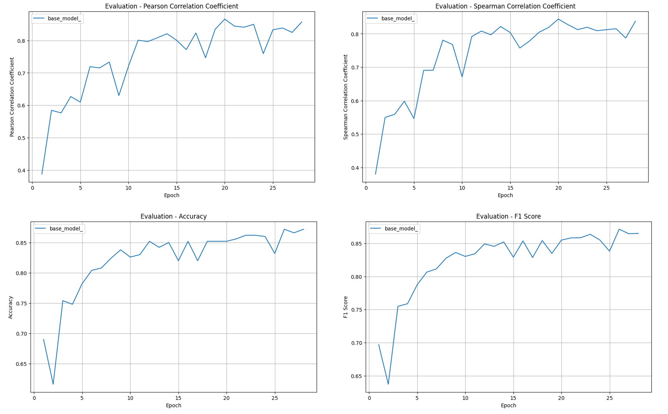



透過上圖可以看到，不管是在 person correlation coefficient, spearman correlation coefficient, accuracy, f1 score，此模型都有隨著 training epoch的提高，並且達到person correlation coefficient, spearman correlation coefficient > 0.8，accuracy, f1 score > 0.85。這說明了這個模型有很好地被訓練，沒有發生過度的 underfitting。

詳細數值請看 appendix [1]

(c) Test set 結果 :

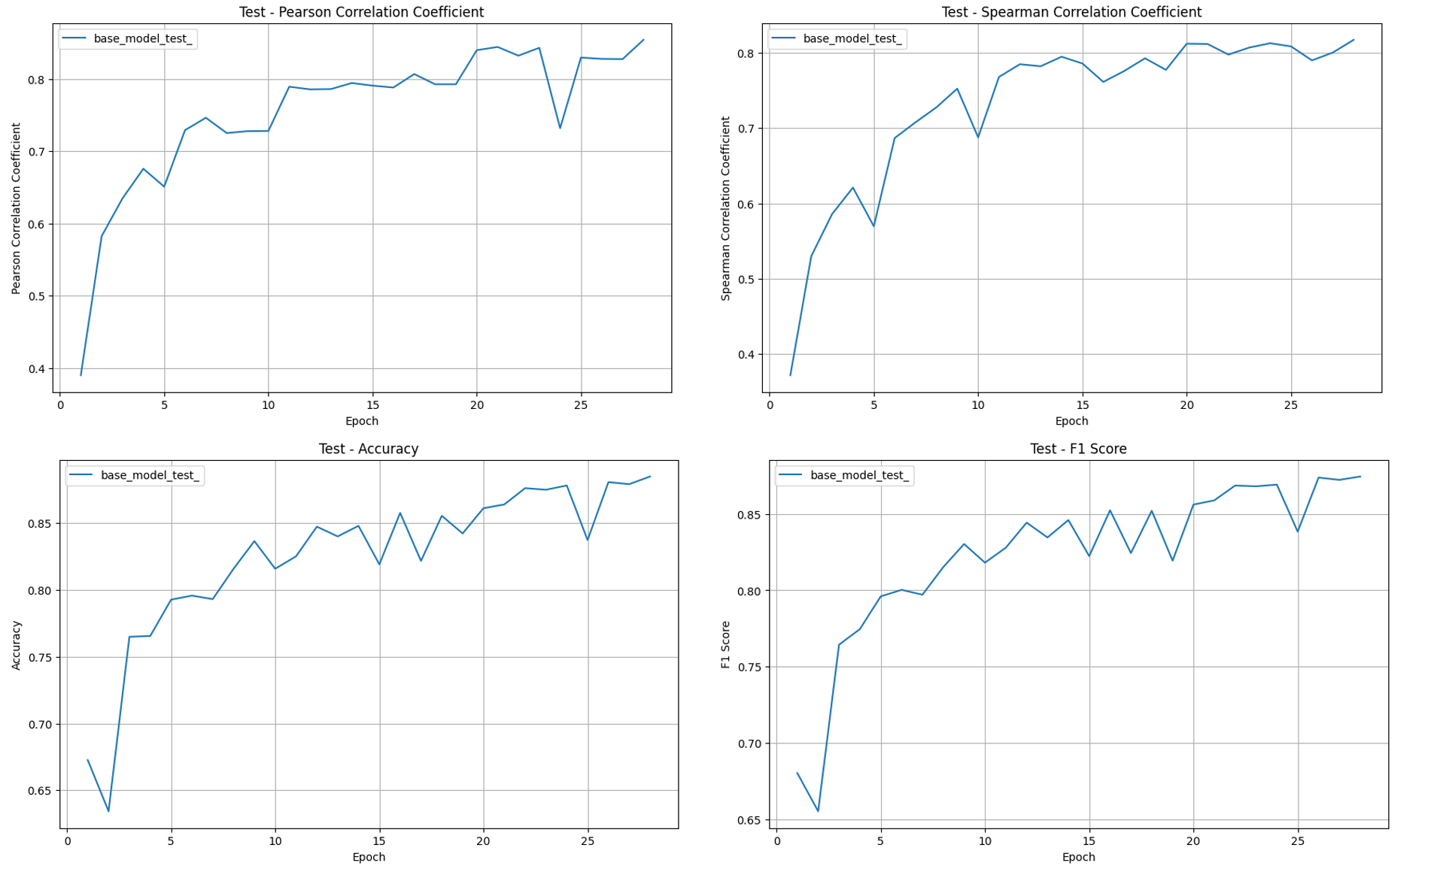



可以看到， model 在第 28 個 epoch 時，在 Test set 的 sperman_corr_coef 可以高達 0.8172、 accuracy 達到 0.88847，超過了 bonus 的門檻，因此我的 model 可以通過 Bonus。

Test set 在四個 score 的分數也都達到不錯的分數，person correlation coefficient, spearman correlation coefficient > 0.8，accuracy, f1 score > 0.85。這代表 training 並沒有overfitting。

詳細數值請看 appendix [2]

Questions :

Which (pre-trained) model do you use? Why to choose the model? (5%) :

我選擇 “sentence-transformers/bert-base-nli-mean-tokens” 作為我的 BERT 模型，它是一個 fine tune 在 NLI task 的 BERT based 模型，因為我們這次作業的任務 entailment就是 NLI (natural language inference) 的任務，使用 fine tune 在 NLI dataset 的模型我認為會取得更好的結果。

我有嘗試了其他的 BERT based model，包含 "google-bert/bert-base-uncased", "google-bert/bert-base-multilingual-uncased", "nlptown/bert-base-multilingual-uncased-sentiment"，將它們與“sentence-transformers/bert-base-nli-mean-tokens”做比較，並且得到了“sentence-transformers/bert-base-nli-mean-tokens”的效果較佳的結論，藉此證明應該要選“sentence-transformers/bert-base-nli-mean-tokens”作為我的模型。

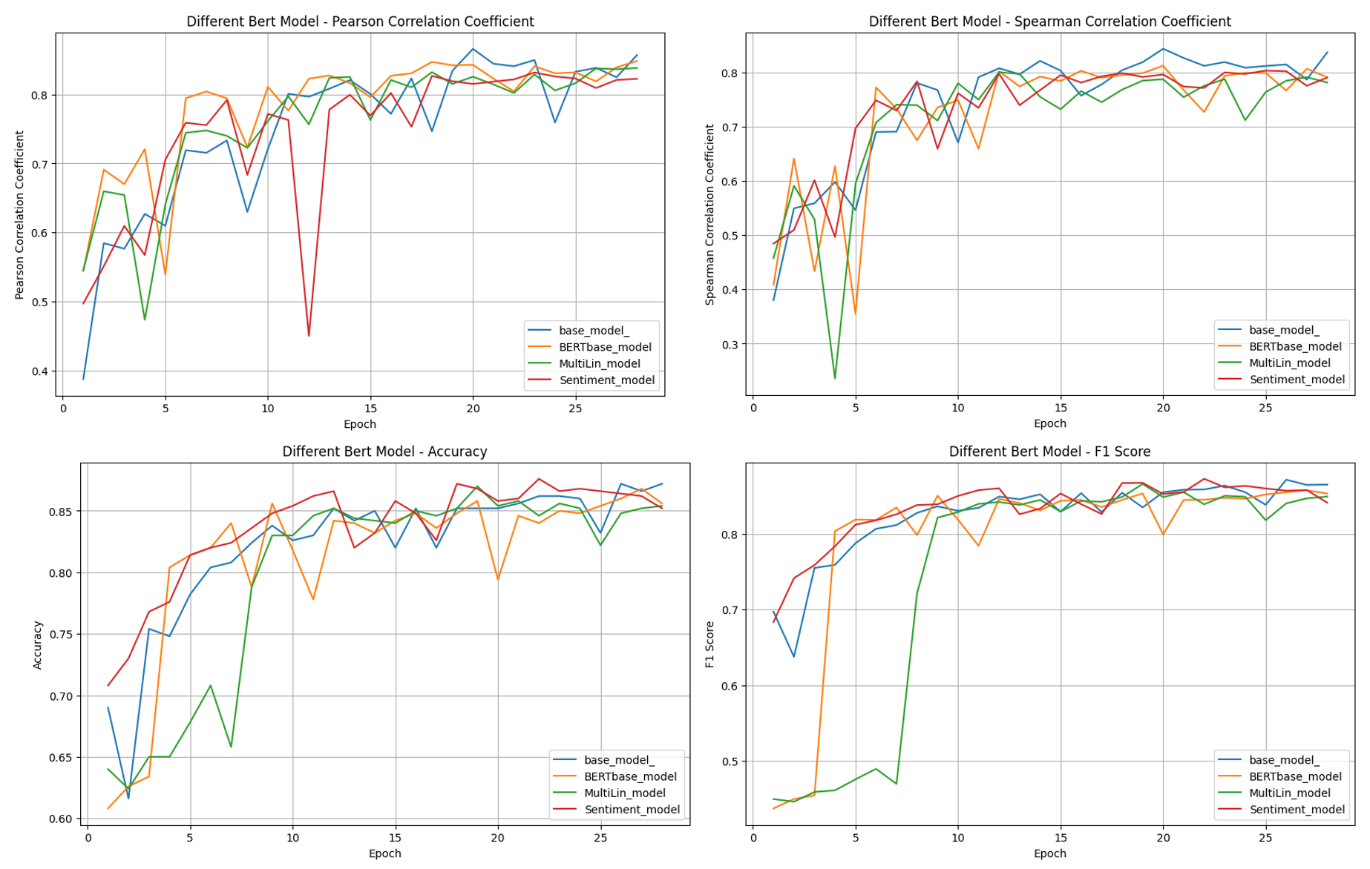

上圖是我使用不同的 BERT base 模型的實驗結果，模型的架構其他部分皆和原本的 Model 一樣，只有改變了 BERT model 的部分。

base_model : “sentence-transformers/bert-base-nli-mean-tokens

Finetune在 Natural language Inference dataset 的 BERT。

BERTbase_model : "google-bert/bert-base-uncased"

最原本的 BERT。

MultiLin_model : "google-bert/bert-base-multilingual-uncased"

訓練在不同語言的 BERT。

Sentiment_model : "nlptown/bert-base-multilingual-uncased-sentiment"

Finetune 在 Sentiment dataset 的 BERT。

從圖中可以看到，base_model (“sentence-transformers/bert-base-nli-mean-tokens) 在最後一個 epoch 皆取得四個 score 的最佳分數。

除此之外，BERTbase_model ("google-bert/bert-base-uncased") 在 accuracy 上訓練過程有很大的震盪，這可能是因為原本的 BERT 沒有經過 finetune，所以在訓練時 gradient 值會較大，導致 update 變動的值較大，所以 accuracy 會有大幅震動。MultiLin_model("google-bert/bert-base-multilingual-uncased") 在四個 score 的震盪是最穩定的，可是沒有辦法 train 到最高的分數。Sentiment_Model (nlptown/bert-base-multilingual-uncased-sentiment) 在 accuracy上面超越了 base_model (“sentence-transformers/bert-base-nli-mean-tokens)，然而，base_model (“sentence-transformers/bert-base-nli-mean-tokens) 在 person correlation coefficient, spearman correlation coefficient 上面始終取得更高的分數，這很合理，因為 person correlation coefficient, spearman correlation coefficient 都是 evaluate 在 entailment 這個 NLI task 上面，而 base_model (“sentence-transformers/bert-base-nli-mean-tokens) 本身就 fine-tune 在 NLI dataset 上。

綜所上述，我決定選 base_model (“sentence-transformers/bert-base-nli-mean-tokens) 作為我的 BERT model。

詳細數值請看 appendix [3], [4], [5]

Compared with models trained separately on each of the sub-task,

does multi-output learning improve the performance? (8%) :

我分別對只有 relatedness head (relatedness output) 和只有 entailment head (entailment output) 的 model 做了實驗，並且和我原來的 model 進行比較。

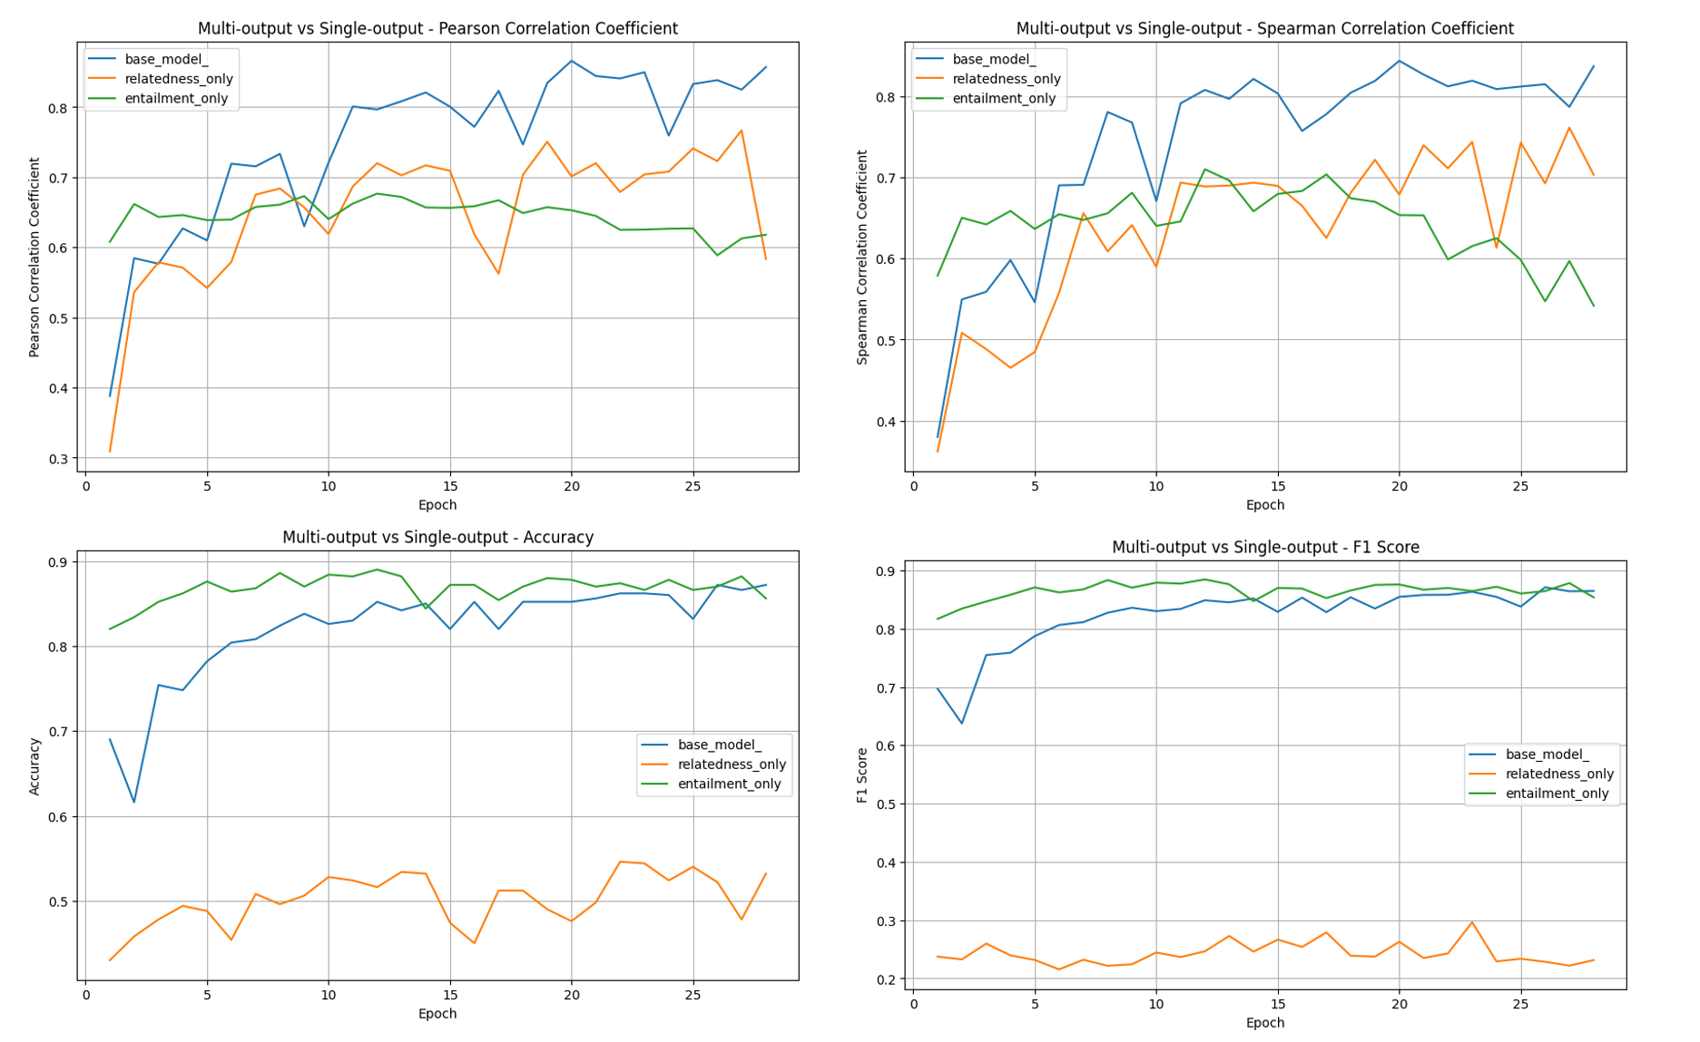

base_model : 原本的 model

relatedness_only : 只留下 relatedness head，把 entailment head 移除

entailment_only : 只留下 entailment head，把 relatedness head 移除

首先，relatedness_only 的 model 在 entailment 任務上表現非常差，accuracy 只有 0.5，F1 score 不到 0.3；entailment_only 的 model 在 relatedness 任務上表現不太好，Person Correlation Coefficient, Spearman Correlation Coefficient 都在 0.6-0.7 附近。這是必然的結果，畢竟這兩個 model 本來就沒有訓練在對方的 objective 上面。

再來，base_model 在 entailment 任務上遠勝 relatedness_only，而且 base_model 在 relatedness 任務上也勝過 relatedness_only，這說明了 multi-task learning 比起只 train 在特定該 task 上的效果還要好，模型在學習其他 task 的時候也能增進另一個 task 的 performance。base model 在 relatedness task 上面遠勝 entailment_only，base model 在前幾個 epoch 時在 entailment task 上面是輸給 entailment_only 的，可是到越後面的 epoch 此差距越來越小，到 25 epoch 之後兩者不分上下。這代表就算 multi-task learning 同時訓練另一個 task，但在特定的 task 上面也可以得到和專精訓練在該task 相同的 performance。

由以上結論可知，multi-task learning 在SemEval 2014 Task 1 dataset 上面的效果優於 single-task learning。

詳細數值請看 appendix [6], [7]

(c)

Why does your model fail to correctly predict some data points?  
Please provide an error analysis. (8%) :

由於 test dataset 的 data 數量有點多，因此我對於 evaluation dataset 進行 error analysis。

這裡我透過 Colab AI + ChatGPT 來協助我完成這部分的程式碼。

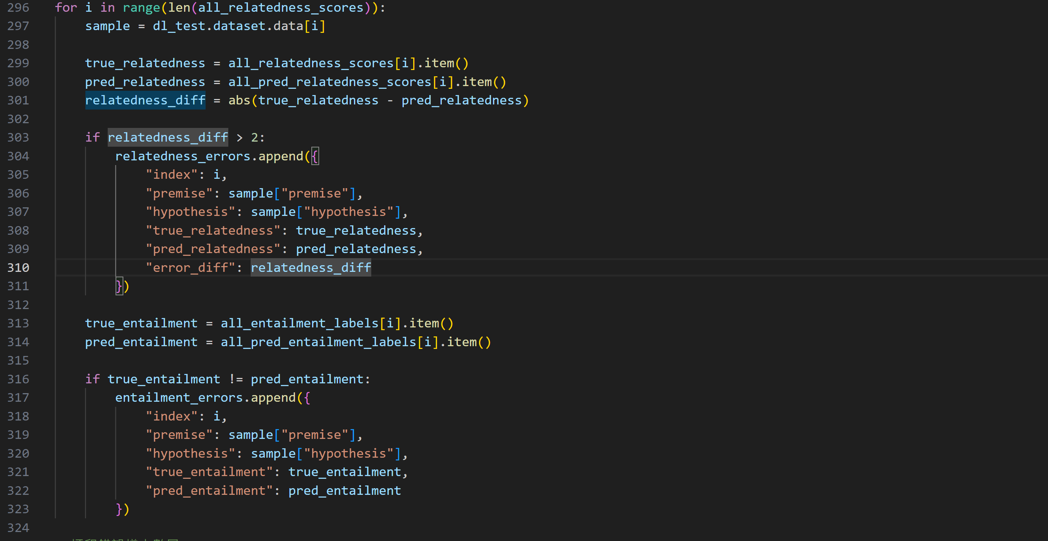

我把 relatedness task 中 relatedness predict 和 ground truth 相差超過 2 的 data 以及 entailment task 中預測錯誤的 data 找出來進行分析。

Relatedness Error :

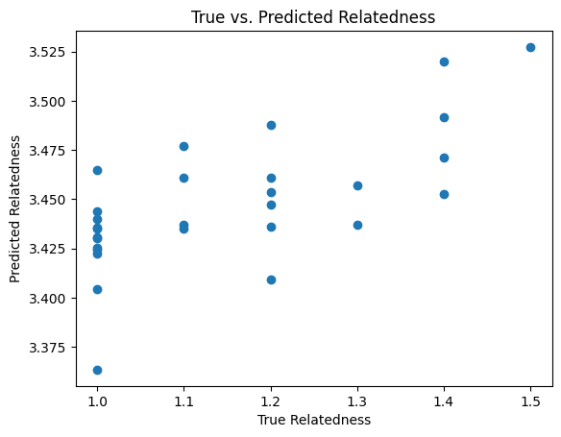

我們可以從上圖來觀察 relatedness error。圖片中的每個點都是 relatedness prediction 和 ground truth 相差超過 2 的點 (|prediction – ground_truth| > 2)。x 軸是該點實際的 relatedness (ground thruth)，y 軸是模型預測出來的 relatedness 值。

可以看到，造成 Relatedness Error 超過 2 的那些點全部都在 Truth Relatendess 1.1-1.5。這說明了一件事情 : 模型的值預測普遍偏大 : 你可以看到，error 全部發生在 truth relatedness 值小於等於1.5 的 data，這代表模型預測錯誤只發生在 truth relatedness 小、predict relatedness大的情況。這也就說明了我訓練出來的模型傾向把 relatedness 小的值 predict 的比較大。

因此我去觀察了模型的輸出結果，如下圖，發現了一個很神奇的事情 :

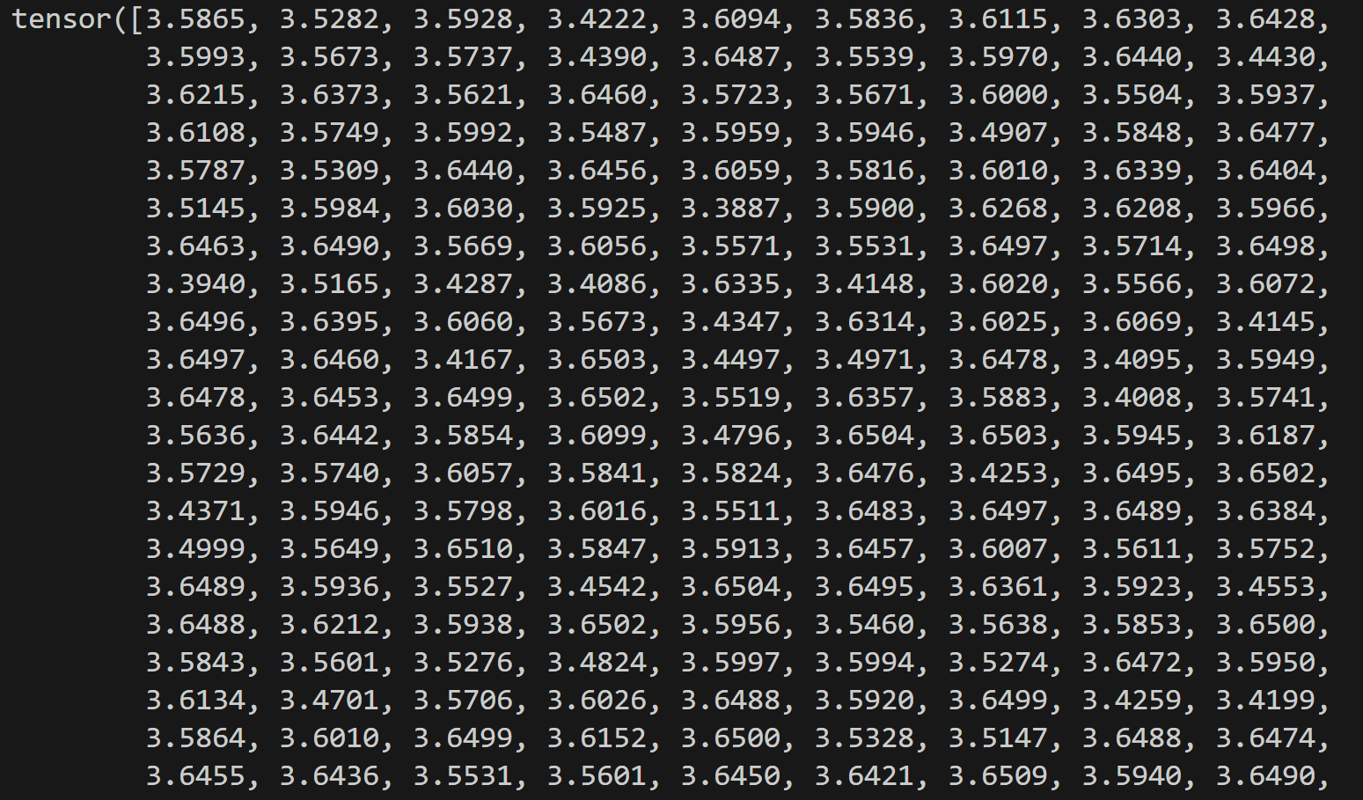

Relatedness Predictions 的值幾乎都在 3.5 附近，不過和 ground truth 的值有正相關 :

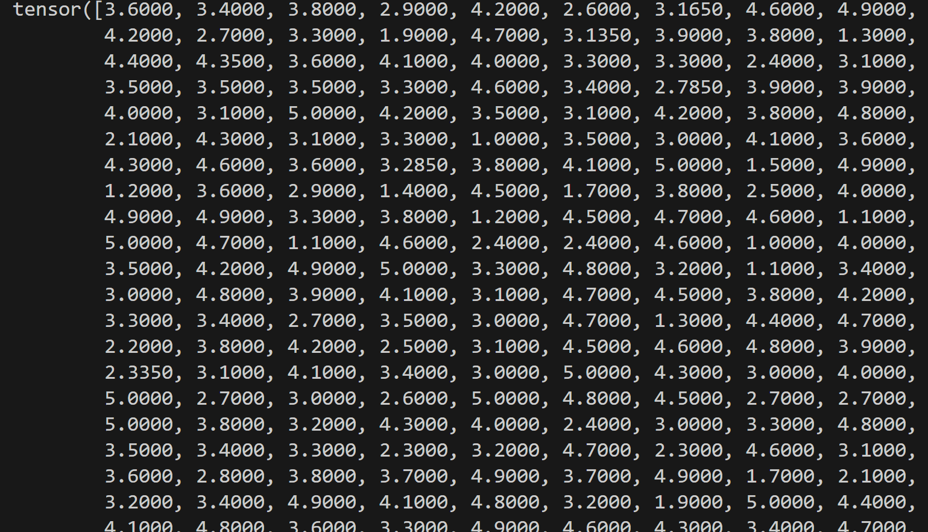

上圖是 ground truth 的值，可以看到，predictions 和 ground truth 之間是有正相關的，所以模型訓練確實可以讓 correlation coefficient的值變大。但在我的測試中，不管再怎麼訓練，都沒有辦法擺脫 predictions 的值都在接近 3.5 的位置。我想這應該是因為 input 的 premise 和 hypothesis 的內容太像了，縱使它們因為一些字，造成語意上差距非常大，但模型可能無法那麼精確地理解語意上的差別，所以 regression task 輸出的值也就會很相近。這造成了這個 regression 任務非常困難，我想這也是為甚麼 evaluation 只用 correlation coefficient來計算，而不使用 MSE。

下圖是我用 train 好的 model 做 prediction vs ground truth 的圖片，可以看出有明顯的正相關 :

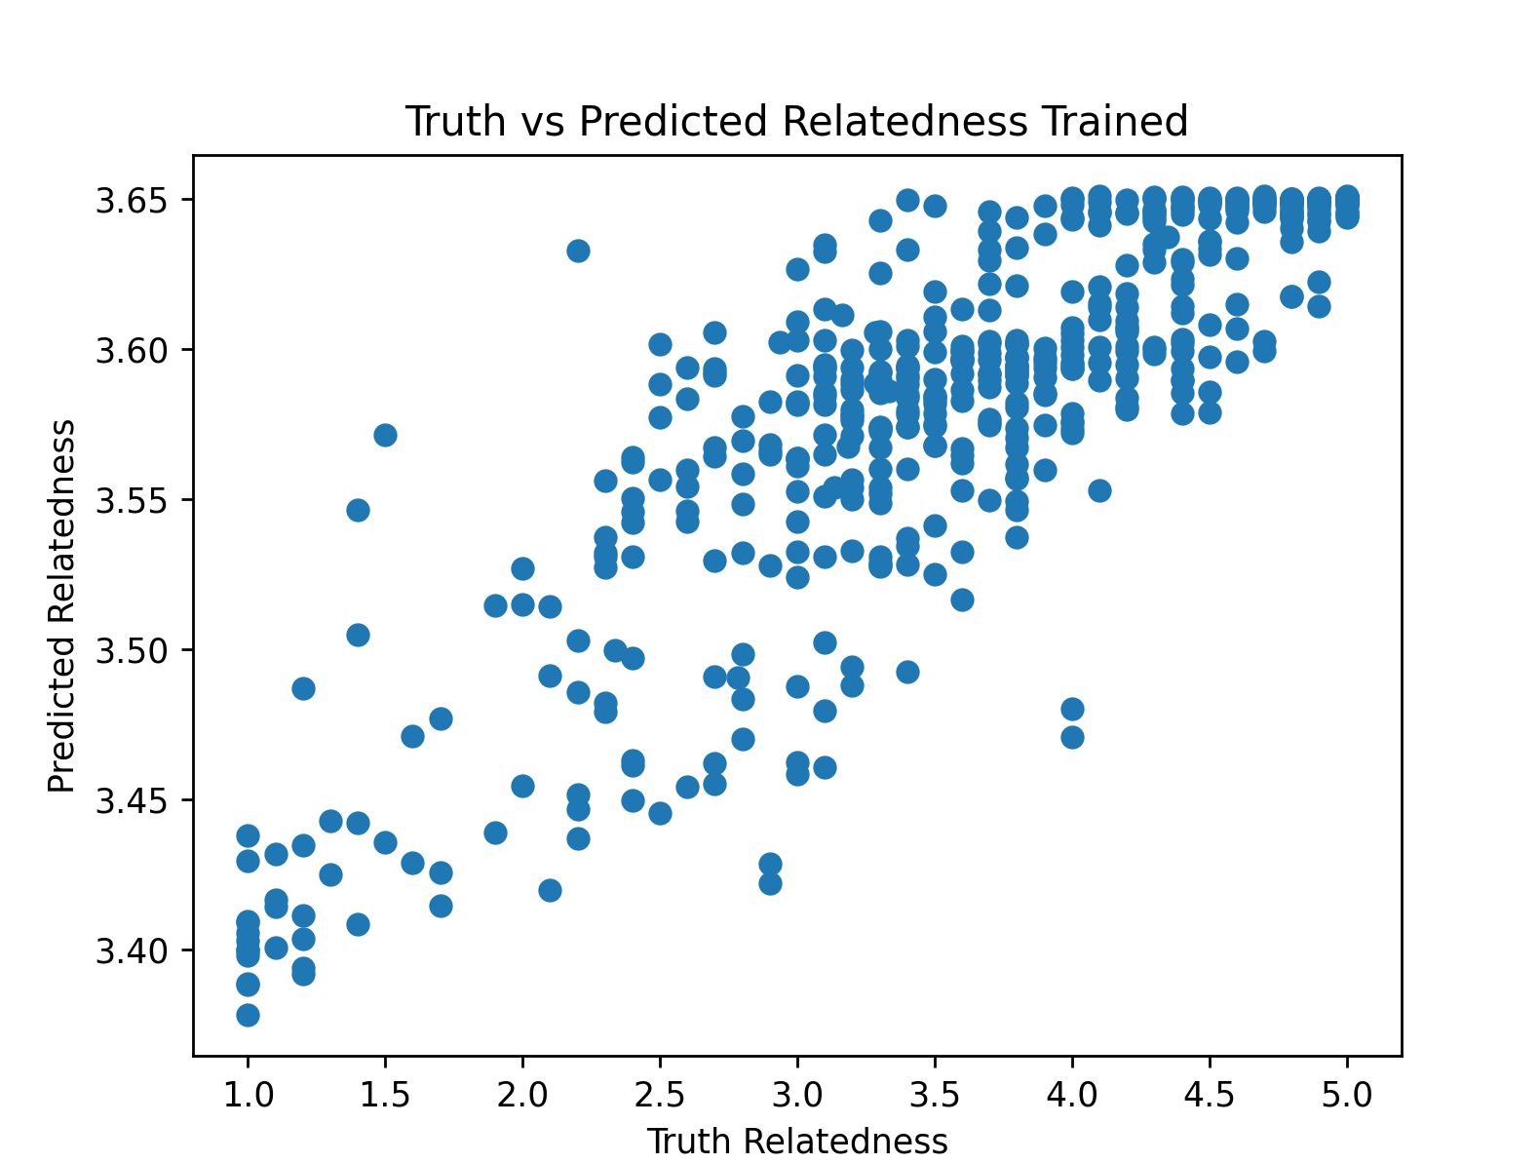

下面這張圖是用還沒被 train 過的 model 作圖，可以看出，幾乎沒有相關性 :

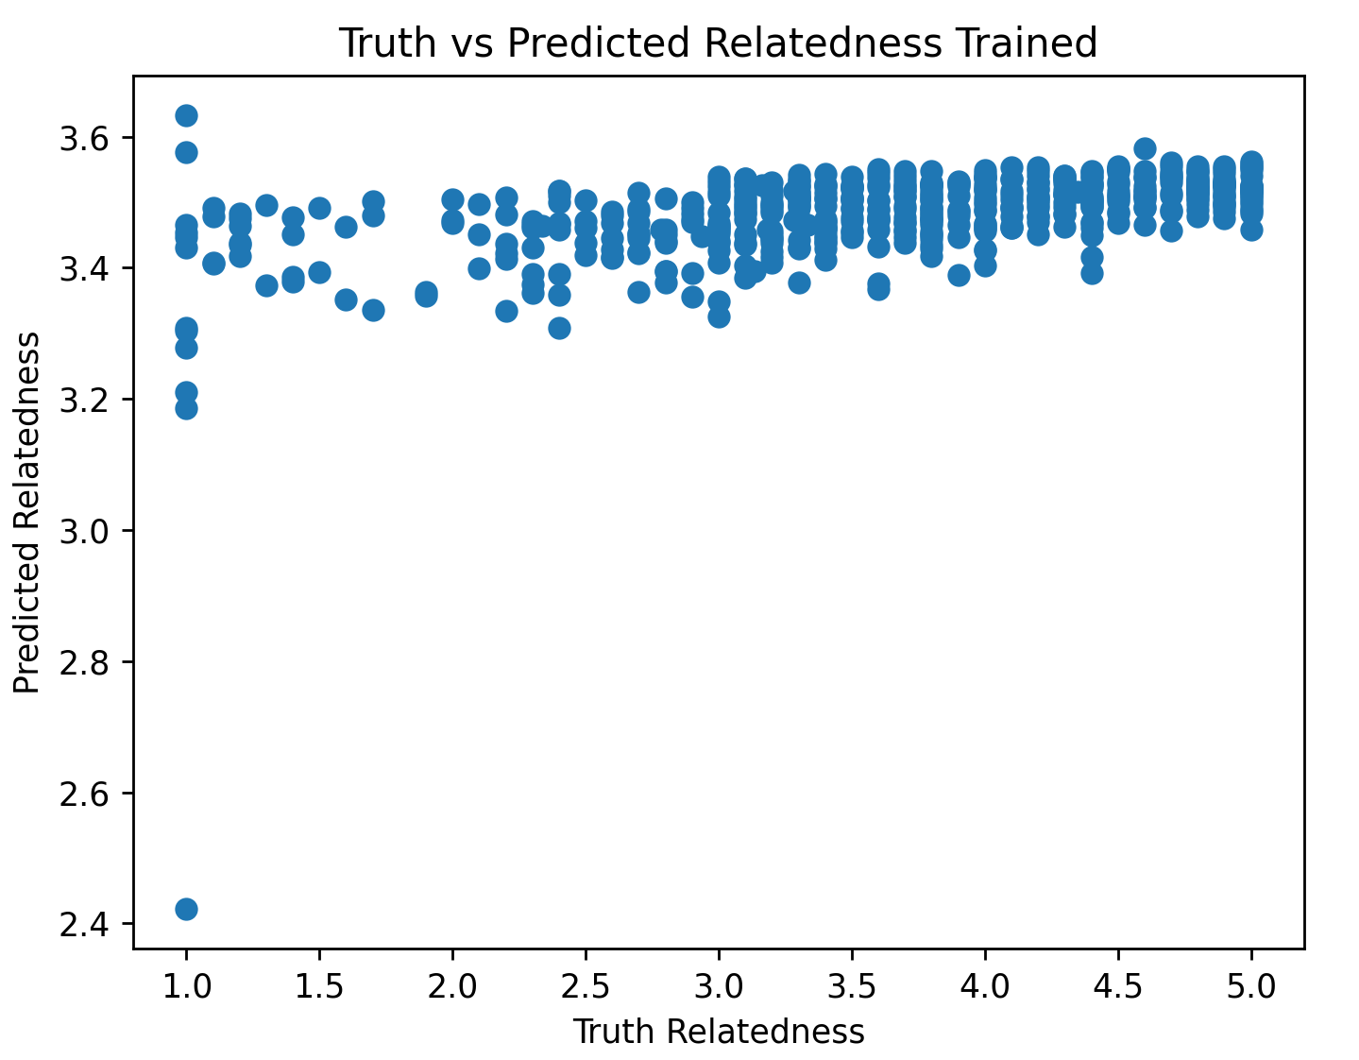

透過 related error 的分析，我們知道會造成 correlation coefficient 的值很難再提高的原因很可能就是因為模型的premise 和 hypothesis 的內容對於模型來說太像，造成 predict 都只集中在 3.5 的附近，也很容易混淆。

Entailment Error :

我們可以從下圖觀察容易發生 entailment error 都是發生在什麼樣的情況 :

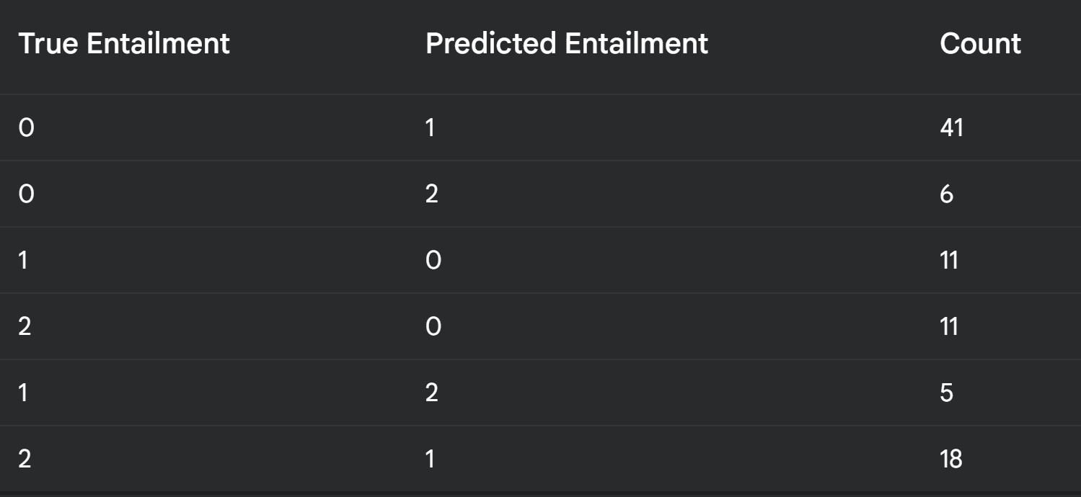

可以看到，最常發生的是把 NEUTRAL(0) 預測為 ENTAILMENT(1)，把 CONTRADICTION(2) 預測為 ENTAILMENT(1) 次之。

我們先來觀察把 NEUTRAL(0) 預測為 ENTAILMENT(1) 的模型錯誤樣本 :

Index: 4

Premise: Five children are standing in front of a wooden hut

Hypothesis: Five children are standing in a wooden hut

True Entailment: 0

Predicted Entailment: 1

我推測模型可能將「in front of」和「in」視為等價，未充分理解它們的區別。

Index: 18

Premise: A brown and white dog is running through the tall grass

Hypothesis: A brown and white dog is moving through the wild grass

True Entailment: 0

Predicted Entailment: 1

我推測模型可能未能識別「running」和「moving」之間的語義細節差異，當作它們是相同的。

從這兩個錯誤範例可以看出來，模型對於某些相似意思的詞語未能完全區分出它們之間的差異，造成錯把不相同意思的句子預測為相同的，把 NEUTRAL(0) 預測為 ENTAILMENT(1)。

再看下面

Index: 96

Premise: The man is denying an interview

Hypothesis: The man is granting an interview

True Entailment: 2

Predicted Entailment: 1

在這裡，模型未能識別「denying」和「granting」的矛盾性。

Index: 146

Premise: A woman is playing a flute

Hypothesis: The woman is not playing the flute

True Entailment: 2

Predicted Entailment: 1

這個例子，模型沒有理解「not playing」跟 「playing」之間的差別，也就是模型不理解 「not」副詞加在動詞前面修飾的意義。

綜所上述，我認為模型對於某一些單詞和單詞連接起來的語意理解還不夠好，造成模型預測上的困難。

How do you improve your model performance? (9%) :

我有做一些額外的 ablation study 來說明我的 model architecture 應該是不錯的。

1. Different Shared Layer

我對於 Shared Layer 的必要性作了以下的實驗 :

remove_share : 把 shared layer 直接移除掉，BERT 的 output 直接接到分別兩個 head。

two_share : 我讓一層 shared layer 變成兩層，也就是 BERT output 經過兩層 shared layer 之後才輸入到分別兩個 head。兩個 shared layer 是一模一樣的。

bigger_share : 我讓 share layer 的 dimension 從 768 -> 1024。

smaller_share : 我讓 share layer 的 dimension 從 768 -> 512。

下圖是我比較 base_model, bigger_share, smaller_share 的實驗結果。

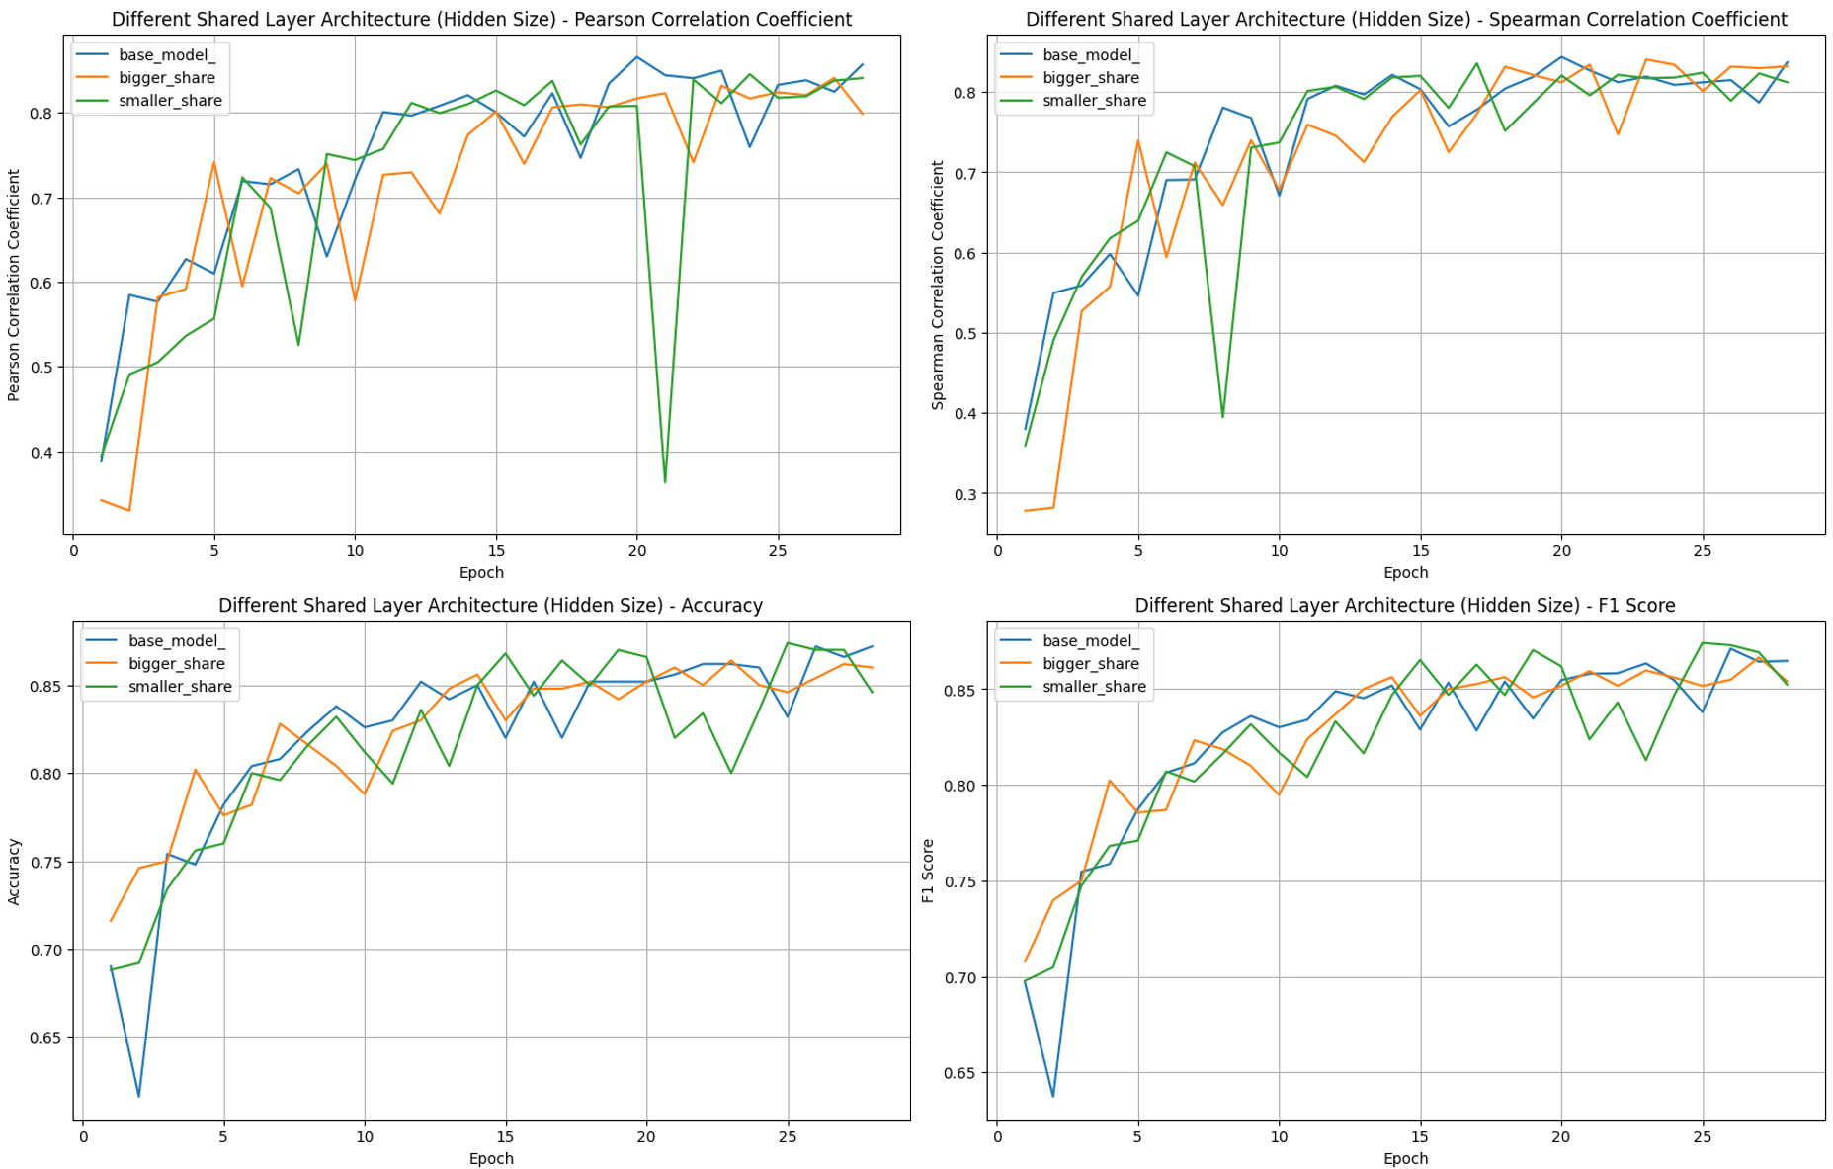

從上圖可以看到，bigger_share 在 Pearson Correlation Coefficient, Spearman Correlation Coefficient 的收斂速度比較慢，這可能是因為 bigger_share 的參數量較大，比較難收斂。

Smaller_share 在四種 score 上面的震盪起伏比較大，這可能是因為 smaller_share 的參數量太少，模型不夠複雜，沒辦法收斂到一個較佳的 local minimum，loss 只能在各種不同的地方到處移動。

由以上的結論，我認為我現在的 model 的 share layer size 是一個較佳的數值。

詳細數值請看 appendix [8], [9]

下圖是我比較 base_model, remove _share, two_share 的實驗結果。

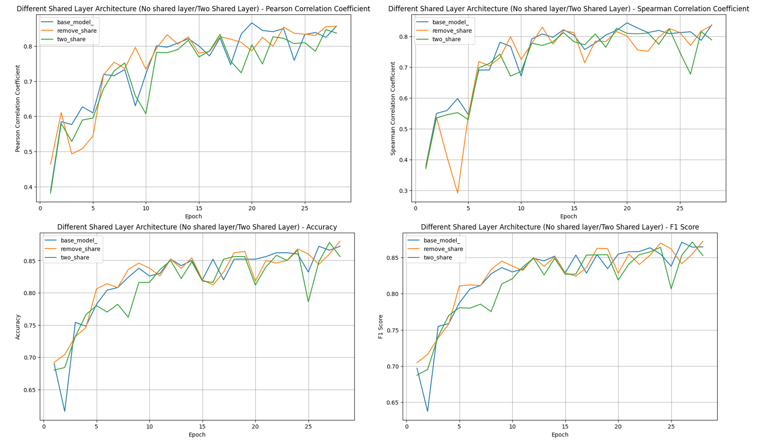

由上圖可以看到，不管是哪一個 model，在四種 score 最後幾個 epoch 都能得到滿好的結果。

Remove_share 的趨勢通常震盪比較大，可能是因為沒有 share layer 先把 BERT 的 features 先做處理，一開始 train 時會容易產生偏差，不過訓練到後面就也能穩定下來。

Two_share 的問題是收斂速度稍微慢一點點，應該是因為多一層 layer 比較難 train，不過同樣地，訓練到後面就也能穩定下來。

我認為不管事幾層 share layer 都能夠得到好的結果，不過我傾向選擇穩定性高且收斂不會太慢的一層 share layer。

詳細數值請看 appendix [10], [11]

1. Different Separate Layer

我對於 Separate Layer 的差異作了以下的實驗 :

Big_separate : 把 Separate layer除了 output 層以外的 hidden size 都乘以 2倍。

Bigger_separte : 把Separate layer除了 output 層以外的 hidden size 都乘以 1.5倍。

small_separate : 把 Separate layer除了 output 層以外的 hidden size 都乘以 1/2倍。

smaller_separate : 把Separate layer除了 output 層以外的 hidden size 都乘以 1/4倍。

deep_separate : 在 Head 的尾端中多加一層 layer Linear(256, 64), relu, layer_norm。

shallow_saperate : 移除掉 Head 的一層 layer，layer Linear(512, 256), relu, layer_norm。

詳細數值請看 appendix [12], [13], [14], [15]

下圖是我比較 base_model, Big_separate, Bigger_separte, small_separate, smaller_separate 的實驗結果。

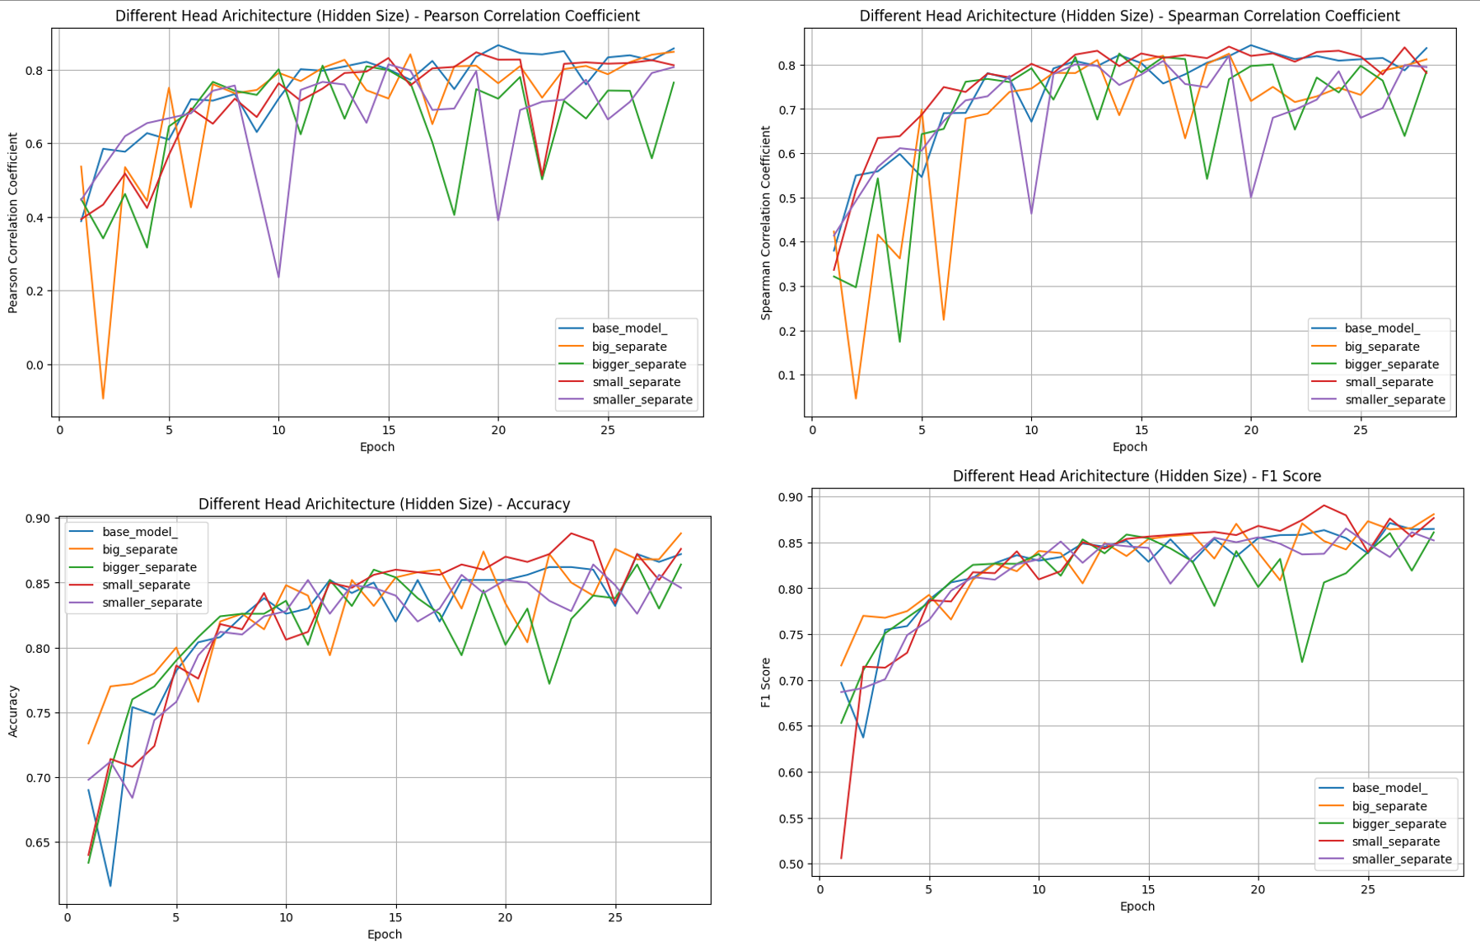

首先，從圖中可知，bigger_separate 的結果是最不好的，smaller_separate 的結果也不是很好。Small_sepeate 和 big_seperate 最後的結果雖然不錯，但前面的震盪幅度相較 base 來說還是比較大。

雖然我沒有辦法得到一個很好的結論，到底模型 hidden size 要多大比較好，但我傾向於目前的模型的這個 hidden size。

下圖是我比較 base_model, shallow_separate, deep_separte 的實驗結果。

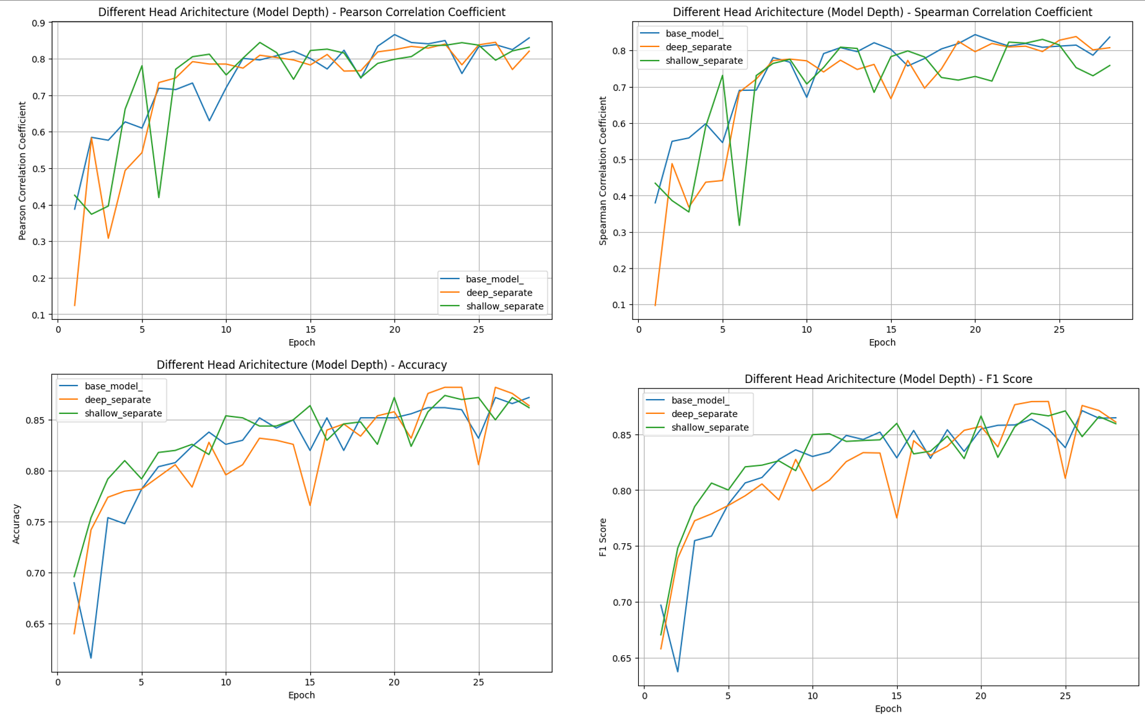

根據上圖， shallow_separate 在 person correlation coefficient 和 spearman correlation coefficient 的震盪幅度較大，可能是因為少了一層 layer 導致深度和參數量都下降，loss update 容易偏離幅度大。Deep_separate 看起來結果在兩個 correlation coefficient 稍差於 base_model。

綜所上述，我覺得 base_model 的 separate layer 深度是較佳的。

詳細數值請看 appendix [16], [17]

1. Trade off between relatedness and entailment loss

我在 base_model 中設定 relatedness loss 的權重是 1.9，entailment loss 的權重是 0.1。



我想要知道不同的 relatedness loss, entailment loss 權重對模型訓練的影響。我做了以下實驗 :

loss_16_04 : relatedness loss 權重為 1.6，entailment loss 權重為 0.4

loss_18_02 : relatedness loss 權重為 1.8，entailment loss 權重為 0.2

loss_195_005 : relatedness loss 權重為 1.95，entailment loss 權重為 0.05

loss_199_001 : relatedness loss 權重為 1.99，entailment loss 權重為 0.001

下圖是我比較 base_model, loss_16_04, loss_18_02, loss_195_005, loss_199_001 的實驗結果。

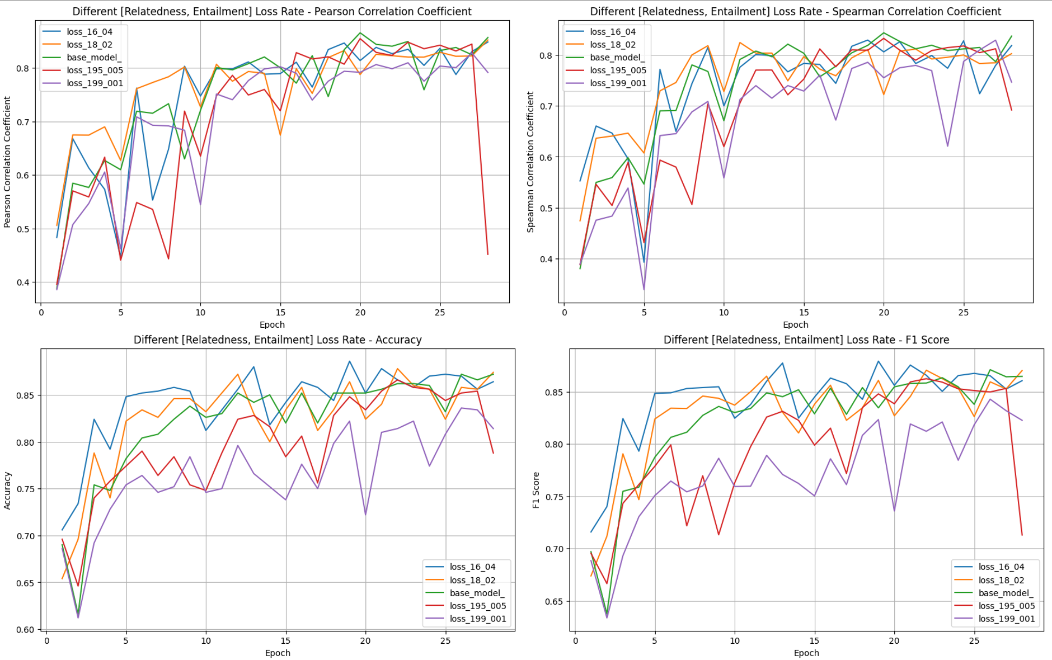

從這張圖中，我們可以看出，當 entailment 的權重太小時，模型會根本訓練不起來。而 entailment 的權重太大時，Spearman Correlation Coefficient 的分數很難變得更高、難以超過 baseline 0.8。因此，我認為 relatedness loss 的權重 1.9，entailment loss 的權重 0.1 是一個還不錯的數字。

詳細數值請看 appendix [19], [20], [21], [22]

1. Learning Rate

我做了以下實驗來測試哪一組 learning rate 效果較好 (base_model 的 learning rate 是 8e-6) :

lr_8e-4 : learning rate = 8e-4。

lr_8e-5 : learning rate = 8e-5。

lr_8e-7 : learning rate = 8e-7。

下圖是我比較 base_model, lr_8e-4, lr_8e-5, l lr_8e-7 的實驗結果。

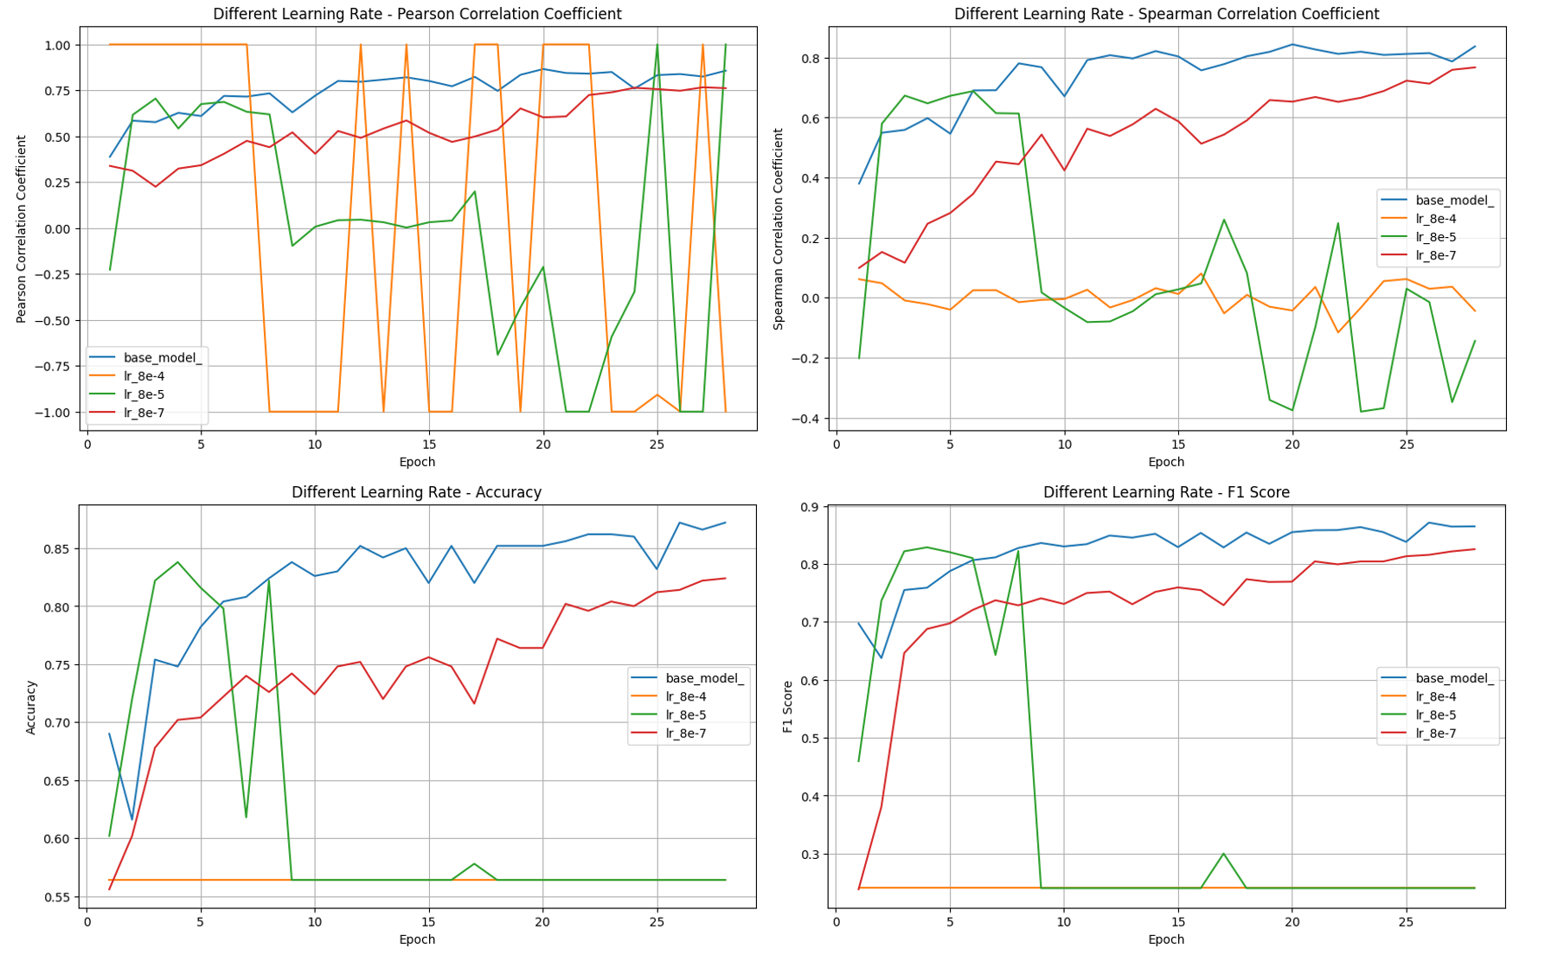

你可以看到 learning rate = 8e-4, 8e-5 對於模型來說是完全無法訓練的，而 8e-7 雖然可以訓練了，但收斂速度有點慢，因此，我選擇 learning rate =   
8e-6 來訓練我的模型。

詳細數值請看 appendix [23], [24], [25]

1. Layer Norm vs Batch Norm

Transformer 是一個用 layer norm 來增強訓練的模型，BERT 因此也使用了 layer norm。不過，我想知道對於串接 BERT 到 downstream task 的 head，使用 layer norm 還是 batch norm 會比較合適。因此我做了以下實驗 :

batch_norm : 把 base_model 中所有的 layer_norm 都換成 batch_norm。

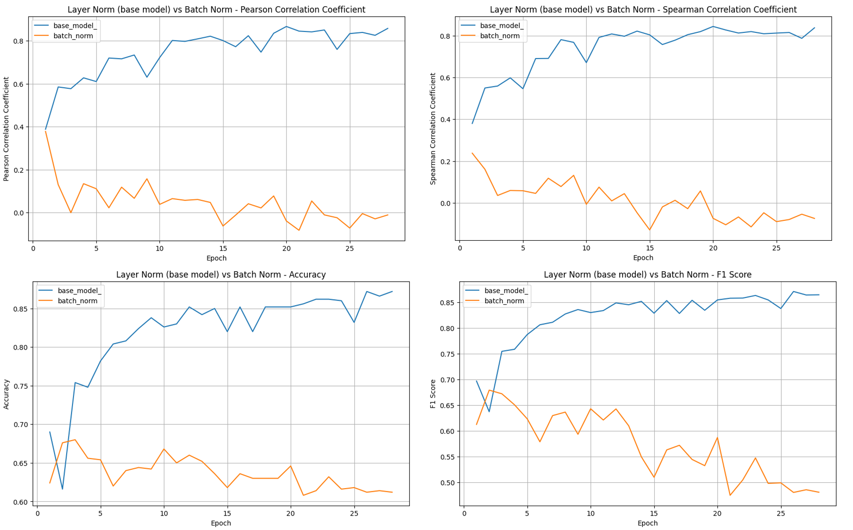

由上圖可知，把 layer norm 換成 batch norm 在這個任務上的效果變得非常的差，我推測主要原因是因為我的 batch size 只設為 16，batch size 太小，導致每一個 batch 的 mean, variance 沒辦法近似於整個 dataset，因此使用 batch norm 的效果很差。由上述我們知道，在這個作業使用 layer norm 會比較合適。

參考文獻 : <https://blog.csdn.net/qq_36560894/article/details/115017087>

詳細數值請看 appendix [26]

透過這些ablation study，我使用了綜合起來較佳的策略、模型架構、hyperparamters 來訓練我的模型，得到不錯的 accuracy, spearman correlation coefficient，通過了 bonus threshold。

... Anything that can strengthen your report. (10%) :

Emm…… 我覺得我前面寫的東西已經夠完整了，所以想不太到有什麼可以 strength my report。

所以這部分我就以 Appendix 的實驗數據紀錄作為代表，把所有實驗數據寫下來，藉此證明我花了很多時間 (和GPU算力) 來完成這個作業，我相信這應該足以strengthen my report。

我順便放上我每一個不同於 base_model 模型架構 .py 檔案的模型架構，讓前面 report 沒有解釋清楚的部分能夠有解答。

BERTbase_model

class MultiLabelModel(torch.nn.Module):

    def __init__(self, *args, **kwargs):

        super().__init__(*args, **kwargs)

        # Write your code here

        # Define what modules you will use in the model

        self.bert = T.BertModel.from_pretrained("google-bert/bert-base-uncased", cache_dir="./cache/")

        self.share_1 = torch.nn.Linear(768, 768)

        self.separate_fc = torch.nn.Linear(768, 1024)

        self.separate_fc_2 = torch.nn.Linear(768, 1024)

        self.separate_pass = torch.nn.Linear(1024, 1024)

        self.separate_fc_5 = torch.nn.Linear(1024, 512)

        self.separate_fc_6 = torch.nn.Linear(1024, 512)

        self.separate_pass_2 = torch.nn.Linear(512, 512)

        self.separate_fc_3 = torch.nn.Linear(512, 256)

        self.separate_fc_4 = torch.nn.Linear(512, 256)

        self.relatedness_fc = torch.nn.Linear(256, 1)

        self.entailment_fc = torch.nn.Linear(256, 3)

        self.batch_norm = torch.nn.BatchNorm1d(768)

        self.batch_norm_1 = torch.nn.BatchNorm1d(512)

        self.relu = torch.nn.ReLU()

        self.layer_norm = torch.nn.LayerNorm(768)

        self.layer_norm_1 = torch.nn.LayerNorm(1024)

        self.layer_norm_2 = torch.nn.LayerNorm(512)

        self.layer_norm_3 = torch.nn.LayerNorm(256)

    def forward(self, **kwargs):

        # Write your code here

        # Forward pass

        x = self.bert(**kwargs).pooler_output

        x = self.share_1(x)

        x = self.relu(x)

        x = self.layer_norm(x)

        x1 = self.separate_fc(x)

        x1 = self.relu(x1)

        x1 = self.layer_norm_1(x1)

        x2 = self.separate_fc_2(x)

        x2 = self.relu(x2)

        x2 = self.layer_norm_1(x2)

        x1 = self.separate_pass(x1)

        x1 = self.relu(x1)

        x1 = self.layer_norm_1(x1)

        x2 = self.separate_pass(x2)

        x2 = self.relu(x2)

        x2 = self.layer_norm_1(x2)

        x1 = self.separate_fc_5(x1)

        x1 = self.relu(x1)

        x1 = self.layer_norm_2(x1)

        x2 = self.separate_fc_6(x2)

        x2 = self.relu(x2)

        x2 = self.layer_norm_2(x2)

        x1 = self.separate_pass_2(x1)

        x1 = self.relu(x1)

        x1 = self.layer_norm_2(x1)

        x2 = self.separate_pass_2(x2)

        x2 = self.relu(x2)

        x2 = self.layer_norm_2(x2)

        x1 = self.separate_fc_3(x1)

        x1 = self.relu(x1)

        x1 = self.layer_norm_3(x1)

        x2 = self.separate_fc_4(x2)

        x2 = self.relu(x2)

        x2 = self.layer_norm_3(x2)

        x1 = self.relatedness_fc(x1)

        x2 = self.entailment_fc(x2)

        x2 = torch.nn.functional.softmax(x2, dim=-1)

        return x1, x2

MultiLin_model

class MultiLabelModel(torch.nn.Module):

    def __init__(self, *args, **kwargs):

        super().__init__(*args, **kwargs)

        # Write your code here

        # Define what modules you will use in the model

        self.bert = T.BertModel.from_pretrained(model_name, cache_dir="./cache/")

        self.share_1 = torch.nn.Linear(768, 768)

        self.separate_fc = torch.nn.Linear(768, 1024)

        self.separate_fc_2 = torch.nn.Linear(768, 1024)

        self.separate_pass = torch.nn.Linear(1024, 1024)

        self.separate_fc_5 = torch.nn.Linear(1024, 512)

        self.separate_fc_6 = torch.nn.Linear(1024, 512)

        self.separate_pass_2 = torch.nn.Linear(512, 512)

        self.separate_fc_3 = torch.nn.Linear(512, 256)

        self.separate_fc_4 = torch.nn.Linear(512, 256)

        self.relatedness_fc = torch.nn.Linear(256, 1)

        self.entailment_fc = torch.nn.Linear(256, 3)

        self.batch_norm = torch.nn.BatchNorm1d(768)

        self.batch_norm_1 = torch.nn.BatchNorm1d(512)

        self.relu = torch.nn.ReLU()

        self.layer_norm = torch.nn.LayerNorm(768)

        self.layer_norm_1 = torch.nn.LayerNorm(1024)

        self.layer_norm_2 = torch.nn.LayerNorm(512)

        self.layer_norm_3 = torch.nn.LayerNorm(256)

    def forward(self, **kwargs):

        # Write your code here

        # Forward pass

        x = self.bert(**kwargs).pooler_output

        x = self.share_1(x)

        x = self.relu(x)

        x = self.layer_norm(x)

        x1 = self.separate_fc(x)

        x1 = self.relu(x1)

        x1 = self.layer_norm_1(x1)

        x2 = self.separate_fc_2(x)

        x2 = self.relu(x2)

        x2 = self.layer_norm_1(x2)

        x1 = self.separate_pass(x1)

        x1 = self.relu(x1)

        x1 = self.layer_norm_1(x1)

        x2 = self.separate_pass(x2)

        x2 = self.relu(x2)

        x2 = self.layer_norm_1(x2)

        x1 = self.separate_fc_5(x1)

        x1 = self.relu(x1)

        x1 = self.layer_norm_2(x1)

        x2 = self.separate_fc_6(x2)

        x2 = self.relu(x2)

        x2 = self.layer_norm_2(x2)

        x1 = self.separate_pass_2(x1)

        x1 = self.relu(x1)

        x1 = self.layer_norm_2(x1)

        x2 = self.separate_pass_2(x2)

        x2 = self.relu(x2)

        x2 = self.layer_norm_2(x2)

        x1 = self.separate_fc_3(x1)

        x1 = self.relu(x1)

        x1 = self.layer_norm_3(x1)

        x2 = self.separate_fc_4(x2)

        x2 = self.relu(x2)

        x2 = self.layer_norm_3(x2)

        x1 = self.relatedness_fc(x1)

        x2 = self.entailment_fc(x2)

        x2 = torch.nn.functional.softmax(x2, dim=-1)

        return x1, x2

Sentiment_model

class MultiLabelModel(torch.nn.Module):

    def __init__(self, *args, **kwargs):

        super().__init__(*args, **kwargs)

        # Write your code here

        # Define what modules you will use in the model

        self.bert = T.BertModel.from_pretrained(model_name, cache_dir="./cache/")

        self.share_1 = torch.nn.Linear(768, 768)

        self.separate_fc = torch.nn.Linear(768, 1024)

        self.separate_fc_2 = torch.nn.Linear(768, 1024)

        self.separate_pass = torch.nn.Linear(1024, 1024)

        self.separate_fc_5 = torch.nn.Linear(1024, 512)

        self.separate_fc_6 = torch.nn.Linear(1024, 512)

        self.separate_pass_2 = torch.nn.Linear(512, 512)

        self.separate_fc_3 = torch.nn.Linear(512, 256)

        self.separate_fc_4 = torch.nn.Linear(512, 256)

        self.relatedness_fc = torch.nn.Linear(256, 1)

        self.entailment_fc = torch.nn.Linear(256, 3)

        self.batch_norm = torch.nn.BatchNorm1d(768)

        self.batch_norm_1 = torch.nn.BatchNorm1d(512)

        self.relu = torch.nn.ReLU()

        self.layer_norm = torch.nn.LayerNorm(768)

        self.layer_norm_1 = torch.nn.LayerNorm(1024)

        self.layer_norm_2 = torch.nn.LayerNorm(512)

        self.layer_norm_3 = torch.nn.LayerNorm(256)

    def forward(self, **kwargs):

        # Write your code here

        # Forward pass

        x = self.bert(**kwargs).pooler_output

        x = self.share_1(x)

        x = self.relu(x)

        x = self.layer_norm(x)

        x1 = self.separate_fc(x)

        x1 = self.relu(x1)

        x1 = self.layer_norm_1(x1)

        x2 = self.separate_fc_2(x)

        x2 = self.relu(x2)

        x2 = self.layer_norm_1(x2)

        x1 = self.separate_pass(x1)

        x1 = self.relu(x1)

        x1 = self.layer_norm_1(x1)

        x2 = self.separate_pass(x2)

        x2 = self.relu(x2)

        x2 = self.layer_norm_1(x2)

        x1 = self.separate_fc_5(x1)

        x1 = self.relu(x1)

        x1 = self.layer_norm_2(x1)

        x2 = self.separate_fc_6(x2)

        x2 = self.relu(x2)

        x2 = self.layer_norm_2(x2)

        x1 = self.separate_pass_2(x1)

        x1 = self.relu(x1)

        x1 = self.layer_norm_2(x1)

        x2 = self.separate_pass_2(x2)

        x2 = self.relu(x2)

        x2 = self.layer_norm_2(x2)

        x1 = self.separate_fc_3(x1)

        x1 = self.relu(x1)

        x1 = self.layer_norm_3(x1)

        x2 = self.separate_fc_4(x2)

        x2 = self.relu(x2)

        x2 = self.layer_norm_3(x2)

        x1 = self.relatedness_fc(x1)

        x2 = self.entailment_fc(x2)

        x2 = torch.nn.functional.softmax(x2, dim=-1)

        return x1, x2

big_separate

class MultiLabelModel(torch.nn.Module):

    def __init__(self, *args, **kwargs):

        super().__init__(*args, **kwargs)

        # Write your code here

        # Define what modules you will use in the model

        self.bert = T.BertModel.from_pretrained("sentence-transformers/bert-base-nli-mean-tokens", cache_dir="./cache/")

        self.share_1 = torch.nn.Linear(768, 768)

        self.separate_fc = torch.nn.Linear(768, 2048)

        self.separate_fc_2 = torch.nn.Linear(768, 2048)

        self.separate_pass = torch.nn.Linear(2048, 2048)

        self.separate_fc_5 = torch.nn.Linear(2048, 1024)

        self.separate_fc_6 = torch.nn.Linear(2048, 1024)

        self.separate_pass_2 = torch.nn.Linear(1024, 1024)

        self.separate_fc_3 = torch.nn.Linear(1024, 512)

        self.separate_fc_4 = torch.nn.Linear(1024, 512)

        self.relatedness_fc = torch.nn.Linear(512, 1)

        self.entailment_fc = torch.nn.Linear(512, 3)

        self.batch_norm = torch.nn.BatchNorm1d(768)

        self.batch_norm_1 = torch.nn.BatchNorm1d(512)

        self.relu = torch.nn.ReLU()

        self.layer_norm = torch.nn.LayerNorm(768)

        self.layer_norm_1 = torch.nn.LayerNorm(2048)

        self.layer_norm_2 = torch.nn.LayerNorm(1024)

        self.layer_norm_3 = torch.nn.LayerNorm(512)

    def forward(self, **kwargs):

        # Write your code here

        # Forward pass

        x = self.bert(**kwargs).pooler_output

        x = self.share_1(x)

        x = self.relu(x)

        x = self.layer_norm(x)

        x1 = self.separate_fc(x)

        x1 = self.relu(x1)

        x1 = self.layer_norm_1(x1)

        x2 = self.separate_fc_2(x)

        x2 = self.relu(x2)

        x2 = self.layer_norm_1(x2)

        x1 = self.separate_pass(x1)

        x1 = self.relu(x1)

        x1 = self.layer_norm_1(x1)

        x2 = self.separate_pass(x2)

        x2 = self.relu(x2)

        x2 = self.layer_norm_1(x2)

        x1 = self.separate_fc_5(x1)

        x1 = self.relu(x1)

        x1 = self.layer_norm_2(x1)

        x2 = self.separate_fc_6(x2)

        x2 = self.relu(x2)

        x2 = self.layer_norm_2(x2)

        x1 = self.separate_pass_2(x1)

        x1 = self.relu(x1)

        x1 = self.layer_norm_2(x1)

        x2 = self.separate_pass_2(x2)

        x2 = self.relu(x2)

        x2 = self.layer_norm_2(x2)

        x1 = self.separate_fc_3(x1)

        x1 = self.relu(x1)

        x1 = self.layer_norm_3(x1)

        x2 = self.separate_fc_4(x2)

        x2 = self.relu(x2)

        x2 = self.layer_norm_3(x2)

        x1 = self.relatedness_fc(x1)

        x2 = self.entailment_fc(x2)

        x2 = torch.nn.functional.softmax(x2, dim=-1)

        return x1, x2

bigger_separate

class MultiLabelModel(torch.nn.Module):

    def __init__(self, *args, **kwargs):

        super().__init__(*args, **kwargs)

        # Write your code here

        # Define what modules you will use in the model

        self.bert = T.BertModel.from_pretrained("sentence-transformers/bert-base-nli-mean-tokens", cache_dir="./cache/")

        self.share_1 = torch.nn.Linear(768, 768)

        self.separate_fc = torch.nn.Linear(768, 1536)

        self.separate_fc_2 = torch.nn.Linear(768, 1536)

        self.separate_pass = torch.nn.Linear(1536, 1536)

        self.separate_fc_5 = torch.nn.Linear(1536, 768)

        self.separate_fc_6 = torch.nn.Linear(1536, 768)

        self.separate_pass_2 = torch.nn.Linear(768, 768)

        self.separate_fc_3 = torch.nn.Linear(768, 384)

        self.separate_fc_4 = torch.nn.Linear(768, 384)

        self.relatedness_fc = torch.nn.Linear(384, 1)

        self.entailment_fc = torch.nn.Linear(384, 3)

        self.batch_norm = torch.nn.BatchNorm1d(768)

        self.batch_norm_1 = torch.nn.BatchNorm1d(512)

        self.relu = torch.nn.ReLU()

        self.layer_norm = torch.nn.LayerNorm(768)

        self.layer_norm_1 = torch.nn.LayerNorm(1536)

        self.layer_norm_2 = torch.nn.LayerNorm(768)

        self.layer_norm_3 = torch.nn.LayerNorm(384)

    def forward(self, **kwargs):

        # Write your code here

        # Forward pass

        x = self.bert(**kwargs).pooler_output

        x = self.share_1(x)

        x = self.relu(x)

        x = self.layer_norm(x)

        x1 = self.separate_fc(x)

        x1 = self.relu(x1)

        x1 = self.layer_norm_1(x1)

        x2 = self.separate_fc_2(x)

        x2 = self.relu(x2)

        x2 = self.layer_norm_1(x2)

        x1 = self.separate_pass(x1)

        x1 = self.relu(x1)

        x1 = self.layer_norm_1(x1)

        x2 = self.separate_pass(x2)

        x2 = self.relu(x2)

        x2 = self.layer_norm_1(x2)

        x1 = self.separate_fc_5(x1)

        x1 = self.relu(x1)

        x1 = self.layer_norm_2(x1)

        x2 = self.separate_fc_6(x2)

        x2 = self.relu(x2)

        x2 = self.layer_norm_2(x2)

        x1 = self.separate_pass_2(x1)

        x1 = self.relu(x1)

        x1 = self.layer_norm_2(x1)

        x2 = self.separate_pass_2(x2)

        x2 = self.relu(x2)

        x2 = self.layer_norm_2(x2)

        x1 = self.separate_fc_3(x1)

        x1 = self.relu(x1)

        x1 = self.layer_norm_3(x1)

        x2 = self.separate_fc_4(x2)

        x2 = self.relu(x2)

        x2 = self.layer_norm_3(x2)

        x1 = self.relatedness_fc(x1)

        x2 = self.entailment_fc(x2)

        x2 = torch.nn.functional.softmax(x2, dim=-1)

        return x1, x2

deep_separate

class MultiLabelModel(torch.nn.Module):

    def __init__(self, *args, **kwargs):

        super().__init__(*args, **kwargs)

        # Write your code here

        # Define what modules you will use in the model

        self.bert = T.BertModel.from_pretrained("sentence-transformers/bert-base-nli-mean-tokens", cache_dir="./cache/")

        self.share_1 = torch.nn.Linear(768, 768)

        self.separate_fc = torch.nn.Linear(768, 1024)

        self.separate_fc_2 = torch.nn.Linear(768, 1024)

        self.separate_pass = torch.nn.Linear(1024, 1024)

        self.separate_fc_5 = torch.nn.Linear(1024, 512)

        self.separate_fc_6 = torch.nn.Linear(1024, 512)

        self.separate_pass_2 = torch.nn.Linear(512, 512)

        self.separate_fc_3 = torch.nn.Linear(512, 256)

        self.separate_fc_4 = torch.nn.Linear(512, 256)

        self.separate_pass_3 = torch.nn.Linear(256, 256)

        self.separate_fc_7 = torch.nn.Linear(256, 128)

        self.separate_fc_8 = torch.nn.Linear(256, 128)

        self.relatedness_fc = torch.nn.Linear(128, 1)

        self.entailment_fc = torch.nn.Linear(128, 3)

        self.batch_norm = torch.nn.BatchNorm1d(768)

        self.batch_norm_1 = torch.nn.BatchNorm1d(512)

        self.relu = torch.nn.ReLU()

        self.layer_norm = torch.nn.LayerNorm(768)

        self.layer_norm_1 = torch.nn.LayerNorm(1024)

        self.layer_norm_2 = torch.nn.LayerNorm(512)

        self.layer_norm_3 = torch.nn.LayerNorm(256)

        self.layer_norm_4 = torch.nn.LayerNorm(128)

    def forward(self, **kwargs):

        # Write your code here

        # Forward pass

        x = self.bert(**kwargs).pooler_output

        x = self.share_1(x)

        x = self.relu(x)

        x = self.layer_norm(x)

        x1 = self.separate_fc(x)

        x1 = self.relu(x1)

        x1 = self.layer_norm_1(x1)

        x2 = self.separate_fc_2(x)

        x2 = self.relu(x2)

        x2 = self.layer_norm_1(x2)

        x1 = self.separate_pass(x1)

        x1 = self.relu(x1)

        x1 = self.layer_norm_1(x1)

        x2 = self.separate_pass(x2)

        x2 = self.relu(x2)

        x2 = self.layer_norm_1(x2)

        x1 = self.separate_fc_5(x1)

        x1 = self.relu(x1)

        x1 = self.layer_norm_2(x1)

        x2 = self.separate_fc_6(x2)

        x2 = self.relu(x2)

        x2 = self.layer_norm_2(x2)

        x1 = self.separate_pass_2(x1)

        x1 = self.relu(x1)

        x1 = self.layer_norm_2(x1)

        x2 = self.separate_pass_2(x2)

        x2 = self.relu(x2)

        x2 = self.layer_norm_2(x2)

        x1 = self.separate_fc_3(x1)

        x1 = self.relu(x1)

        x1 = self.layer_norm_3(x1)

        x2 = self.separate_fc_4(x2)

        x2 = self.relu(x2)

        x2 = self.layer_norm_3(x2)

        x1 = self.separate_pass_3(x1)

        x1 = self.relu(x1)

        x1 = self.layer_norm_3(x1)

        x2 = self.separate_pass_3(x2)

        x2 = self.relu(x2)

        x2 = self.layer_norm_3(x2)

        x1 = self.separate_fc_7(x1)

        x1 = self.relu(x1)

        x1 = self.layer_norm_4(x1)

        x2 = self.separate_fc_8(x2)

        x2 = self.relu(x2)

        x2 = self.layer_norm_4(x2)

        x1 = self.relatedness_fc(x1)

        x2 = self.entailment_fc(x2)

        x2 = torch.nn.functional.softmax(x2, dim=-1)

        return x1, x2

shallow_separate

class MultiLabelModel(torch.nn.Module):

    def __init__(self, *args, **kwargs):

        super().__init__(*args, **kwargs)

        # Write your code here

        # Define what modules you will use in the model

        self.bert = T.BertModel.from_pretrained("sentence-transformers/bert-base-nli-mean-tokens", cache_dir="./cache/")

        self.share_1 = torch.nn.Linear(768, 768)

        self.separate_fc = torch.nn.Linear(768, 1024)

        self.separate_fc_2 = torch.nn.Linear(768, 1024)

        self.separate_pass = torch.nn.Linear(1024, 1024)

        self.separate_fc_3 = torch.nn.Linear(1024, 256)

        self.separate_fc_4 = torch.nn.Linear(1024, 256)

        self.relatedness_fc = torch.nn.Linear(256, 1)

        self.entailment_fc = torch.nn.Linear(256, 3)

        self.batch_norm = torch.nn.BatchNorm1d(768)

        self.batch_norm_1 = torch.nn.BatchNorm1d(512)

        self.relu = torch.nn.ReLU()

        self.layer_norm = torch.nn.LayerNorm(768)

        self.layer_norm_1 = torch.nn.LayerNorm(1024)

        self.layer_norm_2 = torch.nn.LayerNorm(512)

        self.layer_norm_3 = torch.nn.LayerNorm(256)

    def forward(self, **kwargs):

        # Write your code here

        # Forward pass

        x = self.bert(**kwargs).pooler_output

        x = self.share_1(x)

        x = self.relu(x)

        x = self.layer_norm(x)

        x1 = self.separate_fc(x)

        x1 = self.relu(x1)

        x1 = self.layer_norm_1(x1)

        x2 = self.separate_fc_2(x)

        x2 = self.relu(x2)

        x2 = self.layer_norm_1(x2)

        x1 = self.separate_pass(x1)

        x1 = self.relu(x1)

        x1 = self.layer_norm_1(x1)

        x2 = self.separate_pass(x2)

        x2 = self.relu(x2)

        x2 = self.layer_norm_1(x2)

        x1 = self.separate_fc_3(x1)

        x1 = self.relu(x1)

        x1 = self.layer_norm_3(x1)

        x2 = self.separate_fc_4(x2)

        x2 = self.relu(x2)

        x2 = self.layer_norm_3(x2)

        x1 = self.relatedness_fc(x1)

        x2 = self.entailment_fc(x2)

        x2 = torch.nn.functional.softmax(x2, dim=-1)

        return x1, x2

small_separate

class MultiLabelModel(torch.nn.Module):

    def __init__(self, *args, **kwargs):

        super().__init__(*args, **kwargs)

        # Write your code here

        # Define what modules you will use in the model

        self.bert = T.BertModel.from_pretrained("sentence-transformers/bert-base-nli-mean-tokens", cache_dir="./cache/")

        self.share_1 = torch.nn.Linear(768, 768)

        self.separate_fc = torch.nn.Linear(768, 512)

        self.separate_fc_2 = torch.nn.Linear(768, 512)

        self.separate_pass = torch.nn.Linear(512, 512)

        self.separate_fc_5 = torch.nn.Linear(512, 256)

        self.separate_fc_6 = torch.nn.Linear(512, 256)

        self.separate_pass_2 = torch.nn.Linear(256, 256)

        self.separate_fc_3 = torch.nn.Linear(256, 64)

        self.separate_fc_4 = torch.nn.Linear(256, 64)

        self.relatedness_fc = torch.nn.Linear(64, 1)

        self.entailment_fc = torch.nn.Linear(64, 3)

        self.batch_norm = torch.nn.BatchNorm1d(768)

        self.batch_norm_1 = torch.nn.BatchNorm1d(256)

        self.relu = torch.nn.ReLU()

        self.layer_norm = torch.nn.LayerNorm(768)

        self.layer_norm_1 = torch.nn.LayerNorm(512)

        self.layer_norm_2 = torch.nn.LayerNorm(256)

        self.layer_norm_3 = torch.nn.LayerNorm(64)

    def forward(self, **kwargs):

        # Write your code here

        # Forward pass

        x = self.bert(**kwargs).pooler_output

        x = self.share_1(x)

        x = self.relu(x)

        x = self.layer_norm(x)

        x1 = self.separate_fc(x)

        x1 = self.relu(x1)

        x1 = self.layer_norm_1(x1)

        x2 = self.separate_fc_2(x)

        x2 = self.relu(x2)

        x2 = self.layer_norm_1(x2)

        x1 = self.separate_pass(x1)

        x1 = self.relu(x1)

        x1 = self.layer_norm_1(x1)

        x2 = self.separate_pass(x2)

        x2 = self.relu(x2)

        x2 = self.layer_norm_1(x2)

        x1 = self.separate_fc_5(x1)

        x1 = self.relu(x1)

        x1 = self.layer_norm_2(x1)

        x2 = self.separate_fc_6(x2)

        x2 = self.relu(x2)

        x2 = self.layer_norm_2(x2)

        x1 = self.separate_pass_2(x1)

        x1 = self.relu(x1)

        x1 = self.layer_norm_2(x1)

        x2 = self.separate_pass_2(x2)

        x2 = self.relu(x2)

        x2 = self.layer_norm_2(x2)

        x1 = self.separate_fc_3(x1)

        x1 = self.relu(x1)

        x1 = self.layer_norm_3(x1)

        x2 = self.separate_fc_4(x2)

        x2 = self.relu(x2)

        x2 = self.layer_norm_3(x2)

        x1 = self.relatedness_fc(x1)

        x2 = self.entailment_fc(x2)

        x2 = torch.nn.functional.softmax(x2, dim=-1)

        return x1, x2

smaller_separate

class MultiLabelModel(torch.nn.Module):

    def __init__(self, *args, **kwargs):

        super().__init__(*args, **kwargs)

        # Write your code here

        # Define what modules you will use in the model

        self.bert = T.BertModel.from_pretrained("sentence-transformers/bert-base-nli-mean-tokens", cache_dir="./cache/")

        self.share_1 = torch.nn.Linear(768, 768)

        self.separate_fc = torch.nn.Linear(768, 768)

        self.separate_fc_2 = torch.nn.Linear(768, 768)

        self.separate_pass = torch.nn.Linear(768, 768)

        self.separate_fc_5 = torch.nn.Linear(768, 384)

        self.separate_fc_6 = torch.nn.Linear(768, 384)

        self.separate_pass_2 = torch.nn.Linear(384, 384)

        self.separate_fc_3 = torch.nn.Linear(384, 192)

        self.separate_fc_4 = torch.nn.Linear(384, 192)

        self.relatedness_fc = torch.nn.Linear(192, 1)

        self.entailment_fc = torch.nn.Linear(192, 3)

        self.batch_norm = torch.nn.BatchNorm1d(768)

        self.batch_norm_1 = torch.nn.BatchNorm1d(512)

        self.relu = torch.nn.ReLU()

        self.layer_norm = torch.nn.LayerNorm(768)

        self.layer_norm_1 = torch.nn.LayerNorm(768)

        self.layer_norm_2 = torch.nn.LayerNorm(384)

        self.layer_norm_3 = torch.nn.LayerNorm(192)

    def forward(self, **kwargs):

        # Write your code here

        # Forward pass

        x = self.bert(**kwargs).pooler_output

        x = self.share_1(x)

        x = self.relu(x)

        x = self.layer_norm(x)

        x1 = self.separate_fc(x)

        x1 = self.relu(x1)

        x1 = self.layer_norm_1(x1)

        x2 = self.separate_fc_2(x)

        x2 = self.relu(x2)

        x2 = self.layer_norm_1(x2)

        x1 = self.separate_pass(x1)

        x1 = self.relu(x1)

        x1 = self.layer_norm_1(x1)

        x2 = self.separate_pass(x2)

        x2 = self.relu(x2)

        x2 = self.layer_norm_1(x2)

        x1 = self.separate_fc_5(x1)

        x1 = self.relu(x1)

        x1 = self.layer_norm_2(x1)

        x2 = self.separate_fc_6(x2)

        x2 = self.relu(x2)

        x2 = self.layer_norm_2(x2)

        x1 = self.separate_pass_2(x1)

        x1 = self.relu(x1)

        x1 = self.layer_norm_2(x1)

        x2 = self.separate_pass_2(x2)

        x2 = self.relu(x2)

        x2 = self.layer_norm_2(x2)

        x1 = self.separate_fc_3(x1)

        x1 = self.relu(x1)

        x1 = self.layer_norm_3(x1)

        x2 = self.separate_fc_4(x2)

        x2 = self.relu(x2)

        x2 = self.layer_norm_3(x2)

        x1 = self.relatedness_fc(x1)

        x2 = self.entailment_fc(x2)

        x2 = torch.nn.functional.softmax(x2, dim=-1)

        return x1, x2

batch_norm

class MultiLabelModel(torch.nn.Module):

    def __init__(self, *args, **kwargs):

        super().__init__(*args, **kwargs)

        # Write your code here

        # Define what modules you will use in the model

        self.bert = T.BertModel.from_pretrained("sentence-transformers/bert-base-nli-mean-tokens", cache_dir="./cache/")

        self.share_1 = torch.nn.Linear(768, 768)

        self.separate_fc = torch.nn.Linear(768, 1024)

        self.separate_fc_2 = torch.nn.Linear(768, 1024)

        self.separate_pass = torch.nn.Linear(1024, 1024)

        self.separate_fc_5 = torch.nn.Linear(1024, 512)

        self.separate_fc_6 = torch.nn.Linear(1024, 512)

        self.separate_pass_2 = torch.nn.Linear(512, 512)

        self.separate_fc_3 = torch.nn.Linear(512, 256)

        self.separate_fc_4 = torch.nn.Linear(512, 256)

        self.relatedness_fc = torch.nn.Linear(256, 1)

        self.entailment_fc = torch.nn.Linear(256, 3)

        self.batch_norm = torch.nn.BatchNorm1d(768)

        self.batch_norm_1 = torch.nn.BatchNorm1d(1024)

        self.batch_norm_2 = torch.nn.BatchNorm1d(512)

        self.batch_norm_3 = torch.nn.BatchNorm1d(256)

        self.relu = torch.nn.ReLU()

        self.layer_norm = torch.nn.LayerNorm(768)

        self.layer_norm_1 = torch.nn.LayerNorm(1024)

        self.layer_norm_2 = torch.nn.LayerNorm(512)

        self.layer_norm_3 = torch.nn.LayerNorm(256)

    def forward(self, **kwargs):

        # Write your code here

        # Forward pass

        x = self.bert(**kwargs).pooler_output

        x = self.share_1(x)

        x = self.relu(x)

        x = self.batch_norm(x)

        x1 = self.separate_fc(x)

        x1 = self.relu(x1)

        x1 = self.batch_norm_1(x1)

        x2 = self.separate_fc_2(x)

        x2 = self.relu(x2)

        x2 = self.batch_norm_1(x2)

        x1 = self.separate_pass(x1)

        x1 = self.relu(x1)

        x1 = self.batch_norm_1(x1)

        x2 = self.separate_pass(x2)

        x2 = self.relu(x2)

        x2 = self.batch_norm_1(x2)

        x1 = self.separate_fc_5(x1)

        x1 = self.relu(x1)

        x1 = self.batch_norm_2(x1)

        x2 = self.separate_fc_6(x2)

        x2 = self.relu(x2)

        x2 = self.batch_norm_2(x2)

        x1 = self.separate_pass_2(x1)

        x1 = self.relu(x1)

        x1 = self.batch_norm_2(x1)

        x2 = self.separate_pass_2(x2)

        x2 = self.relu(x2)

        x2 = self.batch_norm_2(x2)

        x1 = self.separate_fc_3(x1)

        x1 = self.relu(x1)

        x1 = self.batch_norm_3(x1)

        x2 = self.separate_fc_4(x2)

        x2 = self.relu(x2)

        x2 = self.batch_norm_3(x2)

        x1 = self.relatedness_fc(x1)

        x2 = self.entailment_fc(x2)

        x2 = torch.nn.functional.softmax(x2, dim=-1)

        return x1, x2

bigger_share

class MultiLabelModel(torch.nn.Module):

    def __init__(self, *args, **kwargs):

        super().__init__(*args, **kwargs)

        # Write your code here

        # Define what modules you will use in the model

        self.bert = T.BertModel.from_pretrained("sentence-transformers/bert-base-nli-mean-tokens", cache_dir="./cache/")

        self.share_1 = torch.nn.Linear(768, 1024) # 768 -> 1024

        self.separate_fc = torch.nn.Linear(1024, 1024) # 768 -> 1024

        self.separate_fc_2 = torch.nn.Linear(1024, 1024) # 768 -> 1024

        self.separate_pass = torch.nn.Linear(1024, 1024)

        self.separate_fc_5 = torch.nn.Linear(1024, 512)

        self.separate_fc_6 = torch.nn.Linear(1024, 512)

        self.separate_pass_2 = torch.nn.Linear(512, 512)

        self.separate_fc_3 = torch.nn.Linear(512, 256)

        self.separate_fc_4 = torch.nn.Linear(512, 256)

        self.relatedness_fc = torch.nn.Linear(256, 1)

        self.entailment_fc = torch.nn.Linear(256, 3)

        self.batch_norm = torch.nn.BatchNorm1d(768)

        self.batch_norm_1 = torch.nn.BatchNorm1d(512)

        self.relu = torch.nn.ReLU()

        self.layer_norm = torch.nn.LayerNorm(768)

        self.layer_norm_1 = torch.nn.LayerNorm(1024)

        self.layer_norm_2 = torch.nn.LayerNorm(512)

        self.layer_norm_3 = torch.nn.LayerNorm(256)

    def forward(self, **kwargs):

        # Write your code here

        # Forward pass

        x = self.bert(**kwargs).pooler_output

        x = self.share_1(x)

        x = self.relu(x)

        x = self.layer_norm_1(x)

        x1 = self.separate_fc(x)

        x1 = self.relu(x1)

        x1 = self.layer_norm_1(x1)

        x2 = self.separate_fc_2(x)

        x2 = self.relu(x2)

        x2 = self.layer_norm_1(x2)

        x1 = self.separate_pass(x1)

        x1 = self.relu(x1)

        x1 = self.layer_norm_1(x1)

        x2 = self.separate_pass(x2)

        x2 = self.relu(x2)

        x2 = self.layer_norm_1(x2)

        x1 = self.separate_fc_5(x1)

        x1 = self.relu(x1)

        x1 = self.layer_norm_2(x1)

        x2 = self.separate_fc_6(x2)

        x2 = self.relu(x2)

        x2 = self.layer_norm_2(x2)

        x1 = self.separate_pass_2(x1)

        x1 = self.relu(x1)

        x1 = self.layer_norm_2(x1)

        x2 = self.separate_pass_2(x2)

        x2 = self.relu(x2)

        x2 = self.layer_norm_2(x2)

        x1 = self.separate_fc_3(x1)

        x1 = self.relu(x1)

        x1 = self.layer_norm_3(x1)

        x2 = self.separate_fc_4(x2)

        x2 = self.relu(x2)

        x2 = self.layer_norm_3(x2)

        x1 = self.relatedness_fc(x1)

        x2 = self.entailment_fc(x2)

        x2 = torch.nn.functional.softmax(x2, dim=-1)

        return x1, x2

remove_share

class MultiLabelModel(torch.nn.Module):

    def __init__(self, *args, **kwargs):

        super().__init__(*args, **kwargs)

        # Write your code here

        # Define what modules you will use in the model

        self.bert = T.BertModel.from_pretrained("sentence-transformers/bert-base-nli-mean-tokens", cache_dir="./cache/")

        self.share_1 = torch.nn.Linear(768, 768)

        self.separate_fc = torch.nn.Linear(768, 1024)

        self.separate_fc_2 = torch.nn.Linear(768, 1024)

        self.separate_pass = torch.nn.Linear(1024, 1024)

        self.separate_fc_5 = torch.nn.Linear(1024, 512)

        self.separate_fc_6 = torch.nn.Linear(1024, 512)

        self.separate_pass_2 = torch.nn.Linear(512, 512)

        self.separate_fc_3 = torch.nn.Linear(512, 256)

        self.separate_fc_4 = torch.nn.Linear(512, 256)

        self.relatedness_fc = torch.nn.Linear(256, 1)

        self.entailment_fc = torch.nn.Linear(256, 3)

        self.batch_norm = torch.nn.BatchNorm1d(768)

        self.batch_norm_1 = torch.nn.BatchNorm1d(512)

        self.relu = torch.nn.ReLU()

        self.layer_norm = torch.nn.LayerNorm(768)

        self.layer_norm_1 = torch.nn.LayerNorm(1024)

        self.layer_norm_2 = torch.nn.LayerNorm(512)

        self.layer_norm_3 = torch.nn.LayerNorm(256)

    def forward(self, **kwargs):

        # Write your code here

        # Forward pass

        x = self.bert(**kwargs).pooler_output

        # No share layer after BERT, just directly connect to two head.

        x1 = self.separate_fc(x)

        x1 = self.relu(x1)

        x1 = self.layer_norm_1(x1)

        x2 = self.separate_fc_2(x)

        x2 = self.relu(x2)

        x2 = self.layer_norm_1(x2)

        x1 = self.separate_pass(x1)

        x1 = self.relu(x1)

        x1 = self.layer_norm_1(x1)

        x2 = self.separate_pass(x2)

        x2 = self.relu(x2)

        x2 = self.layer_norm_1(x2)

        x1 = self.separate_fc_5(x1)

        x1 = self.relu(x1)

        x1 = self.layer_norm_2(x1)

        x2 = self.separate_fc_6(x2)

        x2 = self.relu(x2)

        x2 = self.layer_norm_2(x2)

        x1 = self.separate_pass_2(x1)

        x1 = self.relu(x1)

        x1 = self.layer_norm_2(x1)

        x2 = self.separate_pass_2(x2)

        x2 = self.relu(x2)

        x2 = self.layer_norm_2(x2)

        x1 = self.separate_fc_3(x1)

        x1 = self.relu(x1)

        x1 = self.layer_norm_3(x1)

        x2 = self.separate_fc_4(x2)

        x2 = self.relu(x2)

        x2 = self.layer_norm_3(x2)

        x1 = self.relatedness_fc(x1)

        x2 = self.entailment_fc(x2)

        x2 = torch.nn.functional.softmax(x2, dim=-1)

        return x1, x2

smaller_share

class MultiLabelModel(torch.nn.Module):

    def __init__(self, *args, **kwargs):

        super().__init__(*args, **kwargs)

        # Write your code here

        # Define what modules you will use in the model

        self.bert = T.BertModel.from_pretrained("sentence-transformers/bert-base-nli-mean-tokens", cache_dir="./cache/")

        self.share_1 = torch.nn.Linear(768, 512) # 768 -> 512

        self.separate_fc = torch.nn.Linear(512, 1024) # 768 -> 512

        self.separate_fc_2 = torch.nn.Linear(512, 1024) # 768 -> 512

        self.separate_pass = torch.nn.Linear(1024, 1024)

        self.separate_fc_5 = torch.nn.Linear(1024, 512)

        self.separate_fc_6 = torch.nn.Linear(1024, 512)

        self.separate_pass_2 = torch.nn.Linear(512, 512)

        self.separate_fc_3 = torch.nn.Linear(512, 256)

        self.separate_fc_4 = torch.nn.Linear(512, 256)

        self.relatedness_fc = torch.nn.Linear(256, 1)

        self.entailment_fc = torch.nn.Linear(256, 3)

        self.batch_norm = torch.nn.BatchNorm1d(768)

        self.batch_norm_1 = torch.nn.BatchNorm1d(512)

        self.relu = torch.nn.ReLU()

        self.layer_norm = torch.nn.LayerNorm(768)

        self.layer_norm_1 = torch.nn.LayerNorm(1024)

        self.layer_norm_2 = torch.nn.LayerNorm(512)

        self.layer_norm_3 = torch.nn.LayerNorm(256)

    def forward(self, **kwargs):

        # Write your code here

        # Forward pass

        x = self.bert(**kwargs).pooler_output

        x = self.share_1(x)

        x = self.relu(x)

        x = self.layer_norm_2(x)

        x1 = self.separate_fc(x)

        x1 = self.relu(x1)

        x1 = self.layer_norm_1(x1)

        x2 = self.separate_fc_2(x)

        x2 = self.relu(x2)

        x2 = self.layer_norm_1(x2)

        x1 = self.separate_pass(x1)

        x1 = self.relu(x1)

        x1 = self.layer_norm_1(x1)

        x2 = self.separate_pass(x2)

        x2 = self.relu(x2)

        x2 = self.layer_norm_1(x2)

        x1 = self.separate_fc_5(x1)

        x1 = self.relu(x1)

        x1 = self.layer_norm_2(x1)

        x2 = self.separate_fc_6(x2)

        x2 = self.relu(x2)

        x2 = self.layer_norm_2(x2)

        x1 = self.separate_pass_2(x1)

        x1 = self.relu(x1)

        x1 = self.layer_norm_2(x1)

        x2 = self.separate_pass_2(x2)

        x2 = self.relu(x2)

        x2 = self.layer_norm_2(x2)

        x1 = self.separate_fc_3(x1)

        x1 = self.relu(x1)

        x1 = self.layer_norm_3(x1)

        x2 = self.separate_fc_4(x2)

        x2 = self.relu(x2)

        x2 = self.layer_norm_3(x2)

        x1 = self.relatedness_fc(x1)

        x2 = self.entailment_fc(x2)

        x2 = torch.nn.functional.softmax(x2, dim=-1)

        return x1, x2

two_share

class MultiLabelModel(torch.nn.Module):

    def __init__(self, *args, **kwargs):

        super().__init__(*args, **kwargs)

        # Write your code here

        # Define what modules you will use in the model

        self.bert = T.BertModel.from_pretrained("sentence-transformers/bert-base-nli-mean-tokens", cache_dir="./cache/")

        self.share_1 = torch.nn.Linear(768, 768)

        self.separate_fc = torch.nn.Linear(768, 1024)

        self.separate_fc_2 = torch.nn.Linear(768, 1024)

        self.separate_pass = torch.nn.Linear(1024, 1024)

        self.separate_fc_5 = torch.nn.Linear(1024, 512)

        self.separate_fc_6 = torch.nn.Linear(1024, 512)

        self.separate_pass_2 = torch.nn.Linear(512, 512)

        self.separate_fc_3 = torch.nn.Linear(512, 256)

        self.separate_fc_4 = torch.nn.Linear(512, 256)

        self.relatedness_fc = torch.nn.Linear(256, 1)

        self.entailment_fc = torch.nn.Linear(256, 3)

        self.batch_norm = torch.nn.BatchNorm1d(768)

        self.batch_norm_1 = torch.nn.BatchNorm1d(512)

        self.relu = torch.nn.ReLU()

        self.layer_norm = torch.nn.LayerNorm(768)

        self.layer_norm_1 = torch.nn.LayerNorm(1024)

        self.layer_norm_2 = torch.nn.LayerNorm(512)

        self.layer_norm_3 = torch.nn.LayerNorm(256)

    def forward(self, **kwargs):

        # Write your code here

        # Forward pass

        x = self.bert(**kwargs).pooler_output

        x = self.share_1(x)

        x = self.relu(x)

        x = self.layer_norm(x)

        x = self.share_1(x) # Second shared layer

        x = self.relu(x)

        x = self.layer_norm(x)

        x1 = self.separate_fc(x)

        x1 = self.relu(x1)

        x1 = self.layer_norm_1(x1)

        x2 = self.separate_fc_2(x)

        x2 = self.relu(x2)

        x2 = self.layer_norm_1(x2)

        x1 = self.separate_pass(x1)

        x1 = self.relu(x1)

        x1 = self.layer_norm_1(x1)

        x2 = self.separate_pass(x2)

        x2 = self.relu(x2)

        x2 = self.layer_norm_1(x2)

        x1 = self.separate_fc_5(x1)

        x1 = self.relu(x1)

        x1 = self.layer_norm_2(x1)

        x2 = self.separate_fc_6(x2)

        x2 = self.relu(x2)

        x2 = self.layer_norm_2(x2)

        x1 = self.separate_pass_2(x1)

        x1 = self.relu(x1)

        x1 = self.layer_norm_2(x1)

        x2 = self.separate_pass_2(x2)

        x2 = self.relu(x2)

        x2 = self.layer_norm_2(x2)

        x1 = self.separate_fc_3(x1)

        x1 = self.relu(x1)

        x1 = self.layer_norm_3(x1)

        x2 = self.separate_fc_4(x2)

        x2 = self.relu(x2)

        x2 = self.layer_norm_3(x2)

        x1 = self.relatedness_fc(x1)

        x2 = self.entailment_fc(x2)

        x2 = torch.nn.functional.softmax(x2, dim=-1)

        return x1, x2

Appendix :

[1]

Base model Evaluation

epoch 1 :

pearson_corr_coef: 0.3879, spearman_corr_coef: 0.3801, accuracy: 0.6900, f1_score: 0.6970

epoch 2 :

pearson_corr_coef: 0.5846, spearman_corr_coef: 0.5496, accuracy: 0.6160, f1_score: 0.6374

epoch 3 :

pearson_corr_coef: 0.5766, spearman_corr_coef: 0.5590, accuracy: 0.7540, f1_score: 0.7548

epoch 4 :

pearson_corr_coef: 0.6270, spearman_corr_coef: 0.5981, accuracy: 0.7480, f1_score: 0.7588

epoch 5 :

pearson_corr_coef: 0.6098, spearman_corr_coef: 0.5462, accuracy: 0.7820, f1_score: 0.7874

epoch 6 :

pearson_corr_coef: 0.7192, spearman_corr_coef: 0.6903, accuracy: 0.8040, f1_score: 0.8064

epoch 7 :

pearson_corr_coef: 0.7154, spearman_corr_coef: 0.6909, accuracy: 0.8080, f1_score: 0.8113

epoch 8 :

pearson_corr_coef: 0.7333, spearman_corr_coef: 0.7807, accuracy: 0.8240, f1_score: 0.8274

epoch 9 :

pearson_corr_coef: 0.6300, spearman_corr_coef: 0.7677, accuracy: 0.8380, f1_score: 0.8360

epoch 10 :

pearson_corr_coef: 0.7209, spearman_corr_coef: 0.6709, accuracy: 0.8260, f1_score: 0.8301

epoch 11 :

pearson_corr_coef: 0.8008, spearman_corr_coef: 0.7914, accuracy: 0.8300, f1_score: 0.8340

epoch 12 :

pearson_corr_coef: 0.7966, spearman_corr_coef: 0.8079, accuracy: 0.8520, f1_score: 0.8489

epoch 13 :

pearson_corr_coef: 0.8082, spearman_corr_coef: 0.7969, accuracy: 0.8420, f1_score: 0.8453

epoch 14 :

pearson_corr_coef: 0.8207, spearman_corr_coef: 0.8215, accuracy: 0.8500, f1_score: 0.8519

epoch 15 :

pearson_corr_coef: 0.8005, spearman_corr_coef: 0.8035, accuracy: 0.8200, f1_score: 0.8289

epoch 16 :

pearson_corr_coef: 0.7718, spearman_corr_coef: 0.7573, accuracy: 0.8520, f1_score: 0.8534

epoch 17 :

pearson_corr_coef: 0.8231, spearman_corr_coef: 0.7781, accuracy: 0.8200, f1_score: 0.8284

epoch 18 :

pearson_corr_coef: 0.7466, spearman_corr_coef: 0.8044, accuracy: 0.8520, f1_score: 0.8540

epoch 19 :

pearson_corr_coef: 0.8343, spearman_corr_coef: 0.8191, accuracy: 0.8520, f1_score: 0.8346

epoch 20 :

pearson_corr_coef: 0.8659, spearman_corr_coef: 0.8438, accuracy: 0.8520, f1_score: 0.8547

epoch 21 :

pearson_corr_coef: 0.8443, spearman_corr_coef: 0.8269, accuracy: 0.8560, f1_score: 0.8580

epoch 22 :

pearson_corr_coef: 0.8408, spearman_corr_coef: 0.8123, accuracy: 0.8620, f1_score: 0.8583

epoch 23 :

pearson_corr_coef: 0.8497, spearman_corr_coef: 0.8193, accuracy: 0.8620, f1_score: 0.8634

epoch 24 :

pearson_corr_coef: 0.7593, spearman_corr_coef: 0.8089, accuracy: 0.8600, f1_score: 0.8547

epoch 25 :

pearson_corr_coef: 0.8328, spearman_corr_coef: 0.8121, accuracy: 0.8320, f1_score: 0.8380

epoch 26 :

pearson_corr_coef: 0.8384, spearman_corr_coef: 0.8149, accuracy: 0.8720, f1_score: 0.8711

epoch 27 :

pearson_corr_coef: 0.8248, spearman_corr_coef: 0.7870, accuracy: 0.8660, f1_score: 0.8643

epoch 28 :

pearson_corr_coef: 0.8570, spearman_corr_coef: 0.8372, accuracy: 0.8720, f1_score: 0.8647

[2]

Base Model Test

epoch 1 :

pearson_corr_coef: 0.3903, spearman_corr_coef: 0.3719, accuracy: 0.6726, f1_score: 0.6803

epoch 2 :

pearson_corr_coef: 0.5826, spearman_corr_coef: 0.5298, accuracy: 0.6343, f1_score: 0.6553

epoch 3 :

pearson_corr_coef: 0.6348, spearman_corr_coef: 0.5859, accuracy: 0.7648, f1_score: 0.7644

epoch 4 :

pearson_corr_coef: 0.6758, spearman_corr_coef: 0.6210, accuracy: 0.7654, f1_score: 0.7746

epoch 5 :

pearson_corr_coef: 0.6510, spearman_corr_coef: 0.5696, accuracy: 0.7926, f1_score: 0.7960

epoch 6 :

pearson_corr_coef: 0.7291, spearman_corr_coef: 0.6868, accuracy: 0.7956, f1_score: 0.8003

epoch 7 :

pearson_corr_coef: 0.7463, spearman_corr_coef: 0.7077, accuracy: 0.7930, f1_score: 0.7971

epoch 8 :

pearson_corr_coef: 0.7251, spearman_corr_coef: 0.7276, accuracy: 0.8157, f1_score: 0.8152

epoch 9 :

pearson_corr_coef: 0.7277, spearman_corr_coef: 0.7524, accuracy: 0.8364, f1_score: 0.8303

epoch 10 :

pearson_corr_coef: 0.7280, spearman_corr_coef: 0.6877, accuracy: 0.8157, f1_score: 0.8181

epoch 11 :

pearson_corr_coef: 0.7892, spearman_corr_coef: 0.7680, accuracy: 0.8250, f1_score: 0.8279

epoch 12 :

pearson_corr_coef: 0.7855, spearman_corr_coef: 0.7848, accuracy: 0.8472, f1_score: 0.8443

epoch 13 :

pearson_corr_coef: 0.7859, spearman_corr_coef: 0.7821, accuracy: 0.8399, f1_score: 0.8346

epoch 14 :

pearson_corr_coef: 0.7943, spearman_corr_coef: 0.7948, accuracy: 0.8478, f1_score: 0.8460

epoch 15 :

pearson_corr_coef: 0.7907, spearman_corr_coef: 0.7858, accuracy: 0.8190, f1_score: 0.8224

epoch 16 :

pearson_corr_coef: 0.7881, spearman_corr_coef: 0.7613, accuracy: 0.8575, f1_score: 0.8524

epoch 17 :

pearson_corr_coef: 0.8067, spearman_corr_coef: 0.7758, accuracy: 0.8216, f1_score: 0.8244

epoch 18 :

pearson_corr_coef: 0.7926, spearman_corr_coef: 0.7927, accuracy: 0.8553, f1_score: 0.8521

epoch 19 :

pearson_corr_coef: 0.7926, spearman_corr_coef: 0.7773, accuracy: 0.8421, f1_score: 0.8194

epoch 20 :

pearson_corr_coef: 0.8397, spearman_corr_coef: 0.8121, accuracy: 0.8610, f1_score: 0.8561

epoch 21 :

pearson_corr_coef: 0.8442, spearman_corr_coef: 0.8117, accuracy: 0.8638, f1_score: 0.8589

epoch 22 :

pearson_corr_coef: 0.8321, spearman_corr_coef: 0.7976, accuracy: 0.8760, f1_score: 0.8686

epoch 23 :

pearson_corr_coef: 0.8430, spearman_corr_coef: 0.8070, accuracy: 0.8748, f1_score: 0.8681

epoch 24 :

pearson_corr_coef: 0.7318, spearman_corr_coef: 0.8127, accuracy: 0.8780, f1_score: 0.8692

epoch 25 :

pearson_corr_coef: 0.8295, spearman_corr_coef: 0.8085, accuracy: 0.8372, f1_score: 0.8384

epoch 26 :

pearson_corr_coef: 0.8277, spearman_corr_coef: 0.7899, accuracy: 0.8805, f1_score: 0.8738

epoch 27 :

pearson_corr_coef: 0.8274, spearman_corr_coef: 0.8003, accuracy: 0.8790, f1_score: 0.8723

epoch 28 :

pearson_corr_coef: 0.8540, spearman_corr_coef: 0.8172, accuracy: 0.8847, f1_score: 0.8745

[3] BERTbase_model

epoch 1 :

pearson_corr_coef: 0.5440, spearman_corr_coef: 0.4082, accuracy: 0.6080, f1_score: 0.4373

epoch 2 :

pearson_corr_coef: 0.6911, spearman_corr_coef: 0.6413, accuracy: 0.6260, f1_score: 0.4499

epoch 3 :

pearson_corr_coef: 0.6701, spearman_corr_coef: 0.4336, accuracy: 0.6340, f1_score: 0.4546

epoch 4 :

pearson_corr_coef: 0.7207, spearman_corr_coef: 0.6271, accuracy: 0.8040, f1_score: 0.8033

epoch 5 :

pearson_corr_coef: 0.5391, spearman_corr_coef: 0.3549, accuracy: 0.8140, f1_score: 0.8185

epoch 6 :

pearson_corr_coef: 0.7945, spearman_corr_coef: 0.7727, accuracy: 0.8200, f1_score: 0.8181

epoch 7 :

pearson_corr_coef: 0.8042, spearman_corr_coef: 0.7332, accuracy: 0.8400, f1_score: 0.8345

epoch 8 :

pearson_corr_coef: 0.7943, spearman_corr_coef: 0.6751, accuracy: 0.7880, f1_score: 0.7980

epoch 9 :

pearson_corr_coef: 0.7233, spearman_corr_coef: 0.7355, accuracy: 0.8560, f1_score: 0.8500

epoch 10 :

pearson_corr_coef: 0.8109, spearman_corr_coef: 0.7491, accuracy: 0.8180, f1_score: 0.8183

epoch 11 :

pearson_corr_coef: 0.7764, spearman_corr_coef: 0.6596, accuracy: 0.7780, f1_score: 0.7840

epoch 12 :

pearson_corr_coef: 0.8227, spearman_corr_coef: 0.8022, accuracy: 0.8420, f1_score: 0.8457

epoch 13 :

pearson_corr_coef: 0.8274, spearman_corr_coef: 0.7744, accuracy: 0.8400, f1_score: 0.8404

epoch 14 :

pearson_corr_coef: 0.8164, spearman_corr_coef: 0.7925, accuracy: 0.8320, f1_score: 0.8306

epoch 15 :

pearson_corr_coef: 0.7960, spearman_corr_coef: 0.7843, accuracy: 0.8420, f1_score: 0.8434

epoch 16 :

pearson_corr_coef: 0.8269, spearman_corr_coef: 0.8032, accuracy: 0.8480, f1_score: 0.8446

epoch 17 :

pearson_corr_coef: 0.8305, spearman_corr_coef: 0.7904, accuracy: 0.8360, f1_score: 0.8351

epoch 18 :

pearson_corr_coef: 0.8470, spearman_corr_coef: 0.7954, accuracy: 0.8480, f1_score: 0.8445

epoch 19 :

pearson_corr_coef: 0.8421, spearman_corr_coef: 0.7990, accuracy: 0.8580, f1_score: 0.8530

epoch 20 :

pearson_corr_coef: 0.8428, spearman_corr_coef: 0.8126, accuracy: 0.7940, f1_score: 0.7989

epoch 21 :

pearson_corr_coef: 0.8228, spearman_corr_coef: 0.7676, accuracy: 0.8460, f1_score: 0.8445

epoch 22 :

pearson_corr_coef: 0.8043, spearman_corr_coef: 0.7273, accuracy: 0.8400, f1_score: 0.8448

epoch 23 :

pearson_corr_coef: 0.8408, spearman_corr_coef: 0.7939, accuracy: 0.8500, f1_score: 0.8473

epoch 24 :

pearson_corr_coef: 0.8305, spearman_corr_coef: 0.7994, accuracy: 0.8480, f1_score: 0.8461

epoch 25 :

pearson_corr_coef: 0.8319, spearman_corr_coef: 0.7993, accuracy: 0.8540, f1_score: 0.8517

epoch 26 :

pearson_corr_coef: 0.8188, spearman_corr_coef: 0.7668, accuracy: 0.8600, f1_score: 0.8546

epoch 27 :

pearson_corr_coef: 0.8391, spearman_corr_coef: 0.8069, accuracy: 0.8680, f1_score: 0.8573

epoch 28 :

pearson_corr_coef: 0.8483, spearman_corr_coef: 0.7913, accuracy: 0.8560, f1_score: 0.8528

[4] MultiLin_model

epoch 1 :

pearson_corr_coef: 0.5455, spearman_corr_coef: 0.4577, accuracy: 0.6400, f1_score: 0.4497

epoch 2 :

pearson_corr_coef: 0.6597, spearman_corr_coef: 0.5911, accuracy: 0.6240, f1_score: 0.4463

epoch 3 :

pearson_corr_coef: 0.6543, spearman_corr_coef: 0.5293, accuracy: 0.6500, f1_score: 0.4591

epoch 4 :

pearson_corr_coef: 0.4737, spearman_corr_coef: 0.2359, accuracy: 0.6500, f1_score: 0.4612

epoch 5 :

pearson_corr_coef: 0.6407, spearman_corr_coef: 0.5951, accuracy: 0.6780, f1_score: 0.4758

epoch 6 :

pearson_corr_coef: 0.7444, spearman_corr_coef: 0.7076, accuracy: 0.7080, f1_score: 0.4896

epoch 7 :

pearson_corr_coef: 0.7478, spearman_corr_coef: 0.7407, accuracy: 0.6580, f1_score: 0.4697

epoch 8 :

pearson_corr_coef: 0.7400, spearman_corr_coef: 0.7398, accuracy: 0.7880, f1_score: 0.7211

epoch 9 :

pearson_corr_coef: 0.7225, spearman_corr_coef: 0.7114, accuracy: 0.8300, f1_score: 0.8211

epoch 10 :

pearson_corr_coef: 0.7613, spearman_corr_coef: 0.7802, accuracy: 0.8300, f1_score: 0.8284

epoch 11 :

pearson_corr_coef: 0.7972, spearman_corr_coef: 0.7500, accuracy: 0.8460, f1_score: 0.8393

epoch 12 :

pearson_corr_coef: 0.7566, spearman_corr_coef: 0.8007, accuracy: 0.8520, f1_score: 0.8417

epoch 13 :

pearson_corr_coef: 0.8239, spearman_corr_coef: 0.7973, accuracy: 0.8440, f1_score: 0.8379

epoch 14 :

pearson_corr_coef: 0.8253, spearman_corr_coef: 0.7552, accuracy: 0.8420, f1_score: 0.8445

epoch 15 :

pearson_corr_coef: 0.7629, spearman_corr_coef: 0.7323, accuracy: 0.8400, f1_score: 0.8291

epoch 16 :

pearson_corr_coef: 0.8209, spearman_corr_coef: 0.7658, accuracy: 0.8500, f1_score: 0.8431

epoch 17 :

pearson_corr_coef: 0.8102, spearman_corr_coef: 0.7453, accuracy: 0.8460, f1_score: 0.8421

epoch 18 :

pearson_corr_coef: 0.8322, spearman_corr_coef: 0.7685, accuracy: 0.8520, f1_score: 0.8483

epoch 19 :

pearson_corr_coef: 0.8152, spearman_corr_coef: 0.7851, accuracy: 0.8700, f1_score: 0.8656

epoch 20 :

pearson_corr_coef: 0.8256, spearman_corr_coef: 0.7876, accuracy: 0.8540, f1_score: 0.8482

epoch 21 :

pearson_corr_coef: 0.8144, spearman_corr_coef: 0.7546, accuracy: 0.8580, f1_score: 0.8547

epoch 22 :

pearson_corr_coef: 0.8020, spearman_corr_coef: 0.7756, accuracy: 0.8460, f1_score: 0.8387

epoch 23 :

pearson_corr_coef: 0.8288, spearman_corr_coef: 0.7879, accuracy: 0.8560, f1_score: 0.8499

epoch 24 :

pearson_corr_coef: 0.8057, spearman_corr_coef: 0.7121, accuracy: 0.8520, f1_score: 0.8487

epoch 25 :

pearson_corr_coef: 0.8163, spearman_corr_coef: 0.7640, accuracy: 0.8220, f1_score: 0.8177

epoch 26 :

pearson_corr_coef: 0.8377, spearman_corr_coef: 0.7849, accuracy: 0.8480, f1_score: 0.8399

epoch 27 :

pearson_corr_coef: 0.8365, spearman_corr_coef: 0.7913, accuracy: 0.8520, f1_score: 0.8466

epoch 28 :

pearson_corr_coef: 0.8383, spearman_corr_coef: 0.7817, accuracy: 0.8540, f1_score: 0.8489

[5] Sentiment_model

epoch 1 :

pearson_corr_coef: 0.4974, spearman_corr_coef: 0.4845, accuracy: 0.7080, f1_score: 0.6834

epoch 2 :

pearson_corr_coef: 0.5512, spearman_corr_coef: 0.5097, accuracy: 0.7300, f1_score: 0.7413

epoch 3 :

pearson_corr_coef: 0.6096, spearman_corr_coef: 0.6014, accuracy: 0.7680, f1_score: 0.7585

epoch 4 :

pearson_corr_coef: 0.5674, spearman_corr_coef: 0.4967, accuracy: 0.7760, f1_score: 0.7834

epoch 5 :

pearson_corr_coef: 0.7055, spearman_corr_coef: 0.6971, accuracy: 0.8140, f1_score: 0.8118

epoch 6 :

pearson_corr_coef: 0.7590, spearman_corr_coef: 0.7488, accuracy: 0.8200, f1_score: 0.8175

epoch 7 :

pearson_corr_coef: 0.7555, spearman_corr_coef: 0.7299, accuracy: 0.8240, f1_score: 0.8256

epoch 8 :

pearson_corr_coef: 0.7918, spearman_corr_coef: 0.7838, accuracy: 0.8360, f1_score: 0.8377

epoch 9 :

pearson_corr_coef: 0.6835, spearman_corr_coef: 0.6595, accuracy: 0.8480, f1_score: 0.8387

epoch 10 :

pearson_corr_coef: 0.7717, spearman_corr_coef: 0.7618, accuracy: 0.8540, f1_score: 0.8497

epoch 11 :

pearson_corr_coef: 0.7630, spearman_corr_coef: 0.7349, accuracy: 0.8620, f1_score: 0.8574

epoch 12 :

pearson_corr_coef: 0.4503, spearman_corr_coef: 0.7977, accuracy: 0.8660, f1_score: 0.8599

epoch 13 :

pearson_corr_coef: 0.7781, spearman_corr_coef: 0.7398, accuracy: 0.8200, f1_score: 0.8256

epoch 14 :

pearson_corr_coef: 0.7995, spearman_corr_coef: 0.7676, accuracy: 0.8320, f1_score: 0.8330

epoch 15 :

pearson_corr_coef: 0.7694, spearman_corr_coef: 0.7953, accuracy: 0.8580, f1_score: 0.8529

epoch 16 :

pearson_corr_coef: 0.8020, spearman_corr_coef: 0.7815, accuracy: 0.8480, f1_score: 0.8389

epoch 17 :

pearson_corr_coef: 0.7532, spearman_corr_coef: 0.7930, accuracy: 0.8260, f1_score: 0.8259

epoch 18 :

pearson_corr_coef: 0.8268, spearman_corr_coef: 0.7990, accuracy: 0.8720, f1_score: 0.8667

epoch 19 :

pearson_corr_coef: 0.8191, spearman_corr_coef: 0.7918, accuracy: 0.8680, f1_score: 0.8671

epoch 20 :

pearson_corr_coef: 0.8152, spearman_corr_coef: 0.7964, accuracy: 0.8580, f1_score: 0.8523

epoch 21 :

pearson_corr_coef: 0.8185, spearman_corr_coef: 0.7742, accuracy: 0.8600, f1_score: 0.8550

epoch 22 :

pearson_corr_coef: 0.8217, spearman_corr_coef: 0.7717, accuracy: 0.8760, f1_score: 0.8723

epoch 23 :

pearson_corr_coef: 0.8317, spearman_corr_coef: 0.8002, accuracy: 0.8660, f1_score: 0.8611

epoch 24 :

pearson_corr_coef: 0.8259, spearman_corr_coef: 0.7974, accuracy: 0.8680, f1_score: 0.8631

epoch 25 :

pearson_corr_coef: 0.8230, spearman_corr_coef: 0.8036, accuracy: 0.8660, f1_score: 0.8596

epoch 26 :

pearson_corr_coef: 0.8092, spearman_corr_coef: 0.8024, accuracy: 0.8640, f1_score: 0.8567

epoch 27 :

pearson_corr_coef: 0.8209, spearman_corr_coef: 0.7757, accuracy: 0.8620, f1_score: 0.8575

epoch 28 :

pearson_corr_coef: 0.8226, spearman_corr_coef: 0.7906, accuracy: 0.8520, f1_score: 0.8409

epoch 29 :

pearson_corr_coef: 0.8093, spearman_corr_coef: 0.7680, accuracy: 0.8680, f1_score: 0.8635

epoch 30 :

pearson_corr_coef: 0.7778, spearman_corr_coef: 0.7687, accuracy: 0.8540, f1_score: 0.8492

[6] Relatedness_only

epoch 1 :

pearson_corr_coef: 0.3089, spearman_corr_coef: 0.3621, accuracy: 0.4300, f1_score: 0.2375

epoch 2 :

pearson_corr_coef: 0.5361, spearman_corr_coef: 0.5084, accuracy: 0.4580, f1_score: 0.2327

epoch 3 :

pearson_corr_coef: 0.5786, spearman_corr_coef: 0.4883, accuracy: 0.4780, f1_score: 0.2598

epoch 4 :

pearson_corr_coef: 0.5710, spearman_corr_coef: 0.4653, accuracy: 0.4940, f1_score: 0.2396

epoch 5 :

pearson_corr_coef: 0.5421, spearman_corr_coef: 0.4847, accuracy: 0.4880, f1_score: 0.2317

epoch 6 :

pearson_corr_coef: 0.5792, spearman_corr_coef: 0.5579, accuracy: 0.4540, f1_score: 0.2155

epoch 7 :

pearson_corr_coef: 0.6751, spearman_corr_coef: 0.6560, accuracy: 0.5080, f1_score: 0.2321

epoch 8 :

pearson_corr_coef: 0.6839, spearman_corr_coef: 0.6088, accuracy: 0.4960, f1_score: 0.2216

epoch 9 :

pearson_corr_coef: 0.6569, spearman_corr_coef: 0.6413, accuracy: 0.5060, f1_score: 0.2243

epoch 10 :

pearson_corr_coef: 0.6189, spearman_corr_coef: 0.5898, accuracy: 0.5280, f1_score: 0.2446

epoch 11 :

pearson_corr_coef: 0.6868, spearman_corr_coef: 0.6937, accuracy: 0.5240, f1_score: 0.2367

epoch 12 :

pearson_corr_coef: 0.7199, spearman_corr_coef: 0.6889, accuracy: 0.5160, f1_score: 0.2466

epoch 13 :

pearson_corr_coef: 0.7027, spearman_corr_coef: 0.6900, accuracy: 0.5340, f1_score: 0.2729

epoch 14 :

pearson_corr_coef: 0.7168, spearman_corr_coef: 0.6936, accuracy: 0.5320, f1_score: 0.2461

epoch 15 :

pearson_corr_coef: 0.7091, spearman_corr_coef: 0.6896, accuracy: 0.4740, f1_score: 0.2666

epoch 16 :

pearson_corr_coef: 0.6184, spearman_corr_coef: 0.6650, accuracy: 0.4500, f1_score: 0.2541

epoch 17 :

pearson_corr_coef: 0.5624, spearman_corr_coef: 0.6254, accuracy: 0.5120, f1_score: 0.2788

epoch 18 :

pearson_corr_coef: 0.7033, spearman_corr_coef: 0.6810, accuracy: 0.5120, f1_score: 0.2390

epoch 19 :

pearson_corr_coef: 0.7506, spearman_corr_coef: 0.7217, accuracy: 0.4900, f1_score: 0.2375

epoch 20 :

pearson_corr_coef: 0.7011, spearman_corr_coef: 0.6788, accuracy: 0.4760, f1_score: 0.2630

epoch 21 :

pearson_corr_coef: 0.7200, spearman_corr_coef: 0.7398, accuracy: 0.4980, f1_score: 0.2350

epoch 22 :

pearson_corr_coef: 0.6788, spearman_corr_coef: 0.7112, accuracy: 0.5460, f1_score: 0.2430

epoch 23 :

pearson_corr_coef: 0.7040, spearman_corr_coef: 0.7439, accuracy: 0.5440, f1_score: 0.2963

epoch 24 :

pearson_corr_coef: 0.7079, spearman_corr_coef: 0.6132, accuracy: 0.5240, f1_score: 0.2292

epoch 25 :

pearson_corr_coef: 0.7410, spearman_corr_coef: 0.7429, accuracy: 0.5400, f1_score: 0.2338

epoch 26 :

pearson_corr_coef: 0.7229, spearman_corr_coef: 0.6927, accuracy: 0.5220, f1_score: 0.2286

epoch 27 :

pearson_corr_coef: 0.7668, spearman_corr_coef: 0.7614, accuracy: 0.4780, f1_score: 0.2219

epoch 28 :

pearson_corr_coef: 0.5835, spearman_corr_coef: 0.7031, accuracy: 0.5320, f1_score: 0.2315

epoch 29 :

pearson_corr_coef: 0.6618, spearman_corr_coef: 0.4037, accuracy: 0.5560, f1_score: 0.2382

epoch 30 :

pearson_corr_coef: 0.6317, spearman_corr_coef: 0.3306, accuracy: 0.5020, f1_score: 0.2228

[7] Entailment_only

epoch 1 :

pearson_corr_coef: 0.6078, spearman_corr_coef: 0.5789, accuracy: 0.8200, f1_score: 0.8168

epoch 2 :

pearson_corr_coef: 0.6617, spearman_corr_coef: 0.6503, accuracy: 0.8340, f1_score: 0.8345

epoch 3 :

pearson_corr_coef: 0.6433, spearman_corr_coef: 0.6421, accuracy: 0.8520, f1_score: 0.8468

epoch 4 :

pearson_corr_coef: 0.6460, spearman_corr_coef: 0.6587, accuracy: 0.8620, f1_score: 0.8583

epoch 5 :

pearson_corr_coef: 0.6388, spearman_corr_coef: 0.6365, accuracy: 0.8760, f1_score: 0.8709

epoch 6 :

pearson_corr_coef: 0.6396, spearman_corr_coef: 0.6547, accuracy: 0.8640, f1_score: 0.8623

epoch 7 :

pearson_corr_coef: 0.6575, spearman_corr_coef: 0.6477, accuracy: 0.8680, f1_score: 0.8675

epoch 8 :

pearson_corr_coef: 0.6608, spearman_corr_coef: 0.6558, accuracy: 0.8860, f1_score: 0.8834

epoch 9 :

pearson_corr_coef: 0.6730, spearman_corr_coef: 0.6811, accuracy: 0.8700, f1_score: 0.8704

epoch 10 :

pearson_corr_coef: 0.6402, spearman_corr_coef: 0.6403, accuracy: 0.8840, f1_score: 0.8790

epoch 11 :

pearson_corr_coef: 0.6623, spearman_corr_coef: 0.6458, accuracy: 0.8820, f1_score: 0.8774

epoch 12 :

pearson_corr_coef: 0.6765, spearman_corr_coef: 0.7101, accuracy: 0.8900, f1_score: 0.8845

epoch 13 :

pearson_corr_coef: 0.6718, spearman_corr_coef: 0.6963, accuracy: 0.8820, f1_score: 0.8762

epoch 14 :

pearson_corr_coef: 0.6568, spearman_corr_coef: 0.6582, accuracy: 0.8440, f1_score: 0.8473

epoch 15 :

pearson_corr_coef: 0.6562, spearman_corr_coef: 0.6797, accuracy: 0.8720, f1_score: 0.8700

epoch 16 :

pearson_corr_coef: 0.6585, spearman_corr_coef: 0.6833, accuracy: 0.8720, f1_score: 0.8689

epoch 17 :

pearson_corr_coef: 0.6671, spearman_corr_coef: 0.7037, accuracy: 0.8540, f1_score: 0.8526

epoch 18 :

pearson_corr_coef: 0.6488, spearman_corr_coef: 0.6743, accuracy: 0.8700, f1_score: 0.8656

epoch 19 :

pearson_corr_coef: 0.6572, spearman_corr_coef: 0.6699, accuracy: 0.8800, f1_score: 0.8751

epoch 20 :

pearson_corr_coef: 0.6528, spearman_corr_coef: 0.6536, accuracy: 0.8780, f1_score: 0.8759

epoch 21 :

pearson_corr_coef: 0.6448, spearman_corr_coef: 0.6533, accuracy: 0.8700, f1_score: 0.8669

epoch 22 :

pearson_corr_coef: 0.6249, spearman_corr_coef: 0.5989, accuracy: 0.8740, f1_score: 0.8699

epoch 23 :

pearson_corr_coef: 0.6253, spearman_corr_coef: 0.6153, accuracy: 0.8660, f1_score: 0.8646

epoch 24 :

pearson_corr_coef: 0.6265, spearman_corr_coef: 0.6251, accuracy: 0.8780, f1_score: 0.8720

epoch 25 :

pearson_corr_coef: 0.6270, spearman_corr_coef: 0.5983, accuracy: 0.8660, f1_score: 0.8604

epoch 26 :

pearson_corr_coef: 0.5886, spearman_corr_coef: 0.5473, accuracy: 0.8700, f1_score: 0.8646

epoch 27 :

pearson_corr_coef: 0.6126, spearman_corr_coef: 0.5970, accuracy: 0.8820, f1_score: 0.8783

epoch 28 :

pearson_corr_coef: 0.6179, spearman_corr_coef: 0.5418, accuracy: 0.8560, f1_score: 0.8538

epoch 29 :

pearson_corr_coef: 0.6248, spearman_corr_coef: 0.6191, accuracy: 0.8900, f1_score: 0.8861

epoch 30 :

pearson_corr_coef: 0.6110, spearman_corr_coef: 0.5848, accuracy: 0.8920, f1_score: 0.8863

[8] bigger_share

epoch 1 :

pearson_corr_coef: 0.3421, spearman_corr_coef: 0.2781, accuracy: 0.7160, f1_score: 0.7079

epoch 2 :

pearson_corr_coef: 0.3296, spearman_corr_coef: 0.2820, accuracy: 0.7460, f1_score: 0.7398

epoch 3 :

pearson_corr_coef: 0.5819, spearman_corr_coef: 0.5271, accuracy: 0.7500, f1_score: 0.7500

epoch 4 :

pearson_corr_coef: 0.5917, spearman_corr_coef: 0.5574, accuracy: 0.8020, f1_score: 0.8024

epoch 5 :

pearson_corr_coef: 0.7416, spearman_corr_coef: 0.7399, accuracy: 0.7760, f1_score: 0.7856

epoch 6 :

pearson_corr_coef: 0.5948, spearman_corr_coef: 0.5942, accuracy: 0.7820, f1_score: 0.7870

epoch 7 :

pearson_corr_coef: 0.7228, spearman_corr_coef: 0.7122, accuracy: 0.8280, f1_score: 0.8233

epoch 8 :

pearson_corr_coef: 0.7047, spearman_corr_coef: 0.6591, accuracy: 0.8160, f1_score: 0.8187

epoch 9 :

pearson_corr_coef: 0.7398, spearman_corr_coef: 0.7400, accuracy: 0.8040, f1_score: 0.8100

epoch 10 :

pearson_corr_coef: 0.5778, spearman_corr_coef: 0.6779, accuracy: 0.7880, f1_score: 0.7948

epoch 11 :

pearson_corr_coef: 0.7266, spearman_corr_coef: 0.7594, accuracy: 0.8240, f1_score: 0.8239

epoch 12 :

pearson_corr_coef: 0.7296, spearman_corr_coef: 0.7456, accuracy: 0.8300, f1_score: 0.8369

epoch 13 :

pearson_corr_coef: 0.6807, spearman_corr_coef: 0.7128, accuracy: 0.8480, f1_score: 0.8501

epoch 14 :

pearson_corr_coef: 0.7737, spearman_corr_coef: 0.7692, accuracy: 0.8560, f1_score: 0.8563

epoch 15 :

pearson_corr_coef: 0.8014, spearman_corr_coef: 0.8026, accuracy: 0.8300, f1_score: 0.8361

epoch 16 :

pearson_corr_coef: 0.7394, spearman_corr_coef: 0.7250, accuracy: 0.8480, f1_score: 0.8500

epoch 17 :

pearson_corr_coef: 0.8063, spearman_corr_coef: 0.7729, accuracy: 0.8480, f1_score: 0.8527

epoch 18 :

pearson_corr_coef: 0.8098, spearman_corr_coef: 0.8316, accuracy: 0.8520, f1_score: 0.8563

epoch 19 :

pearson_corr_coef: 0.8065, spearman_corr_coef: 0.8212, accuracy: 0.8420, f1_score: 0.8457

epoch 20 :

pearson_corr_coef: 0.8169, spearman_corr_coef: 0.8122, accuracy: 0.8520, f1_score: 0.8517

epoch 21 :

pearson_corr_coef: 0.8230, spearman_corr_coef: 0.8342, accuracy: 0.8600, f1_score: 0.8594

epoch 22 :

pearson_corr_coef: 0.7413, spearman_corr_coef: 0.7471, accuracy: 0.8500, f1_score: 0.8518

epoch 23 :

pearson_corr_coef: 0.8318, spearman_corr_coef: 0.8406, accuracy: 0.8640, f1_score: 0.8597

epoch 24 :

pearson_corr_coef: 0.8168, spearman_corr_coef: 0.8340, accuracy: 0.8500, f1_score: 0.8561

epoch 25 :

pearson_corr_coef: 0.8241, spearman_corr_coef: 0.8012, accuracy: 0.8460, f1_score: 0.8517

epoch 26 :

pearson_corr_coef: 0.8208, spearman_corr_coef: 0.8318, accuracy: 0.8540, f1_score: 0.8549

epoch 27 :

pearson_corr_coef: 0.8411, spearman_corr_coef: 0.8298, accuracy: 0.8620, f1_score: 0.8665

epoch 28 :

pearson_corr_coef: 0.7987, spearman_corr_coef: 0.8321, accuracy: 0.8600, f1_score: 0.8541

[9] Smaller_share

epoch 1 :

pearson_corr_coef: 0.3938, spearman_corr_coef: 0.3593, accuracy: 0.6880, f1_score: 0.6978

epoch 2 :

pearson_corr_coef: 0.4908, spearman_corr_coef: 0.4909, accuracy: 0.6920, f1_score: 0.7048

epoch 3 :

pearson_corr_coef: 0.5050, spearman_corr_coef: 0.5698, accuracy: 0.7340, f1_score: 0.7473

epoch 4 :

pearson_corr_coef: 0.5362, spearman_corr_coef: 0.6177, accuracy: 0.7560, f1_score: 0.7682

epoch 5 :

pearson_corr_coef: 0.5566, spearman_corr_coef: 0.6396, accuracy: 0.7600, f1_score: 0.7710

epoch 6 :

pearson_corr_coef: 0.7237, spearman_corr_coef: 0.7248, accuracy: 0.8000, f1_score: 0.8071

epoch 7 :

pearson_corr_coef: 0.6875, spearman_corr_coef: 0.7077, accuracy: 0.7960, f1_score: 0.8018

epoch 8 :

pearson_corr_coef: 0.5254, spearman_corr_coef: 0.3946, accuracy: 0.8160, f1_score: 0.8161

epoch 9 :

pearson_corr_coef: 0.7512, spearman_corr_coef: 0.7308, accuracy: 0.8320, f1_score: 0.8317

epoch 10 :

pearson_corr_coef: 0.7441, spearman_corr_coef: 0.7371, accuracy: 0.8120, f1_score: 0.8170

epoch 11 :

pearson_corr_coef: 0.7573, spearman_corr_coef: 0.8015, accuracy: 0.7940, f1_score: 0.8042

epoch 12 :

pearson_corr_coef: 0.8117, spearman_corr_coef: 0.8066, accuracy: 0.8360, f1_score: 0.8332

epoch 13 :

pearson_corr_coef: 0.7996, spearman_corr_coef: 0.7913, accuracy: 0.8040, f1_score: 0.8165

epoch 14 :

pearson_corr_coef: 0.8101, spearman_corr_coef: 0.8182, accuracy: 0.8500, f1_score: 0.8469

epoch 15 :

pearson_corr_coef: 0.8262, spearman_corr_coef: 0.8202, accuracy: 0.8680, f1_score: 0.8652

epoch 16 :

pearson_corr_coef: 0.8089, spearman_corr_coef: 0.7803, accuracy: 0.8440, f1_score: 0.8470

epoch 17 :

pearson_corr_coef: 0.8377, spearman_corr_coef: 0.8358, accuracy: 0.8640, f1_score: 0.8628

epoch 18 :

pearson_corr_coef: 0.7624, spearman_corr_coef: 0.7516, accuracy: 0.8500, f1_score: 0.8469

epoch 19 :

pearson_corr_coef: 0.8073, spearman_corr_coef: 0.7864, accuracy: 0.8700, f1_score: 0.8704

epoch 20 :

pearson_corr_coef: 0.8080, spearman_corr_coef: 0.8206, accuracy: 0.8660, f1_score: 0.8619

epoch 21 :

pearson_corr_coef: 0.3629, spearman_corr_coef: 0.7960, accuracy: 0.8200, f1_score: 0.8238

epoch 22 :

pearson_corr_coef: 0.8392, spearman_corr_coef: 0.8215, accuracy: 0.8340, f1_score: 0.8431

epoch 23 :

pearson_corr_coef: 0.8112, spearman_corr_coef: 0.8172, accuracy: 0.8000, f1_score: 0.8129

epoch 24 :

pearson_corr_coef: 0.8455, spearman_corr_coef: 0.8181, accuracy: 0.8360, f1_score: 0.8468

epoch 25 :

pearson_corr_coef: 0.8176, spearman_corr_coef: 0.8241, accuracy: 0.8740, f1_score: 0.8741

epoch 26 :

pearson_corr_coef: 0.8194, spearman_corr_coef: 0.7892, accuracy: 0.8700, f1_score: 0.8729

epoch 27 :

pearson_corr_coef: 0.8380, spearman_corr_coef: 0.8232, accuracy: 0.8700, f1_score: 0.8692

epoch 28 :

pearson_corr_coef: 0.8410, spearman_corr_coef: 0.8122, accuracy: 0.8460, f1_score: 0.8524

[10] remove_share

epoch 1 :

pearson_corr_coef: 0.4634, spearman_corr_coef: 0.3762, accuracy: 0.6920, f1_score: 0.7048

epoch 2 :

pearson_corr_coef: 0.6108, spearman_corr_coef: 0.5369, accuracy: 0.7040, f1_score: 0.7161

epoch 3 :

pearson_corr_coef: 0.4928, spearman_corr_coef: 0.4087, accuracy: 0.7320, f1_score: 0.7389

epoch 4 :

pearson_corr_coef: 0.5079, spearman_corr_coef: 0.2907, accuracy: 0.7460, f1_score: 0.7581

epoch 5 :

pearson_corr_coef: 0.5438, spearman_corr_coef: 0.5402, accuracy: 0.8060, f1_score: 0.8107

epoch 6 :

pearson_corr_coef: 0.7178, spearman_corr_coef: 0.7183, accuracy: 0.8140, f1_score: 0.8121

epoch 7 :

pearson_corr_coef: 0.7541, spearman_corr_coef: 0.7043, accuracy: 0.8080, f1_score: 0.8113

epoch 8 :

pearson_corr_coef: 0.7362, spearman_corr_coef: 0.7306, accuracy: 0.8360, f1_score: 0.8334

epoch 9 :

pearson_corr_coef: 0.7961, spearman_corr_coef: 0.7989, accuracy: 0.8460, f1_score: 0.8451

epoch 10 :

pearson_corr_coef: 0.7339, spearman_corr_coef: 0.7248, accuracy: 0.8380, f1_score: 0.8381

epoch 11 :

pearson_corr_coef: 0.7939, spearman_corr_coef: 0.7768, accuracy: 0.8260, f1_score: 0.8320

epoch 12 :

pearson_corr_coef: 0.8325, spearman_corr_coef: 0.8300, accuracy: 0.8520, f1_score: 0.8501

epoch 13 :

pearson_corr_coef: 0.8055, spearman_corr_coef: 0.7749, accuracy: 0.8380, f1_score: 0.8379

epoch 14 :

pearson_corr_coef: 0.8260, spearman_corr_coef: 0.8188, accuracy: 0.8540, f1_score: 0.8510

epoch 15 :

pearson_corr_coef: 0.7795, spearman_corr_coef: 0.8119, accuracy: 0.8200, f1_score: 0.8289

epoch 16 :

pearson_corr_coef: 0.7844, spearman_corr_coef: 0.7142, accuracy: 0.8120, f1_score: 0.8242

epoch 17 :

pearson_corr_coef: 0.8264, spearman_corr_coef: 0.7845, accuracy: 0.8320, f1_score: 0.8363

epoch 18 :

pearson_corr_coef: 0.8198, spearman_corr_coef: 0.7830, accuracy: 0.8620, f1_score: 0.8626

epoch 19 :

pearson_corr_coef: 0.8102, spearman_corr_coef: 0.8157, accuracy: 0.8640, f1_score: 0.8622

epoch 20 :

pearson_corr_coef: 0.7861, spearman_corr_coef: 0.8014, accuracy: 0.8180, f1_score: 0.8281

epoch 21 :

pearson_corr_coef: 0.8250, spearman_corr_coef: 0.7559, accuracy: 0.8500, f1_score: 0.8549

epoch 22 :

pearson_corr_coef: 0.7996, spearman_corr_coef: 0.7515, accuracy: 0.8460, f1_score: 0.8404

epoch 23 :

pearson_corr_coef: 0.8541, spearman_corr_coef: 0.7976, accuracy: 0.8500, f1_score: 0.8531

epoch 24 :

pearson_corr_coef: 0.8363, spearman_corr_coef: 0.8254, accuracy: 0.8680, f1_score: 0.8699

epoch 25 :

pearson_corr_coef: 0.8337, spearman_corr_coef: 0.8122, accuracy: 0.8600, f1_score: 0.8619

epoch 26 :

pearson_corr_coef: 0.8301, spearman_corr_coef: 0.7705, accuracy: 0.8440, f1_score: 0.8413

epoch 27 :

pearson_corr_coef: 0.8551, spearman_corr_coef: 0.8171, accuracy: 0.8600, f1_score: 0.8548

epoch 28 :

pearson_corr_coef: 0.8563, spearman_corr_coef: 0.8350, accuracy: 0.8800, f1_score: 0.8726

[11] two_share

epoch 1 :

pearson_corr_coef: 0.3814, spearman_corr_coef: 0.3707, accuracy: 0.6800, f1_score: 0.6874

epoch 2 :

pearson_corr_coef: 0.5795, spearman_corr_coef: 0.5349, accuracy: 0.6840, f1_score: 0.6953

epoch 3 :

pearson_corr_coef: 0.5283, spearman_corr_coef: 0.5453, accuracy: 0.7320, f1_score: 0.7409

epoch 4 :

pearson_corr_coef: 0.5892, spearman_corr_coef: 0.5523, accuracy: 0.7660, f1_score: 0.7701

epoch 5 :

pearson_corr_coef: 0.5952, spearman_corr_coef: 0.5296, accuracy: 0.7800, f1_score: 0.7806

epoch 6 :

pearson_corr_coef: 0.6786, spearman_corr_coef: 0.6977, accuracy: 0.7700, f1_score: 0.7800

epoch 7 :

pearson_corr_coef: 0.7293, spearman_corr_coef: 0.7120, accuracy: 0.7820, f1_score: 0.7856

epoch 8 :

pearson_corr_coef: 0.7518, spearman_corr_coef: 0.7423, accuracy: 0.7620, f1_score: 0.7753

epoch 9 :

pearson_corr_coef: 0.6589, spearman_corr_coef: 0.6710, accuracy: 0.8160, f1_score: 0.8133

epoch 10 :

pearson_corr_coef: 0.6074, spearman_corr_coef: 0.6857, accuracy: 0.8160, f1_score: 0.8207

epoch 11 :

pearson_corr_coef: 0.7820, spearman_corr_coef: 0.7778, accuracy: 0.8360, f1_score: 0.8371

epoch 12 :

pearson_corr_coef: 0.7808, spearman_corr_coef: 0.7704, accuracy: 0.8500, f1_score: 0.8491

epoch 13 :

pearson_corr_coef: 0.7897, spearman_corr_coef: 0.7817, accuracy: 0.8220, f1_score: 0.8259

epoch 14 :

pearson_corr_coef: 0.8164, spearman_corr_coef: 0.8123, accuracy: 0.8480, f1_score: 0.8487

epoch 15 :

pearson_corr_coef: 0.7689, spearman_corr_coef: 0.7825, accuracy: 0.8180, f1_score: 0.8267

epoch 16 :

pearson_corr_coef: 0.7855, spearman_corr_coef: 0.7726, accuracy: 0.8160, f1_score: 0.8271

epoch 17 :

pearson_corr_coef: 0.8332, spearman_corr_coef: 0.8078, accuracy: 0.8520, f1_score: 0.8533

epoch 18 :

pearson_corr_coef: 0.7571, spearman_corr_coef: 0.7645, accuracy: 0.8560, f1_score: 0.8537

epoch 19 :

pearson_corr_coef: 0.7238, spearman_corr_coef: 0.8263, accuracy: 0.8560, f1_score: 0.8538

epoch 20 :

pearson_corr_coef: 0.8035, spearman_corr_coef: 0.8097, accuracy: 0.8120, f1_score: 0.8188

epoch 21 :

pearson_corr_coef: 0.7488, spearman_corr_coef: 0.8083, accuracy: 0.8400, f1_score: 0.8408

epoch 22 :

pearson_corr_coef: 0.8263, spearman_corr_coef: 0.8107, accuracy: 0.8580, f1_score: 0.8539

epoch 23 :

pearson_corr_coef: 0.8219, spearman_corr_coef: 0.7739, accuracy: 0.8500, f1_score: 0.8577

epoch 24 :

pearson_corr_coef: 0.8068, spearman_corr_coef: 0.8238, accuracy: 0.8660, f1_score: 0.8641

epoch 25 :

pearson_corr_coef: 0.8097, spearman_corr_coef: 0.7477, accuracy: 0.7860, f1_score: 0.8068

epoch 26 :

pearson_corr_coef: 0.7851, spearman_corr_coef: 0.6772, accuracy: 0.8480, f1_score: 0.8530

epoch 27 :

pearson_corr_coef: 0.8466, spearman_corr_coef: 0.8155, accuracy: 0.8780, f1_score: 0.8715

epoch 28 :

pearson_corr_coef: 0.8368, spearman_corr_coef: 0.7884, accuracy: 0.8560, f1_score: 0.8526

[12] big_separate

epoch 1 :

pearson_corr_coef: 0.5362, spearman_corr_coef: 0.4230, accuracy: 0.7260, f1_score: 0.7159

epoch 2 :

pearson_corr_coef: -0.0939, spearman_corr_coef: 0.0459, accuracy: 0.7700, f1_score: 0.7700

epoch 3 :

pearson_corr_coef: 0.5347, spearman_corr_coef: 0.4162, accuracy: 0.7720, f1_score: 0.7679

epoch 4 :

pearson_corr_coef: 0.4432, spearman_corr_coef: 0.3624, accuracy: 0.7800, f1_score: 0.7751

epoch 5 :

pearson_corr_coef: 0.7502, spearman_corr_coef: 0.6985, accuracy: 0.8000, f1_score: 0.7928

epoch 6 :

pearson_corr_coef: 0.4254, spearman_corr_coef: 0.2238, accuracy: 0.7580, f1_score: 0.7660

epoch 7 :

pearson_corr_coef: 0.7599, spearman_corr_coef: 0.6782, accuracy: 0.8200, f1_score: 0.8094

epoch 8 :

pearson_corr_coef: 0.7352, spearman_corr_coef: 0.6892, accuracy: 0.8260, f1_score: 0.8270

epoch 9 :

pearson_corr_coef: 0.7442, spearman_corr_coef: 0.7382, accuracy: 0.8140, f1_score: 0.8186

epoch 10 :

pearson_corr_coef: 0.7908, spearman_corr_coef: 0.7459, accuracy: 0.8480, f1_score: 0.8406

epoch 11 :

pearson_corr_coef: 0.7683, spearman_corr_coef: 0.7814, accuracy: 0.8400, f1_score: 0.8384

epoch 12 :

pearson_corr_coef: 0.8044, spearman_corr_coef: 0.7809, accuracy: 0.7940, f1_score: 0.8054

epoch 13 :

pearson_corr_coef: 0.8262, spearman_corr_coef: 0.8104, accuracy: 0.8520, f1_score: 0.8496

epoch 14 :

pearson_corr_coef: 0.7434, spearman_corr_coef: 0.6857, accuracy: 0.8320, f1_score: 0.8351

epoch 15 :

pearson_corr_coef: 0.7212, spearman_corr_coef: 0.8080, accuracy: 0.8540, f1_score: 0.8538

epoch 16 :

pearson_corr_coef: 0.8412, spearman_corr_coef: 0.8198, accuracy: 0.8580, f1_score: 0.8569

epoch 17 :

pearson_corr_coef: 0.6514, spearman_corr_coef: 0.6335, accuracy: 0.8600, f1_score: 0.8586

epoch 18 :

pearson_corr_coef: 0.8085, spearman_corr_coef: 0.8018, accuracy: 0.8300, f1_score: 0.8324

epoch 19 :

pearson_corr_coef: 0.8102, spearman_corr_coef: 0.8244, accuracy: 0.8740, f1_score: 0.8703

epoch 20 :

pearson_corr_coef: 0.7624, spearman_corr_coef: 0.7177, accuracy: 0.8340, f1_score: 0.8390

epoch 21 :

pearson_corr_coef: 0.8091, spearman_corr_coef: 0.7496, accuracy: 0.8040, f1_score: 0.8087

epoch 22 :

pearson_corr_coef: 0.7233, spearman_corr_coef: 0.7154, accuracy: 0.8720, f1_score: 0.8708

epoch 23 :

pearson_corr_coef: 0.8011, spearman_corr_coef: 0.7282, accuracy: 0.8500, f1_score: 0.8515

epoch 24 :

pearson_corr_coef: 0.8096, spearman_corr_coef: 0.7477, accuracy: 0.8400, f1_score: 0.8423

epoch 25 :

pearson_corr_coef: 0.7870, spearman_corr_coef: 0.7316, accuracy: 0.8760, f1_score: 0.8731

epoch 26 :

pearson_corr_coef: 0.8199, spearman_corr_coef: 0.7863, accuracy: 0.8680, f1_score: 0.8642

epoch 27 :

pearson_corr_coef: 0.8399, spearman_corr_coef: 0.7974, accuracy: 0.8680, f1_score: 0.8657

epoch 28 :

pearson_corr_coef: 0.8479, spearman_corr_coef: 0.8119, accuracy: 0.8880, f1_score: 0.8807

[13] bigger_separate

epoch 1 :

pearson_corr_coef: 0.4479, spearman_corr_coef: 0.3215, accuracy: 0.6340, f1_score: 0.6532

epoch 2 :

pearson_corr_coef: 0.3412, spearman_corr_coef: 0.2971, accuracy: 0.7060, f1_score: 0.7105

epoch 3 :

pearson_corr_coef: 0.4620, spearman_corr_coef: 0.5431, accuracy: 0.7600, f1_score: 0.7510

epoch 4 :

pearson_corr_coef: 0.3161, spearman_corr_coef: 0.1740, accuracy: 0.7700, f1_score: 0.7680

epoch 5 :

pearson_corr_coef: 0.6453, spearman_corr_coef: 0.6430, accuracy: 0.7900, f1_score: 0.7845

epoch 6 :

pearson_corr_coef: 0.6878, spearman_corr_coef: 0.6547, accuracy: 0.8080, f1_score: 0.8075

epoch 7 :

pearson_corr_coef: 0.7663, spearman_corr_coef: 0.7611, accuracy: 0.8240, f1_score: 0.8255

epoch 8 :

pearson_corr_coef: 0.7419, spearman_corr_coef: 0.7676, accuracy: 0.8260, f1_score: 0.8268

epoch 9 :

pearson_corr_coef: 0.7309, spearman_corr_coef: 0.7605, accuracy: 0.8260, f1_score: 0.8266

epoch 10 :

pearson_corr_coef: 0.8006, spearman_corr_coef: 0.7918, accuracy: 0.8360, f1_score: 0.8373

epoch 11 :

pearson_corr_coef: 0.6238, spearman_corr_coef: 0.7209, accuracy: 0.8020, f1_score: 0.8137

epoch 12 :

pearson_corr_coef: 0.8104, spearman_corr_coef: 0.8172, accuracy: 0.8520, f1_score: 0.8533

epoch 13 :

pearson_corr_coef: 0.6661, spearman_corr_coef: 0.6758, accuracy: 0.8320, f1_score: 0.8381

epoch 14 :

pearson_corr_coef: 0.8087, spearman_corr_coef: 0.8249, accuracy: 0.8600, f1_score: 0.8586

epoch 15 :

pearson_corr_coef: 0.7982, spearman_corr_coef: 0.7826, accuracy: 0.8540, f1_score: 0.8546

epoch 16 :

pearson_corr_coef: 0.7637, spearman_corr_coef: 0.8168, accuracy: 0.8380, f1_score: 0.8434

epoch 17 :

pearson_corr_coef: 0.6018, spearman_corr_coef: 0.8123, accuracy: 0.8260, f1_score: 0.8293

epoch 18 :

pearson_corr_coef: 0.4048, spearman_corr_coef: 0.5419, accuracy: 0.7940, f1_score: 0.7807

epoch 19 :

pearson_corr_coef: 0.7464, spearman_corr_coef: 0.7671, accuracy: 0.8440, f1_score: 0.8405

epoch 20 :

pearson_corr_coef: 0.7207, spearman_corr_coef: 0.7969, accuracy: 0.8020, f1_score: 0.8014

epoch 21 :

pearson_corr_coef: 0.7796, spearman_corr_coef: 0.8003, accuracy: 0.8300, f1_score: 0.8320

epoch 22 :

pearson_corr_coef: 0.5015, spearman_corr_coef: 0.6533, accuracy: 0.7720, f1_score: 0.7196

epoch 23 :

pearson_corr_coef: 0.7148, spearman_corr_coef: 0.7708, accuracy: 0.8220, f1_score: 0.8064

epoch 24 :

pearson_corr_coef: 0.6666, spearman_corr_coef: 0.7371, accuracy: 0.8400, f1_score: 0.8164

epoch 25 :

pearson_corr_coef: 0.7427, spearman_corr_coef: 0.7973, accuracy: 0.8380, f1_score: 0.8394

epoch 26 :

pearson_corr_coef: 0.7419, spearman_corr_coef: 0.7639, accuracy: 0.8640, f1_score: 0.8602

epoch 27 :

pearson_corr_coef: 0.5586, spearman_corr_coef: 0.6388, accuracy: 0.8300, f1_score: 0.8192

epoch 28 :

pearson_corr_coef: 0.7643, spearman_corr_coef: 0.7848, accuracy: 0.8640, f1_score: 0.8610

[14] small_separate

epoch 1 :

pearson_corr_coef: 0.3934, spearman_corr_coef: 0.3364, accuracy: 0.6400, f1_score: 0.5059

epoch 2 :

pearson_corr_coef: 0.4327, spearman_corr_coef: 0.5166, accuracy: 0.7140, f1_score: 0.7146

epoch 3 :

pearson_corr_coef: 0.5174, spearman_corr_coef: 0.6342, accuracy: 0.7080, f1_score: 0.7135

epoch 4 :

pearson_corr_coef: 0.4236, spearman_corr_coef: 0.6384, accuracy: 0.7240, f1_score: 0.7297

epoch 5 :

pearson_corr_coef: 0.5680, spearman_corr_coef: 0.6867, accuracy: 0.7860, f1_score: 0.7869

epoch 6 :

pearson_corr_coef: 0.6943, spearman_corr_coef: 0.7492, accuracy: 0.7760, f1_score: 0.7856

epoch 7 :

pearson_corr_coef: 0.6525, spearman_corr_coef: 0.7381, accuracy: 0.8180, f1_score: 0.8175

epoch 8 :

pearson_corr_coef: 0.7207, spearman_corr_coef: 0.7798, accuracy: 0.8140, f1_score: 0.8165

epoch 9 :

pearson_corr_coef: 0.6707, spearman_corr_coef: 0.7712, accuracy: 0.8420, f1_score: 0.8403

epoch 10 :

pearson_corr_coef: 0.7624, spearman_corr_coef: 0.8017, accuracy: 0.8060, f1_score: 0.8097

epoch 11 :

pearson_corr_coef: 0.7152, spearman_corr_coef: 0.7810, accuracy: 0.8120, f1_score: 0.8187

epoch 12 :

pearson_corr_coef: 0.7480, spearman_corr_coef: 0.8226, accuracy: 0.8500, f1_score: 0.8504

epoch 13 :

pearson_corr_coef: 0.7904, spearman_corr_coef: 0.8311, accuracy: 0.8460, f1_score: 0.8432

epoch 14 :

pearson_corr_coef: 0.7943, spearman_corr_coef: 0.7967, accuracy: 0.8560, f1_score: 0.8538

epoch 15 :

pearson_corr_coef: 0.8310, spearman_corr_coef: 0.8250, accuracy: 0.8600, f1_score: 0.8564

epoch 16 :

pearson_corr_coef: 0.7567, spearman_corr_coef: 0.8151, accuracy: 0.8580, f1_score: 0.8582

epoch 17 :

pearson_corr_coef: 0.8030, spearman_corr_coef: 0.8214, accuracy: 0.8560, f1_score: 0.8601

epoch 18 :

pearson_corr_coef: 0.8070, spearman_corr_coef: 0.8145, accuracy: 0.8640, f1_score: 0.8615

epoch 19 :

pearson_corr_coef: 0.8465, spearman_corr_coef: 0.8405, accuracy: 0.8600, f1_score: 0.8580

epoch 20 :

pearson_corr_coef: 0.8266, spearman_corr_coef: 0.8196, accuracy: 0.8700, f1_score: 0.8680

epoch 21 :

pearson_corr_coef: 0.8269, spearman_corr_coef: 0.8252, accuracy: 0.8660, f1_score: 0.8624

epoch 22 :

pearson_corr_coef: 0.5116, spearman_corr_coef: 0.8066, accuracy: 0.8720, f1_score: 0.8744

epoch 23 :

pearson_corr_coef: 0.8153, spearman_corr_coef: 0.8284, accuracy: 0.8880, f1_score: 0.8904

epoch 24 :

pearson_corr_coef: 0.8194, spearman_corr_coef: 0.8312, accuracy: 0.8820, f1_score: 0.8795

epoch 25 :

pearson_corr_coef: 0.8157, spearman_corr_coef: 0.8181, accuracy: 0.8340, f1_score: 0.8396

epoch 26 :

pearson_corr_coef: 0.8177, spearman_corr_coef: 0.7777, accuracy: 0.8720, f1_score: 0.8760

epoch 27 :

pearson_corr_coef: 0.8253, spearman_corr_coef: 0.8388, accuracy: 0.8520, f1_score: 0.8563

epoch 28 :

pearson_corr_coef: 0.8115, spearman_corr_coef: 0.7810, accuracy: 0.8760, f1_score: 0.8765

[15] smaller_separate

epoch 1 :

pearson_corr_coef: 0.4453, spearman_corr_coef: 0.4139, accuracy: 0.6980, f1_score: 0.6869

epoch 2 :

pearson_corr_coef: 0.5347, spearman_corr_coef: 0.4921, accuracy: 0.7120, f1_score: 0.6912

epoch 3 :

pearson_corr_coef: 0.6188, spearman_corr_coef: 0.5688, accuracy: 0.6840, f1_score: 0.7009

epoch 4 :

pearson_corr_coef: 0.6541, spearman_corr_coef: 0.6113, accuracy: 0.7440, f1_score: 0.7489

epoch 5 :

pearson_corr_coef: 0.6674, spearman_corr_coef: 0.6059, accuracy: 0.7580, f1_score: 0.7653

epoch 6 :

pearson_corr_coef: 0.6809, spearman_corr_coef: 0.6724, accuracy: 0.7940, f1_score: 0.7973

epoch 7 :

pearson_corr_coef: 0.7421, spearman_corr_coef: 0.7192, accuracy: 0.8120, f1_score: 0.8123

epoch 8 :

pearson_corr_coef: 0.7563, spearman_corr_coef: 0.7285, accuracy: 0.8100, f1_score: 0.8094

epoch 9 :

pearson_corr_coef: 0.4956, spearman_corr_coef: 0.7746, accuracy: 0.8240, f1_score: 0.8260

epoch 10 :

pearson_corr_coef: 0.2353, spearman_corr_coef: 0.4635, accuracy: 0.8280, f1_score: 0.8315

epoch 11 :

pearson_corr_coef: 0.7443, spearman_corr_coef: 0.7786, accuracy: 0.8520, f1_score: 0.8510

epoch 12 :

pearson_corr_coef: 0.7661, spearman_corr_coef: 0.8005, accuracy: 0.8260, f1_score: 0.8278

epoch 13 :

pearson_corr_coef: 0.7589, spearman_corr_coef: 0.7975, accuracy: 0.8480, f1_score: 0.8485

epoch 14 :

pearson_corr_coef: 0.6550, spearman_corr_coef: 0.7538, accuracy: 0.8460, f1_score: 0.8458

epoch 15 :

pearson_corr_coef: 0.8139, spearman_corr_coef: 0.7773, accuracy: 0.8400, f1_score: 0.8440

epoch 16 :

pearson_corr_coef: 0.7970, spearman_corr_coef: 0.8084, accuracy: 0.8200, f1_score: 0.8050

epoch 17 :

pearson_corr_coef: 0.6902, spearman_corr_coef: 0.7561, accuracy: 0.8300, f1_score: 0.8340

epoch 18 :

pearson_corr_coef: 0.6940, spearman_corr_coef: 0.7486, accuracy: 0.8560, f1_score: 0.8552

epoch 19 :

pearson_corr_coef: 0.7954, spearman_corr_coef: 0.8201, accuracy: 0.8420, f1_score: 0.8502

epoch 20 :

pearson_corr_coef: 0.3902, spearman_corr_coef: 0.5003, accuracy: 0.8520, f1_score: 0.8556

epoch 21 :

pearson_corr_coef: 0.6899, spearman_corr_coef: 0.6800, accuracy: 0.8500, f1_score: 0.8485

epoch 22 :

pearson_corr_coef: 0.7123, spearman_corr_coef: 0.6979, accuracy: 0.8360, f1_score: 0.8369

epoch 23 :

pearson_corr_coef: 0.7181, spearman_corr_coef: 0.7209, accuracy: 0.8280, f1_score: 0.8376

epoch 24 :

pearson_corr_coef: 0.7719, spearman_corr_coef: 0.7850, accuracy: 0.8640, f1_score: 0.8651

epoch 25 :

pearson_corr_coef: 0.6641, spearman_corr_coef: 0.6798, accuracy: 0.8480, f1_score: 0.8488

epoch 26 :

pearson_corr_coef: 0.7120, spearman_corr_coef: 0.7018, accuracy: 0.8260, f1_score: 0.8340

epoch 27 :

pearson_corr_coef: 0.7904, spearman_corr_coef: 0.7989, accuracy: 0.8560, f1_score: 0.8611

epoch 28 :

pearson_corr_coef: 0.8065, spearman_corr_coef: 0.7946, accuracy: 0.8460, f1_score: 0.8522

[16] shallow_seperate

epoch 1 :

pearson_corr_coef: 0.4260, spearman_corr_coef: 0.4343, accuracy: 0.6960, f1_score: 0.6705

epoch 2 :

pearson_corr_coef: 0.3739, spearman_corr_coef: 0.3863, accuracy: 0.7540, f1_score: 0.7482

epoch 3 :

pearson_corr_coef: 0.3964, spearman_corr_coef: 0.3550, accuracy: 0.7920, f1_score: 0.7852

epoch 4 :

pearson_corr_coef: 0.6620, spearman_corr_coef: 0.5906, accuracy: 0.8100, f1_score: 0.8063

epoch 5 :

pearson_corr_coef: 0.7807, spearman_corr_coef: 0.7315, accuracy: 0.7920, f1_score: 0.8001

epoch 6 :

pearson_corr_coef: 0.4196, spearman_corr_coef: 0.3181, accuracy: 0.8180, f1_score: 0.8208

epoch 7 :

pearson_corr_coef: 0.7711, spearman_corr_coef: 0.7310, accuracy: 0.8200, f1_score: 0.8223

epoch 8 :

pearson_corr_coef: 0.8054, spearman_corr_coef: 0.7644, accuracy: 0.8260, f1_score: 0.8262

epoch 9 :

pearson_corr_coef: 0.8122, spearman_corr_coef: 0.7757, accuracy: 0.8160, f1_score: 0.8174

epoch 10 :

pearson_corr_coef: 0.7555, spearman_corr_coef: 0.7077, accuracy: 0.8540, f1_score: 0.8496

epoch 11 :

pearson_corr_coef: 0.8016, spearman_corr_coef: 0.7532, accuracy: 0.8520, f1_score: 0.8504

epoch 12 :

pearson_corr_coef: 0.8445, spearman_corr_coef: 0.8092, accuracy: 0.8440, f1_score: 0.8436

epoch 13 :

pearson_corr_coef: 0.8165, spearman_corr_coef: 0.8056, accuracy: 0.8440, f1_score: 0.8444

epoch 14 :

pearson_corr_coef: 0.7435, spearman_corr_coef: 0.6845, accuracy: 0.8500, f1_score: 0.8450

epoch 15 :

pearson_corr_coef: 0.8224, spearman_corr_coef: 0.7832, accuracy: 0.8640, f1_score: 0.8597

epoch 16 :

pearson_corr_coef: 0.8261, spearman_corr_coef: 0.7988, accuracy: 0.8300, f1_score: 0.8324

epoch 17 :

pearson_corr_coef: 0.8155, spearman_corr_coef: 0.7821, accuracy: 0.8460, f1_score: 0.8348

epoch 18 :

pearson_corr_coef: 0.7485, spearman_corr_coef: 0.7257, accuracy: 0.8480, f1_score: 0.8483

epoch 19 :

pearson_corr_coef: 0.7871, spearman_corr_coef: 0.7183, accuracy: 0.8260, f1_score: 0.8282

epoch 20 :

pearson_corr_coef: 0.7985, spearman_corr_coef: 0.7286, accuracy: 0.8720, f1_score: 0.8663

epoch 21 :

pearson_corr_coef: 0.8058, spearman_corr_coef: 0.7156, accuracy: 0.8240, f1_score: 0.8293

epoch 22 :

pearson_corr_coef: 0.8361, spearman_corr_coef: 0.8232, accuracy: 0.8580, f1_score: 0.8566

epoch 23 :

pearson_corr_coef: 0.8366, spearman_corr_coef: 0.8203, accuracy: 0.8740, f1_score: 0.8687

epoch 24 :

pearson_corr_coef: 0.8439, spearman_corr_coef: 0.8307, accuracy: 0.8700, f1_score: 0.8664

epoch 25 :

pearson_corr_coef: 0.8371, spearman_corr_coef: 0.8154, accuracy: 0.8720, f1_score: 0.8709

epoch 26 :

pearson_corr_coef: 0.7958, spearman_corr_coef: 0.7528, accuracy: 0.8500, f1_score: 0.8478

epoch 27 :

pearson_corr_coef: 0.8213, spearman_corr_coef: 0.7304, accuracy: 0.8720, f1_score: 0.8658

epoch 28 :

pearson_corr_coef: 0.8313, spearman_corr_coef: 0.7587, accuracy: 0.8620, f1_score: 0.8594

[17] deep_separate

epoch 1 :

pearson_corr_coef: 0.1242, spearman_corr_coef: 0.0974, accuracy: 0.6400, f1_score: 0.6580

epoch 2 :

pearson_corr_coef: 0.5831, spearman_corr_coef: 0.4883, accuracy: 0.7420, f1_score: 0.7391

epoch 3 :

pearson_corr_coef: 0.3080, spearman_corr_coef: 0.3683, accuracy: 0.7740, f1_score: 0.7726

epoch 4 :

pearson_corr_coef: 0.4938, spearman_corr_coef: 0.4371, accuracy: 0.7800, f1_score: 0.7787

epoch 5 :

pearson_corr_coef: 0.5428, spearman_corr_coef: 0.4417, accuracy: 0.7820, f1_score: 0.7863

epoch 6 :

pearson_corr_coef: 0.7345, spearman_corr_coef: 0.6854, accuracy: 0.7940, f1_score: 0.7949

epoch 7 :

pearson_corr_coef: 0.7473, spearman_corr_coef: 0.7212, accuracy: 0.8060, f1_score: 0.8055

epoch 8 :

pearson_corr_coef: 0.7919, spearman_corr_coef: 0.7724, accuracy: 0.7840, f1_score: 0.7912

epoch 9 :

pearson_corr_coef: 0.7853, spearman_corr_coef: 0.7764, accuracy: 0.8280, f1_score: 0.8275

epoch 10 :

pearson_corr_coef: 0.7852, spearman_corr_coef: 0.7716, accuracy: 0.7960, f1_score: 0.7992

epoch 11 :

pearson_corr_coef: 0.7741, spearman_corr_coef: 0.7409, accuracy: 0.8060, f1_score: 0.8089

epoch 12 :

pearson_corr_coef: 0.8094, spearman_corr_coef: 0.7733, accuracy: 0.8320, f1_score: 0.8255

epoch 13 :

pearson_corr_coef: 0.8032, spearman_corr_coef: 0.7478, accuracy: 0.8300, f1_score: 0.8335

epoch 14 :

pearson_corr_coef: 0.7965, spearman_corr_coef: 0.7617, accuracy: 0.8260, f1_score: 0.8332

epoch 15 :

pearson_corr_coef: 0.7827, spearman_corr_coef: 0.6672, accuracy: 0.7660, f1_score: 0.7751

epoch 16 :

pearson_corr_coef: 0.8115, spearman_corr_coef: 0.7728, accuracy: 0.8400, f1_score: 0.8443

epoch 17 :

pearson_corr_coef: 0.7660, spearman_corr_coef: 0.6963, accuracy: 0.8460, f1_score: 0.8312

epoch 18 :

pearson_corr_coef: 0.7671, spearman_corr_coef: 0.7493, accuracy: 0.8340, f1_score: 0.8393

epoch 19 :

pearson_corr_coef: 0.8186, spearman_corr_coef: 0.8254, accuracy: 0.8540, f1_score: 0.8535

epoch 20 :

pearson_corr_coef: 0.8248, spearman_corr_coef: 0.7967, accuracy: 0.8580, f1_score: 0.8570

epoch 21 :

pearson_corr_coef: 0.8336, spearman_corr_coef: 0.8195, accuracy: 0.8320, f1_score: 0.8387

epoch 22 :

pearson_corr_coef: 0.8289, spearman_corr_coef: 0.8097, accuracy: 0.8760, f1_score: 0.8764

epoch 23 :

pearson_corr_coef: 0.8400, spearman_corr_coef: 0.8119, accuracy: 0.8820, f1_score: 0.8792

epoch 24 :

pearson_corr_coef: 0.7831, spearman_corr_coef: 0.7971, accuracy: 0.8820, f1_score: 0.8793

epoch 25 :

pearson_corr_coef: 0.8380, spearman_corr_coef: 0.8283, accuracy: 0.8060, f1_score: 0.8106

epoch 26 :

pearson_corr_coef: 0.8450, spearman_corr_coef: 0.8384, accuracy: 0.8820, f1_score: 0.8757

epoch 27 :

pearson_corr_coef: 0.7703, spearman_corr_coef: 0.8017, accuracy: 0.8760, f1_score: 0.8712

epoch 28 :

pearson_corr_coef: 0.8206, spearman_corr_coef: 0.8077, accuracy: 0.8640, f1_score: 0.8609

[19] loss_16_04

epoch 1 :

pearson_corr_coef: 0.4831, spearman_corr_coef: 0.5527, accuracy: 0.7060, f1_score: 0.7159

epoch 2 :

pearson_corr_coef: 0.6678, spearman_corr_coef: 0.6605, accuracy: 0.7340, f1_score: 0.7402

epoch 3 :

pearson_corr_coef: 0.6133, spearman_corr_coef: 0.6465, accuracy: 0.8240, f1_score: 0.8244

epoch 4 :

pearson_corr_coef: 0.5730, spearman_corr_coef: 0.5962, accuracy: 0.7920, f1_score: 0.7932

epoch 5 :

pearson_corr_coef: 0.4456, spearman_corr_coef: 0.3927, accuracy: 0.8480, f1_score: 0.8485

epoch 6 :

pearson_corr_coef: 0.7623, spearman_corr_coef: 0.7718, accuracy: 0.8520, f1_score: 0.8490

epoch 7 :

pearson_corr_coef: 0.5530, spearman_corr_coef: 0.6500, accuracy: 0.8540, f1_score: 0.8531

epoch 8 :

pearson_corr_coef: 0.6484, spearman_corr_coef: 0.7439, accuracy: 0.8580, f1_score: 0.8540

epoch 9 :

pearson_corr_coef: 0.8034, spearman_corr_coef: 0.8151, accuracy: 0.8540, f1_score: 0.8548

epoch 10 :

pearson_corr_coef: 0.7476, spearman_corr_coef: 0.7000, accuracy: 0.8120, f1_score: 0.8247

epoch 11 :

pearson_corr_coef: 0.7986, spearman_corr_coef: 0.7761, accuracy: 0.8340, f1_score: 0.8378

epoch 12 :

pearson_corr_coef: 0.7985, spearman_corr_coef: 0.8011, accuracy: 0.8560, f1_score: 0.8601

epoch 13 :

pearson_corr_coef: 0.8114, spearman_corr_coef: 0.7989, accuracy: 0.8800, f1_score: 0.8775

epoch 14 :

pearson_corr_coef: 0.7884, spearman_corr_coef: 0.7671, accuracy: 0.8180, f1_score: 0.8248

epoch 15 :

pearson_corr_coef: 0.7896, spearman_corr_coef: 0.7837, accuracy: 0.8420, f1_score: 0.8449

epoch 16 :

pearson_corr_coef: 0.8109, spearman_corr_coef: 0.7814, accuracy: 0.8640, f1_score: 0.8631

epoch 17 :

pearson_corr_coef: 0.7642, spearman_corr_coef: 0.7444, accuracy: 0.8580, f1_score: 0.8577

epoch 18 :

pearson_corr_coef: 0.8345, spearman_corr_coef: 0.8173, accuracy: 0.8440, f1_score: 0.8428

epoch 19 :

pearson_corr_coef: 0.8468, spearman_corr_coef: 0.8295, accuracy: 0.8860, f1_score: 0.8793

epoch 20 :

pearson_corr_coef: 0.8140, spearman_corr_coef: 0.8063, accuracy: 0.8520, f1_score: 0.8561

epoch 21 :

pearson_corr_coef: 0.8386, spearman_corr_coef: 0.8261, accuracy: 0.8780, f1_score: 0.8755

epoch 22 :

pearson_corr_coef: 0.8269, spearman_corr_coef: 0.7834, accuracy: 0.8660, f1_score: 0.8658

epoch 23 :

pearson_corr_coef: 0.8351, spearman_corr_coef: 0.7991, accuracy: 0.8580, f1_score: 0.8504

epoch 24 :

pearson_corr_coef: 0.8049, spearman_corr_coef: 0.7740, accuracy: 0.8700, f1_score: 0.8655

epoch 25 :

pearson_corr_coef: 0.8369, spearman_corr_coef: 0.8281, accuracy: 0.8720, f1_score: 0.8676

epoch 26 :

pearson_corr_coef: 0.7879, spearman_corr_coef: 0.7240, accuracy: 0.8700, f1_score: 0.8653

epoch 27 :

pearson_corr_coef: 0.8308, spearman_corr_coef: 0.7797, accuracy: 0.8560, f1_score: 0.8526

epoch 28 :

pearson_corr_coef: 0.8487, spearman_corr_coef: 0.8187, accuracy: 0.8640, f1_score: 0.8606

[20] loss_18_02

epoch 1 :

pearson_corr_coef: 0.5057, spearman_corr_coef: 0.4741, accuracy: 0.6540, f1_score: 0.6739

epoch 2 :

pearson_corr_coef: 0.6749, spearman_corr_coef: 0.6365, accuracy: 0.6960, f1_score: 0.7119

epoch 3 :

pearson_corr_coef: 0.6745, spearman_corr_coef: 0.6408, accuracy: 0.7880, f1_score: 0.7907

epoch 4 :

pearson_corr_coef: 0.6900, spearman_corr_coef: 0.6465, accuracy: 0.7400, f1_score: 0.7468

epoch 5 :

pearson_corr_coef: 0.6272, spearman_corr_coef: 0.6073, accuracy: 0.8220, f1_score: 0.8240

epoch 6 :

pearson_corr_coef: 0.7614, spearman_corr_coef: 0.7297, accuracy: 0.8340, f1_score: 0.8343

epoch 7 :

pearson_corr_coef: 0.7729, spearman_corr_coef: 0.7461, accuracy: 0.8260, f1_score: 0.8340

epoch 8 :

pearson_corr_coef: 0.7837, spearman_corr_coef: 0.8003, accuracy: 0.8460, f1_score: 0.8459

epoch 9 :

pearson_corr_coef: 0.8019, spearman_corr_coef: 0.8185, accuracy: 0.8460, f1_score: 0.8437

epoch 10 :

pearson_corr_coef: 0.7272, spearman_corr_coef: 0.7283, accuracy: 0.8320, f1_score: 0.8372

epoch 11 :

pearson_corr_coef: 0.8070, spearman_corr_coef: 0.8247, accuracy: 0.8520, f1_score: 0.8501

epoch 12 :

pearson_corr_coef: 0.7753, spearman_corr_coef: 0.8039, accuracy: 0.8720, f1_score: 0.8649

epoch 13 :

pearson_corr_coef: 0.7935, spearman_corr_coef: 0.8039, accuracy: 0.8300, f1_score: 0.8304

epoch 14 :

pearson_corr_coef: 0.7901, spearman_corr_coef: 0.7493, accuracy: 0.8000, f1_score: 0.8106

epoch 15 :

pearson_corr_coef: 0.6745, spearman_corr_coef: 0.7971, accuracy: 0.8340, f1_score: 0.8381

epoch 16 :

pearson_corr_coef: 0.7988, spearman_corr_coef: 0.7724, accuracy: 0.8580, f1_score: 0.8562

epoch 17 :

pearson_corr_coef: 0.7525, spearman_corr_coef: 0.7593, accuracy: 0.8120, f1_score: 0.8227

epoch 18 :

pearson_corr_coef: 0.8195, spearman_corr_coef: 0.7945, accuracy: 0.8340, f1_score: 0.8346

epoch 19 :

pearson_corr_coef: 0.8327, spearman_corr_coef: 0.8110, accuracy: 0.8640, f1_score: 0.8609

epoch 20 :

pearson_corr_coef: 0.7878, spearman_corr_coef: 0.7223, accuracy: 0.8240, f1_score: 0.8270

epoch 21 :

pearson_corr_coef: 0.8257, spearman_corr_coef: 0.8076, accuracy: 0.8400, f1_score: 0.8455

epoch 22 :

pearson_corr_coef: 0.8231, spearman_corr_coef: 0.8119, accuracy: 0.8780, f1_score: 0.8706

epoch 23 :

pearson_corr_coef: 0.8205, spearman_corr_coef: 0.7923, accuracy: 0.8600, f1_score: 0.8626

epoch 24 :

pearson_corr_coef: 0.8204, spearman_corr_coef: 0.7958, accuracy: 0.8560, f1_score: 0.8535

epoch 25 :

pearson_corr_coef: 0.8294, spearman_corr_coef: 0.8001, accuracy: 0.8240, f1_score: 0.8263

epoch 26 :

pearson_corr_coef: 0.8220, spearman_corr_coef: 0.7832, accuracy: 0.8580, f1_score: 0.8595

epoch 27 :

pearson_corr_coef: 0.8227, spearman_corr_coef: 0.7850, accuracy: 0.8560, f1_score: 0.8527

epoch 28 :

pearson_corr_coef: 0.8524, spearman_corr_coef: 0.8028, accuracy: 0.8740, f1_score: 0.8703

[21] loss_195_005

epoch 1 :

pearson_corr_coef: 0.3954, spearman_corr_coef: 0.3883, accuracy: 0.6960, f1_score: 0.6955

epoch 2 :

pearson_corr_coef: 0.5702, spearman_corr_coef: 0.5459, accuracy: 0.6460, f1_score: 0.6665

epoch 3 :

pearson_corr_coef: 0.5588, spearman_corr_coef: 0.5042, accuracy: 0.7400, f1_score: 0.7433

epoch 4 :

pearson_corr_coef: 0.6333, spearman_corr_coef: 0.5890, accuracy: 0.7580, f1_score: 0.7613

epoch 5 :

pearson_corr_coef: 0.4405, spearman_corr_coef: 0.4312, accuracy: 0.7740, f1_score: 0.7787

epoch 6 :

pearson_corr_coef: 0.5484, spearman_corr_coef: 0.5934, accuracy: 0.7900, f1_score: 0.7992

epoch 7 :

pearson_corr_coef: 0.5356, spearman_corr_coef: 0.5797, accuracy: 0.7640, f1_score: 0.7218

epoch 8 :

pearson_corr_coef: 0.4430, spearman_corr_coef: 0.5062, accuracy: 0.7840, f1_score: 0.7697

epoch 9 :

pearson_corr_coef: 0.7195, spearman_corr_coef: 0.7043, accuracy: 0.7540, f1_score: 0.7133

epoch 10 :

pearson_corr_coef: 0.6351, spearman_corr_coef: 0.6200, accuracy: 0.7480, f1_score: 0.7629

epoch 11 :

pearson_corr_coef: 0.7480, spearman_corr_coef: 0.7055, accuracy: 0.7880, f1_score: 0.7976

epoch 12 :

pearson_corr_coef: 0.7863, spearman_corr_coef: 0.7706, accuracy: 0.8240, f1_score: 0.8258

epoch 13 :

pearson_corr_coef: 0.7495, spearman_corr_coef: 0.7707, accuracy: 0.8280, f1_score: 0.8313

epoch 14 :

pearson_corr_coef: 0.7599, spearman_corr_coef: 0.7219, accuracy: 0.8160, f1_score: 0.8227

epoch 15 :

pearson_corr_coef: 0.7200, spearman_corr_coef: 0.7527, accuracy: 0.7840, f1_score: 0.7989

epoch 16 :

pearson_corr_coef: 0.8288, spearman_corr_coef: 0.8120, accuracy: 0.8060, f1_score: 0.8152

epoch 17 :

pearson_corr_coef: 0.8169, spearman_corr_coef: 0.7770, accuracy: 0.7560, f1_score: 0.7718

epoch 18 :

pearson_corr_coef: 0.8209, spearman_corr_coef: 0.8104, accuracy: 0.8280, f1_score: 0.8348

epoch 19 :

pearson_corr_coef: 0.8073, spearman_corr_coef: 0.8094, accuracy: 0.8480, f1_score: 0.8480

epoch 20 :

pearson_corr_coef: 0.8550, spearman_corr_coef: 0.8329, accuracy: 0.8340, f1_score: 0.8385

epoch 21 :

pearson_corr_coef: 0.8293, spearman_corr_coef: 0.8098, accuracy: 0.8540, f1_score: 0.8594

epoch 22 :

pearson_corr_coef: 0.8235, spearman_corr_coef: 0.7899, accuracy: 0.8660, f1_score: 0.8625

epoch 23 :

pearson_corr_coef: 0.8483, spearman_corr_coef: 0.8088, accuracy: 0.8580, f1_score: 0.8592

epoch 24 :

pearson_corr_coef: 0.8361, spearman_corr_coef: 0.8147, accuracy: 0.8560, f1_score: 0.8528

epoch 25 :

pearson_corr_coef: 0.8427, spearman_corr_coef: 0.8179, accuracy: 0.8440, f1_score: 0.8511

epoch 26 :

pearson_corr_coef: 0.8319, spearman_corr_coef: 0.8048, accuracy: 0.8520, f1_score: 0.8498

epoch 27 :

pearson_corr_coef: 0.8447, spearman_corr_coef: 0.8124, accuracy: 0.8540, f1_score: 0.8532

epoch 28 :

pearson_corr_coef: 0.4516, spearman_corr_coef: 0.6921, accuracy: 0.7880, f1_score: 0.7130

[22] loss_199_001

epoch 1 :

pearson_corr_coef: 0.3855, spearman_corr_coef: 0.3890, accuracy: 0.6860, f1_score: 0.6885

epoch 2 :

pearson_corr_coef: 0.5070, spearman_corr_coef: 0.4753, accuracy: 0.6120, f1_score: 0.6337

epoch 3 :

pearson_corr_coef: 0.5465, spearman_corr_coef: 0.4834, accuracy: 0.6920, f1_score: 0.6932

epoch 4 :

pearson_corr_coef: 0.6055, spearman_corr_coef: 0.5386, accuracy: 0.7280, f1_score: 0.7305

epoch 5 :

pearson_corr_coef: 0.4617, spearman_corr_coef: 0.3388, accuracy: 0.7540, f1_score: 0.7507

epoch 6 :

pearson_corr_coef: 0.7087, spearman_corr_coef: 0.6416, accuracy: 0.7640, f1_score: 0.7646

epoch 7 :

pearson_corr_coef: 0.6930, spearman_corr_coef: 0.6455, accuracy: 0.7460, f1_score: 0.7543

epoch 8 :

pearson_corr_coef: 0.6917, spearman_corr_coef: 0.6883, accuracy: 0.7520, f1_score: 0.7599

epoch 9 :

pearson_corr_coef: 0.6837, spearman_corr_coef: 0.7089, accuracy: 0.7840, f1_score: 0.7864

epoch 10 :

pearson_corr_coef: 0.5444, spearman_corr_coef: 0.5583, accuracy: 0.7460, f1_score: 0.7594

epoch 11 :

pearson_corr_coef: 0.7514, spearman_corr_coef: 0.7126, accuracy: 0.7500, f1_score: 0.7597

epoch 12 :

pearson_corr_coef: 0.7407, spearman_corr_coef: 0.7399, accuracy: 0.7960, f1_score: 0.7892

epoch 13 :

pearson_corr_coef: 0.7765, spearman_corr_coef: 0.7152, accuracy: 0.7660, f1_score: 0.7709

epoch 14 :

pearson_corr_coef: 0.7983, spearman_corr_coef: 0.7400, accuracy: 0.7520, f1_score: 0.7623

epoch 15 :

pearson_corr_coef: 0.8024, spearman_corr_coef: 0.7293, accuracy: 0.7380, f1_score: 0.7504

epoch 16 :

pearson_corr_coef: 0.7903, spearman_corr_coef: 0.7607, accuracy: 0.7760, f1_score: 0.7859

epoch 17 :

pearson_corr_coef: 0.7400, spearman_corr_coef: 0.6721, accuracy: 0.7500, f1_score: 0.7612

epoch 18 :

pearson_corr_coef: 0.7753, spearman_corr_coef: 0.7736, accuracy: 0.7980, f1_score: 0.8083

epoch 19 :

pearson_corr_coef: 0.7940, spearman_corr_coef: 0.7858, accuracy: 0.8220, f1_score: 0.8234

epoch 20 :

pearson_corr_coef: 0.7920, spearman_corr_coef: 0.7553, accuracy: 0.7220, f1_score: 0.7360

epoch 21 :

pearson_corr_coef: 0.8065, spearman_corr_coef: 0.7750, accuracy: 0.8100, f1_score: 0.8192

epoch 22 :

pearson_corr_coef: 0.7986, spearman_corr_coef: 0.7797, accuracy: 0.8140, f1_score: 0.8122

epoch 23 :

pearson_corr_coef: 0.8098, spearman_corr_coef: 0.7694, accuracy: 0.8220, f1_score: 0.8211

epoch 24 :

pearson_corr_coef: 0.7753, spearman_corr_coef: 0.6209, accuracy: 0.7740, f1_score: 0.7845

epoch 25 :

pearson_corr_coef: 0.8037, spearman_corr_coef: 0.7875, accuracy: 0.8080, f1_score: 0.8184

epoch 26 :

pearson_corr_coef: 0.8007, spearman_corr_coef: 0.8100, accuracy: 0.8360, f1_score: 0.8429

epoch 27 :

pearson_corr_coef: 0.8282, spearman_corr_coef: 0.8293, accuracy: 0.8340, f1_score: 0.8319

epoch 28 :

pearson_corr_coef: 0.7917, spearman_corr_coef: 0.7468, accuracy: 0.8140, f1_score: 0.8227

[23] lr_8e-4

epoch 1 :

pearson_corr_coef: 1.0000, spearman_corr_coef: 0.0614, accuracy: 0.5640, f1_score: 0.2404

epoch 2 :

pearson_corr_coef: 1.0000, spearman_corr_coef: 0.0480, accuracy: 0.5640, f1_score: 0.2404

epoch 3 :

pearson_corr_coef: 1.0000, spearman_corr_coef: -0.0093, accuracy: 0.5640, f1_score: 0.2404

epoch 4 :

pearson_corr_coef: 1.0000, spearman_corr_coef: -0.0216, accuracy: 0.5640, f1_score: 0.2404

epoch 5 :

pearson_corr_coef: 1.0000, spearman_corr_coef: -0.0399, accuracy: 0.5640, f1_score: 0.2404

epoch 6 :

pearson_corr_coef: 1.0000, spearman_corr_coef: 0.0248, accuracy: 0.5640, f1_score: 0.2404

epoch 7 :

pearson_corr_coef: 1.0000, spearman_corr_coef: 0.0250, accuracy: 0.5640, f1_score: 0.2404

epoch 8 :

pearson_corr_coef: -1.0000, spearman_corr_coef: -0.0150, accuracy: 0.5640, f1_score: 0.2404

epoch 9 :

pearson_corr_coef: -1.0000, spearman_corr_coef: -0.0074, accuracy: 0.5640, f1_score: 0.2404

epoch 10 :

pearson_corr_coef: -1.0000, spearman_corr_coef: -0.0045, accuracy: 0.5640, f1_score: 0.2404

epoch 11 :

pearson_corr_coef: -1.0000, spearman_corr_coef: 0.0264, accuracy: 0.5640, f1_score: 0.2404

epoch 12 :

pearson_corr_coef: 1.0000, spearman_corr_coef: -0.0328, accuracy: 0.5640, f1_score: 0.2404

epoch 13 :

pearson_corr_coef: -1.0000, spearman_corr_coef: -0.0078, accuracy: 0.5640, f1_score: 0.2404

epoch 14 :

pearson_corr_coef: 1.0000, spearman_corr_coef: 0.0315, accuracy: 0.5640, f1_score: 0.2404

epoch 15 :

pearson_corr_coef: -1.0000, spearman_corr_coef: 0.0123, accuracy: 0.5640, f1_score: 0.2404

epoch 16 :

pearson_corr_coef: -1.0000, spearman_corr_coef: 0.0805, accuracy: 0.5640, f1_score: 0.2404

epoch 17 :

pearson_corr_coef: 1.0000, spearman_corr_coef: -0.0523, accuracy: 0.5640, f1_score: 0.2404

epoch 18 :

pearson_corr_coef: 1.0000, spearman_corr_coef: 0.0093, accuracy: 0.5640, f1_score: 0.2404

epoch 19 :

pearson_corr_coef: -1.0000, spearman_corr_coef: -0.0303, accuracy: 0.5640, f1_score: 0.2404

epoch 20 :

pearson_corr_coef: 1.0000, spearman_corr_coef: -0.0428, accuracy: 0.5640, f1_score: 0.2404

epoch 21 :

pearson_corr_coef: 1.0000, spearman_corr_coef: 0.0355, accuracy: 0.5640, f1_score: 0.2404

epoch 22 :

pearson_corr_coef: 1.0000, spearman_corr_coef: -0.1160, accuracy: 0.5640, f1_score: 0.2404

epoch 23 :

pearson_corr_coef: -1.0000, spearman_corr_coef: -0.0331, accuracy: 0.5640, f1_score: 0.2404

epoch 24 :

pearson_corr_coef: -1.0000, spearman_corr_coef: 0.0551, accuracy: 0.5640, f1_score: 0.2404

epoch 25 :

pearson_corr_coef: -0.9074, spearman_corr_coef: 0.0620, accuracy: 0.5640, f1_score: 0.2404

epoch 26 :

pearson_corr_coef: -1.0000, spearman_corr_coef: 0.0296, accuracy: 0.5640, f1_score: 0.2404

epoch 27 :

pearson_corr_coef: 1.0000, spearman_corr_coef: 0.0363, accuracy: 0.5640, f1_score: 0.2404

epoch 28 :

pearson_corr_coef: -1.0000, spearman_corr_coef: -0.0439, accuracy: 0.5640, f1_score: 0.2404

[24] lr_8e-5

epoch 1 :

pearson_corr_coef: -0.2271, spearman_corr_coef: -0.2015, accuracy: 0.6020, f1_score: 0.4595

epoch 2 :

pearson_corr_coef: 0.6165, spearman_corr_coef: 0.5799, accuracy: 0.7200, f1_score: 0.7364

epoch 3 :

pearson_corr_coef: 0.7049, spearman_corr_coef: 0.6731, accuracy: 0.8220, f1_score: 0.8217

epoch 4 :

pearson_corr_coef: 0.5421, spearman_corr_coef: 0.6473, accuracy: 0.8380, f1_score: 0.8286

epoch 5 :

pearson_corr_coef: 0.6749, spearman_corr_coef: 0.6723, accuracy: 0.8160, f1_score: 0.8202

epoch 6 :

pearson_corr_coef: 0.6866, spearman_corr_coef: 0.6880, accuracy: 0.7980, f1_score: 0.8099

epoch 7 :

pearson_corr_coef: 0.6328, spearman_corr_coef: 0.6146, accuracy: 0.6180, f1_score: 0.6428

epoch 8 :

pearson_corr_coef: 0.6187, spearman_corr_coef: 0.6134, accuracy: 0.8220, f1_score: 0.8222

epoch 9 :

pearson_corr_coef: -0.0972, spearman_corr_coef: 0.0172, accuracy: 0.5640, f1_score: 0.2404

epoch 10 :

pearson_corr_coef: 0.0073, spearman_corr_coef: -0.0338, accuracy: 0.5640, f1_score: 0.2404

epoch 11 :

pearson_corr_coef: 0.0428, spearman_corr_coef: -0.0815, accuracy: 0.5640, f1_score: 0.2404

epoch 12 :

pearson_corr_coef: 0.0455, spearman_corr_coef: -0.0793, accuracy: 0.5640, f1_score: 0.2404

epoch 13 :

pearson_corr_coef: 0.0315, spearman_corr_coef: -0.0452, accuracy: 0.5640, f1_score: 0.2404

epoch 14 :

pearson_corr_coef: 0.0026, spearman_corr_coef: 0.0114, accuracy: 0.5640, f1_score: 0.2404

epoch 15 :

pearson_corr_coef: 0.0317, spearman_corr_coef: 0.0277, accuracy: 0.5640, f1_score: 0.2404

epoch 16 :

pearson_corr_coef: 0.0410, spearman_corr_coef: 0.0476, accuracy: 0.5640, f1_score: 0.2404

epoch 17 :

pearson_corr_coef: 0.1994, spearman_corr_coef: 0.2599, accuracy: 0.5780, f1_score: 0.3002

epoch 18 :

pearson_corr_coef: -0.6903, spearman_corr_coef: 0.0819, accuracy: 0.5640, f1_score: 0.2404

epoch 19 :

pearson_corr_coef: -0.4323, spearman_corr_coef: -0.3410, accuracy: 0.5640, f1_score: 0.2404

epoch 20 :

pearson_corr_coef: -0.2117, spearman_corr_coef: -0.3756, accuracy: 0.5640, f1_score: 0.2404

epoch 21 :

pearson_corr_coef: -1.0000, spearman_corr_coef: -0.0981, accuracy: 0.5640, f1_score: 0.2404

epoch 22 :

pearson_corr_coef: -1.0000, spearman_corr_coef: 0.2482, accuracy: 0.5640, f1_score: 0.2404

epoch 23 :

pearson_corr_coef: -0.5916, spearman_corr_coef: -0.3799, accuracy: 0.5640, f1_score: 0.2404

epoch 24 :

pearson_corr_coef: -0.3464, spearman_corr_coef: -0.3684, accuracy: 0.5640, f1_score: 0.2404

epoch 25 :

pearson_corr_coef: 1.0000, spearman_corr_coef: 0.0299, accuracy: 0.5640, f1_score: 0.2404

epoch 26 :

pearson_corr_coef: -1.0000, spearman_corr_coef: -0.0148, accuracy: 0.5640, f1_score: 0.2404

epoch 27 :

pearson_corr_coef: -1.0000, spearman_corr_coef: -0.3482, accuracy: 0.5640, f1_score: 0.2404

epoch 28 :

pearson_corr_coef: 1.0000, spearman_corr_coef: -0.1442, accuracy: 0.5640, f1_score: 0.2404

[25] lr_8e-7

epoch 1 :

pearson_corr_coef: 0.3382, spearman_corr_coef: 0.0991, accuracy: 0.5560, f1_score: 0.2385

epoch 2 :

pearson_corr_coef: 0.3117, spearman_corr_coef: 0.1520, accuracy: 0.6020, f1_score: 0.3808

epoch 3 :

pearson_corr_coef: 0.2247, spearman_corr_coef: 0.1163, accuracy: 0.6780, f1_score: 0.6462

epoch 4 :

pearson_corr_coef: 0.3236, spearman_corr_coef: 0.2464, accuracy: 0.7020, f1_score: 0.6877

epoch 5 :

pearson_corr_coef: 0.3419, spearman_corr_coef: 0.2823, accuracy: 0.7040, f1_score: 0.6974

epoch 6 :

pearson_corr_coef: 0.4044, spearman_corr_coef: 0.3458, accuracy: 0.7220, f1_score: 0.7204

epoch 7 :

pearson_corr_coef: 0.4750, spearman_corr_coef: 0.4532, accuracy: 0.7400, f1_score: 0.7371

epoch 8 :

pearson_corr_coef: 0.4402, spearman_corr_coef: 0.4445, accuracy: 0.7260, f1_score: 0.7284

epoch 9 :

pearson_corr_coef: 0.5211, spearman_corr_coef: 0.5433, accuracy: 0.7420, f1_score: 0.7405

epoch 10 :

pearson_corr_coef: 0.4044, spearman_corr_coef: 0.4238, accuracy: 0.7240, f1_score: 0.7307

epoch 11 :

pearson_corr_coef: 0.5286, spearman_corr_coef: 0.5629, accuracy: 0.7480, f1_score: 0.7496

epoch 12 :

pearson_corr_coef: 0.4912, spearman_corr_coef: 0.5387, accuracy: 0.7520, f1_score: 0.7521

epoch 13 :

pearson_corr_coef: 0.5420, spearman_corr_coef: 0.5777, accuracy: 0.7200, f1_score: 0.7303

epoch 14 :

pearson_corr_coef: 0.5856, spearman_corr_coef: 0.6291, accuracy: 0.7480, f1_score: 0.7515

epoch 15 :

pearson_corr_coef: 0.5184, spearman_corr_coef: 0.5871, accuracy: 0.7560, f1_score: 0.7593

epoch 16 :

pearson_corr_coef: 0.4691, spearman_corr_coef: 0.5130, accuracy: 0.7480, f1_score: 0.7546

epoch 17 :

pearson_corr_coef: 0.4985, spearman_corr_coef: 0.5434, accuracy: 0.7160, f1_score: 0.7286

epoch 18 :

pearson_corr_coef: 0.5361, spearman_corr_coef: 0.5906, accuracy: 0.7720, f1_score: 0.7735

epoch 19 :

pearson_corr_coef: 0.6511, spearman_corr_coef: 0.6581, accuracy: 0.7640, f1_score: 0.7687

epoch 20 :

pearson_corr_coef: 0.6026, spearman_corr_coef: 0.6529, accuracy: 0.7640, f1_score: 0.7692

epoch 21 :

pearson_corr_coef: 0.6077, spearman_corr_coef: 0.6683, accuracy: 0.8020, f1_score: 0.8043

epoch 22 :

pearson_corr_coef: 0.7239, spearman_corr_coef: 0.6522, accuracy: 0.7960, f1_score: 0.7992

epoch 23 :

pearson_corr_coef: 0.7388, spearman_corr_coef: 0.6658, accuracy: 0.8040, f1_score: 0.8042

epoch 24 :

pearson_corr_coef: 0.7636, spearman_corr_coef: 0.6884, accuracy: 0.8000, f1_score: 0.8042

epoch 25 :

pearson_corr_coef: 0.7563, spearman_corr_coef: 0.7229, accuracy: 0.8120, f1_score: 0.8132

epoch 26 :

pearson_corr_coef: 0.7474, spearman_corr_coef: 0.7128, accuracy: 0.8140, f1_score: 0.8156

epoch 27 :

pearson_corr_coef: 0.7663, spearman_corr_coef: 0.7591, accuracy: 0.8220, f1_score: 0.8215

epoch 28 :

pearson_corr_coef: 0.7615, spearman_corr_coef: 0.7672, accuracy: 0.8240, f1_score: 0.8253

[26] batch_norm

epoch 1 :

pearson_corr_coef: 0.3777, spearman_corr_coef: 0.2380, accuracy: 0.6240, f1_score: 0.6128

epoch 2 :

pearson_corr_coef: 0.1302, spearman_corr_coef: 0.1610, accuracy: 0.6760, f1_score: 0.6794

epoch 3 :

pearson_corr_coef: -0.0002, spearman_corr_coef: 0.0358, accuracy: 0.6800, f1_score: 0.6723

epoch 4 :

pearson_corr_coef: 0.1347, spearman_corr_coef: 0.0598, accuracy: 0.6560, f1_score: 0.6508

epoch 5 :

pearson_corr_coef: 0.1111, spearman_corr_coef: 0.0584, accuracy: 0.6540, f1_score: 0.6236

epoch 6 :

pearson_corr_coef: 0.0225, spearman_corr_coef: 0.0458, accuracy: 0.6200, f1_score: 0.5790

epoch 7 :

pearson_corr_coef: 0.1185, spearman_corr_coef: 0.1184, accuracy: 0.6400, f1_score: 0.6299

epoch 8 :

pearson_corr_coef: 0.0666, spearman_corr_coef: 0.0784, accuracy: 0.6440, f1_score: 0.6367

epoch 9 :

pearson_corr_coef: 0.1575, spearman_corr_coef: 0.1320, accuracy: 0.6420, f1_score: 0.5936

epoch 10 :

pearson_corr_coef: 0.0383, spearman_corr_coef: -0.0063, accuracy: 0.6680, f1_score: 0.6432

epoch 11 :

pearson_corr_coef: 0.0652, spearman_corr_coef: 0.0758, accuracy: 0.6500, f1_score: 0.6213

epoch 12 :

pearson_corr_coef: 0.0572, spearman_corr_coef: 0.0099, accuracy: 0.6600, f1_score: 0.6429

epoch 13 :

pearson_corr_coef: 0.0613, spearman_corr_coef: 0.0447, accuracy: 0.6520, f1_score: 0.6102

epoch 14 :

pearson_corr_coef: 0.0474, spearman_corr_coef: -0.0465, accuracy: 0.6360, f1_score: 0.5498

epoch 15 :

pearson_corr_coef: -0.0623, spearman_corr_coef: -0.1288, accuracy: 0.6180, f1_score: 0.5101

epoch 16 :

pearson_corr_coef: -0.0114, spearman_corr_coef: -0.0189, accuracy: 0.6360, f1_score: 0.5632

epoch 17 :

pearson_corr_coef: 0.0413, spearman_corr_coef: 0.0128, accuracy: 0.6300, f1_score: 0.5722

epoch 18 :

pearson_corr_coef: 0.0219, spearman_corr_coef: -0.0273, accuracy: 0.6300, f1_score: 0.5447

epoch 19 :

pearson_corr_coef: 0.0777, spearman_corr_coef: 0.0576, accuracy: 0.6300, f1_score: 0.5326

epoch 20 :

pearson_corr_coef: -0.0387, spearman_corr_coef: -0.0734, accuracy: 0.6460, f1_score: 0.5873

epoch 21 :

pearson_corr_coef: -0.0822, spearman_corr_coef: -0.1042, accuracy: 0.6080, f1_score: 0.4750

epoch 22 :

pearson_corr_coef: 0.0543, spearman_corr_coef: -0.0669, accuracy: 0.6140, f1_score: 0.5049

epoch 23 :

pearson_corr_coef: -0.0105, spearman_corr_coef: -0.1144, accuracy: 0.6320, f1_score: 0.5476

epoch 24 :

pearson_corr_coef: -0.0238, spearman_corr_coef: -0.0468, accuracy: 0.6160, f1_score: 0.4982

epoch 25 :

pearson_corr_coef: -0.0717, spearman_corr_coef: -0.0892, accuracy: 0.6180, f1_score: 0.4992

epoch 26 :

pearson_corr_coef: -0.0044, spearman_corr_coef: -0.0791, accuracy: 0.6120, f1_score: 0.4806

epoch 27 :

pearson_corr_coef: -0.0289, spearman_corr_coef: -0.0537, accuracy: 0.6140, f1_score: 0.4858

epoch 28 :

pearson_corr_coef: -0.0107, spearman_corr_coef: -0.0739, accuracy: 0.6120, f1_score: 0.4810